

Call: ERASMUS-EDU-2023-PI-ALL-INNO
Type of Action: ERASMUS Lump Sum Grants
Project Name: GREENPORT Alliances
Acronym: GREENPORT
Project Number: 101139879

GREENPORT Alliances

Work Package 2, Deliverable 2.1
Needs Analysis Report

July 2024

Disclaimer:
This project has been funded with support from the European Commission. This publication reflects the views only of the author, and the Commission cannot be held responsible for any use which may be made of the information contained therein.

Table of contents
Executive summary 5
Introduction 7
Port services – a definition 8
Maritime pilots 8
Towage 9
The views of the industry 10
Methodology 11
Results 11
Survey for the industry - port towage 11
Conclusions of the towage industry questionnaire 20
Survey for Pilots 21
Conclusions from the pilots’ survey 28
The views of academia 29
Methodology 29
Results 30
Survey for academia 30
Review of existing literature on port services emissions 53
Methodology 53
Overview 53
General overview of the study of port vessels 54
Main findings and EPA Regulations 54
Advances in Emission Calculation and Tugboat Operations 55
Industry Research Gaps in Maritime Emissions and Sustainability Practices 56
Emissions Characterisation and Vessel Operations 56
Sustainability Practices, Consumer Behaviour of Tugboat Activities and Port Operations 57
Technological and Methodological Advancements 58
Port Services emission 60
Towage 60
Pilotage 66
Port equipment 69
Specific Port data 71
Bulgarian Black Sea emissions ports over the period 2018- 2023. 71
Port of Naples and Salerno 72
Port of Vigo 76
Port of Klaipeda 78
Port of Aveiro and Port of Figueira da Foz 80
Port of Dubrovnik 80
Port of Zadar 80
Port of Šibenik 81
Port of Rijeka 81
Port of Split 81
Specific research articles worth noting 82
Research into national, regional and European incentives for early adopters 124
Methodology 124
Results 125
Port Discounts 126
Green Port National Programmes 130
Public Financial Guarantees 130
Grants 131
EU projects 135
Awards 138
Certification schemes 139
Conclusions and recommendations 140
Main conclusions 140
Recommendations 143
Annex one 146
Towage Industry survey 146
Annex two 149
Pilotage Industry survey 149
Annex three 152
Academia survey 152
Annex four 158
List of incentives: 158
References 162

Executive summary

The GREENPORT Alliances project, funded by the European Commission, focuses on sustainability and reducing carbon footprints within the port services industry. This document summarises the needs analysis conducted under Work Package 2

Industry Insights
The port services industry needs comprehensive information and data on sustainability practices, green skills, and emission reduction measures. The European Tugowners Association (ETA) and the European Maritime Pilots Association (EMPA) conducted surveys to gather data from towage industry professionals and pilots.

Towage Industry Findings:
- Seventy responses were collected from managers and specialists.
- 64.3% of respondents say that crews acknowledge the need for sustainable practices, but only 55.7% of them are aware of the environmental impact of their daily tasks.
- Key factors affecting emissions include speed, planning, and the need for more awareness.
- Training on emission reduction and sustainability is desirable, but a significant lack of such training is available.
- The industry demonstrates efforts to reduce emissions through better planning and low-impact fuels.

Pilots’ Survey Findings:
- Twenty-six responses were collected.
- 57.7% of pilots are aware of the need for sustainable practices, and 65.4% consider the environmental impact of their tasks.
- Implementing efficient manoeuvring techniques, optimising tugboat power for enhanced safety and efficiency, and refining shipping movement planning and coordination can reduce emissions within ports.
- There is a strong demand for training on environmental legislation, emission monitoring, and sustainable practices.

Academic Insights
A survey conducted among maritime educators by Piri Reis University revealed:
- Seventy-six academic responses indicate a strong agreement on the importance of sustainability in maritime education.
- Despite this, participation in training or workshops on sustainability could be higher.
- There is a need for better integration of sustainability principles into curricula and more training on behavioural change approaches.

Literature Review on Port Services Emissions
The literature review highlights:
- Ports are significant contributors to air pollution due to emissions from vessels.
- Effective regulations and emission inventories are essential for mitigating impacts.
- Research gaps remain in understanding specific emissions from tugboats and pilot boats.

Specific Port Data
Emissions data and sustainability practices were analysed for several European ports, including Naples, Salerno, Vigo, Klaipeda, Aveiro, Dubrovnik, Zadar, Šibenik, Rijeka, and Split. Key findings emphasise the need for targeted emission reduction strategies, such as using alternative fuels, port equipment electrification, and shore power implementation.

Recommendations
- Increase awareness and training on sustainability and emission reduction.
- Develop and implement comprehensive training programs on green skills.
- Enhance coordination between port services and stakeholders to improve sustainability practices.
- Address research gaps by focusing on specific emissions from port vessels and the effectiveness of hybrid technologies.
- Enhance the use of incentives specifically for port services, as this is seen as a tool that will facilitate sustainable practices.

This report underscores the importance of integrating sustainability into port operations and education, highlighting the need for ongoing efforts to reduce the environmental impact of the port services industry.

Introduction

The objective of WP2 was to analyse the port services industry and its integration of sustainability within educational offerings.
The Key Activities of WP 2 included:
An Industry Survey (T2.1): Data from industry representatives on crew awareness of sustainability, emissions, and initiatives to reduce emissions was collected. The survey was disseminated through industry networks to gather European-level data on the port service industry, covering employee profiles, sustainability awareness, emissions, and initiatives to reduce emissions.
A Literature Review (T2.2): Analyse existing data on port services emissions to identify knowledge gaps. Desk-based research was carried out to benchmark existing knowledge on port services emissions and identify gaps. Research indicates the importance of integrating environmental education and management to promote sustainable development (Filho, 1997). Studies have shown that investments in education can help mitigate adverse economic outcomes and enhance the effectiveness of carbon pricing on emissions reduction (Patrinos & Macdonald, 2021).
Incentives Research (T2.3): Compile information on commercial incentives for sustainable practices. Desk-based research was conducted to compile a list of commercial incentives for sustainable port service providers. For instance, research indicates that institutional approaches, command and control, and economic incentives are effective strategies for emissions control (Nisa, 2015).
An Educational Survey (T2.4): Assess current sustainability education and identify gaps in academic offerings. A survey among academic peers and a desk-based review was conducted to assess current sustainability education and identify gaps. Research shows that education quality significantly impacts environmental quality and can aid in reducing emissions (Dincă et al., 2022; Yousef Alkhateeb et al., 2020).
The Methodology, as indicated in the project agreement, was to:
- Distribute surveys to gather at least 100 responses from both academia and industry.
- Conduct desk-based research to complement survey data.
Outcome: The Needs Analysis Report (D2.1) will guide curriculum development and serve as a resource for researchers and policymakers.
The European Tugowners Association led the WP; however, all partners were actively involved in executing the tasks. The Project Coordinator, University of Peri Reis, led Task 2.4.

Port services – a definition
Greenport Alliance focuses on port services. For the purposes of this project, port services incorporate marine work such as pilotage, towage, mooring/unmooring for vessels entering, leaving, or manoeuvring within the port and, more specifically, on the service of pilots and towage.
The primary goal of these port services is safety. The overall mission and objective of port services is to ensure the safety of people, vessels, the environment, and assets within a port. Consequently, tugs protect the property of shipowners, ports, and other port-related companies that have assets in the ports.

Maritime pilots
Maritime pilots provide an essential and unique service to the shipping industry. Their principal role is to:
- Provide critical, independent local knowledge and navigational information to vessels
- Bring the highest level of ship-handling skills to manoeuvre vessels within their port.
Pilots' prime obligation is to provide a critical public safety service by ensuring the careful management and free flow of all traffic within their pilotage area, thus protecting the environment.
Pilots need to be able to exercise their professional judgement undeterred by commercial or economic pressure. Pilotage is an essential part of a Port's Safety Management System, and compulsory pilotage is considered the most effective form of navigation safety regulation.
Pilots board vessels by small boat or helicopter at the most critical phase of a vessel’s voyage to assist with navigation in waters with limited draughts, widths, variable currents, and other traffic competing for space. Ship masters cannot be expected to be fully conversant with an area's special navigational and regulatory requirements.
Pilots also bring highly developed ship-handling skills, which are necessary with ever-larger ships, and they bring the local communications knowledge necessary to work with local services such as tugs and linesmen.
Given the value of ships and their cargoes, a pilot’s training is of necessity long and thorough. Pilots normally enter the profession after a career at sea and learn their new profession mostly by mentoring from a qualified and experienced pilot. This is typically supplemented by simulator training and model training. Thereafter, training continues on a constant basis to maintain skills to the very highest degree.
The Master and Pilot relationship is an intriguing balance of mutual trust and respect, largely unwritten, which provides an unrivalled level of safety in a society that expects and receives the highest standards from the shipping industry.

Towage
There are various types of tugs, in different sizes and power and with different scopes: harbour towage, offshore towage, anchor handling, etc. The type of tugs covered by Greenport are harbour tugs. Harbour tugs play a crucial role in port operations by assisting larger vessels in navigating through narrow or congested waterways, docking, and undocking. Their primary functions include:
Manoeuvring Ships: Tugboats help guide large ships into and out of berths, ensuring they can safely manoeuvre into tight spaces they cannot manage independently due to their size and limited manoeuvrability.
Towing and Pushing: Tugboats can tow or push vessels, including barges and disabled ships, to their destinations within the port or to open waters.
Rescue Operations: Tugboats are often involved in rescue missions, assisting distressed vessels.
Environmental Response: They can also be used in oil spill response and other environmental protection activities within the port area.
Modern harbour tugs are highly specialised vessels designed for power and manoeuvrability. Key characteristics include:
Powerful Engines: Harbour tugs are equipped with engines that generally produce between 4000 and 8000 hp, depending on their size and purpose.
Bollard pull: A tug’s strength is also defined by its bollard pull. 25% of Europe’s fleet has a BP between 55 and 65, whereas 35% has a BP of over 75.
Compact and Sturdy Design: Despite their compact size, tugboats are built to be robust and resilient, capable of handling the stress of towing and pushing large vessels.
Azimuth Thrusters: Many modern tugs use azimuth thrusters, which rotate 360 degrees, providing exceptional manoeuvrability. Seventy per cent of the European harbour fleet has azimuth thrusters.
The crew on a tugboat is typically small but highly skilled, often doubling up on roles due to technological advancements that automate many processes. In Europe, harbour tugs have a maximum of 3 people on the boat: the Tug Master, the engineer and a deckhand. The Tug Master is responsible for all operations, including navigation, crew management, communication with pilots, other vessels, and port control. The job requires leadership skills, extensive experience, and certifications such as the STCW certification. The engineer maintains the tugboat's machinery and systems, ensuring everything runs smoothly and efficiently. The Deckhand performs various tasks, including docking assistance, maintenance, and general operations on deck. They support their team as needed.

The views of the industry

More information and data are needed regarding the current port services industry, its approach to sustainability and green skills, and the adoption of measures that may reduce its carbon footprint. This key barrier prevents academia from developing novel education solutions addressing behavioural changes in the port services sector.

Thus, ETA and EMPA administered two surveys covering the same points but adapted to each industry. These are the following: A survey for industry, (i) employee number and profiles, (ii) employee awareness of sustainability, (iii) their current emissions, and (iv) company initiatives to reduce emissions.

Methodology

The ETA Secretariat, following the feedback of the Association´s Nautical Technical Committee (the specialised working group which examines and discusses the practical aspects of the industry) and the consortium partners designed an online questionnaire for the port towage industry. The document was drafted to be answered mainly by port towage managers. This contained 20 general questions and three optional ones for ETA members. Among the 20 questions, 13 were closed, and three were multiple-choice. The other seven are open questions, some of them linked to the answers given by the respondents.

These questions addressed the current degree of environmental awareness of the port services sector´s workers, their needs in acquiring green skills, the availability of educational programmes and materials that may cover these competencies, and company practices related to sustainability.

The online survey was shared with ETA´s vast network of members and partners in the port services industry through emails, social media posts, and mailing campaigns. Moreover, the Greenport Alliance communication team disseminated the survey through its social media and newsletter.

The pilots’ questionnaire was designed by ETA and tested by the Board of the European Maritime Pilots Association (EMPA). It was then shared with the Presidents of the 24 national associations represented by EMPA, who circulated it among the pilots of those states and their social networks. The survey´s questions are similar to those used for the towage industry, but they are adapted to the sectoral specificities of the pilotage industry. The Greenport Alliance communication team disseminated the survey through its social media and newsletter.

Results

Survey for the industry - port towage

ETA reached 70 responses among its full members, companies offering port towage services, national federations of tug owners, some associate members directly linked with this industry, like shipyards and crewing companies, and several stakeholders who are active members of the port services community.

The respondents were mainly managers of these port towage services companies, but some tug masters, naval engineers and crewing company specialists also answered the questionnaire.

The results demonstrated that 64,3% of the respondents strongly agree or agree that the tug masters and engineers in their companies generally know the need to be more sustainable in their daily work.

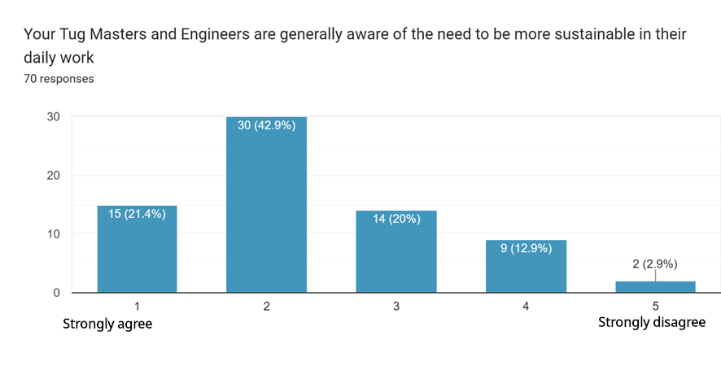
This proportion falls to 55,7% of respondents who strongly agree or agree that tug masters and engineers in their companies are generally aware of tugboat operations' impact on the marine ecosystem. This could indicate that, even if there is general awareness about the sustainability of port services operations, there is still room to increase it, especially concerning the actual environmental impact of tugboat operations.

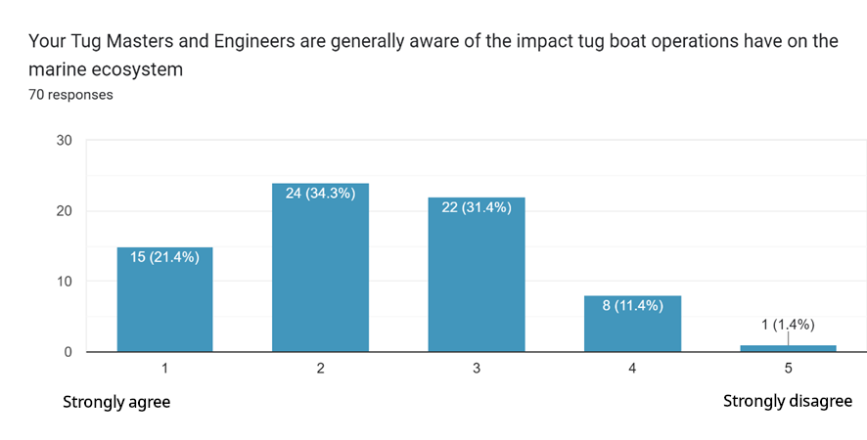
Similar conclusions could be drawn from the results of another question, whereby 55,7% of respondents strongly agree or agree on whether their companies´ tug masters and engineers consider the environmental impact they have when carrying out their daily tasks. 20% disagree or strongly disagree with this statement, while 24,3% are between these views. This could indicate there is a slight discrepancy between the general opinions on the need to increase the sustainability of towage operations tug masters and engineers may have, and on the other hand, their awareness regarding the environmental impact of their actual daily tasks.

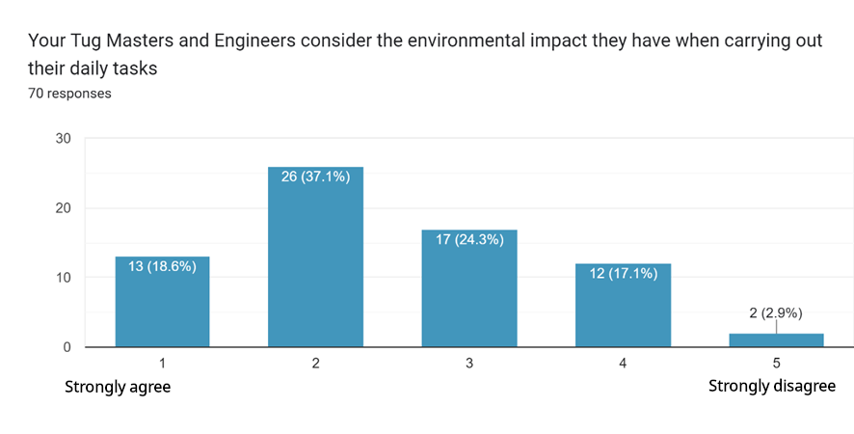
Regarding tugboat operation´s impact on emissions and fuel consumption, 82,9% of the respondents strongly agree or agree that how a tugboat is operated can generate extra emissions and increase fuel consumption.
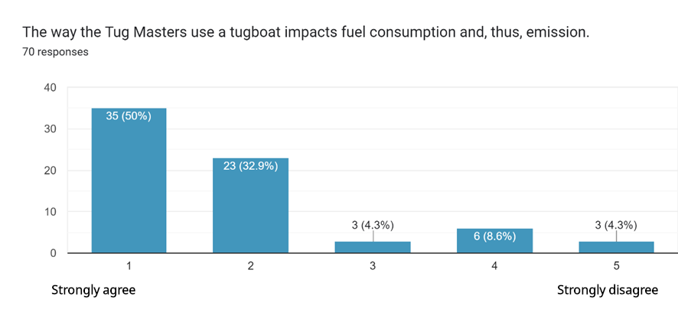
Those respondents who chose the strongly agree and agree options were asked to outline the instances that cause the highest unnecessary fuel consumption. The answers varied, but over half of them underlined speed as the main factor affecting fuel consumption. 26% of respondents mentioned poor planning, coordination and communication between tug masters, pilots, harbour masters and the vessels´ captains as the significant factors affecting tugboats´ fuel consumption. 10% of answers chose the execution of towage manoeuvres at full power. Still, most of these respondents underlined the need to operate that way to guarantee the highest safety of these manoeuvres. 6% of answers highlighted the lack of awareness among tug masters and crews, and just 4% chose the lack of shore power as the primary instance affecting tugboats´ fuel consumption.

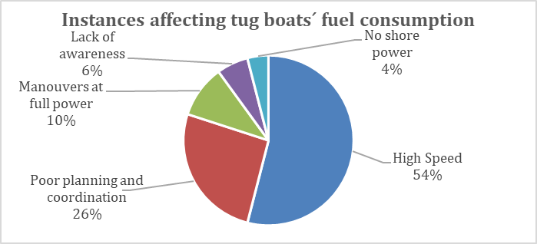

When asked about the necessary skills and knowledge tug crews need to operate tugboats more sustainably and reduce emissions, two-thirds of respondents chose knowledge of emission monitoring and documentation. At the same time, half of them picked the ability to use performance management systems. 42% of respondents chose knowledge of environmental economics, while 37.7% answered tug crews would need a better understanding of ecological economics and communication skills.

The answers show how respondents prioritise acquiring knowledge that we could deem technical and directly connected to the green legislation in force over soft skills and more general skills like digital, leadership, or safety.
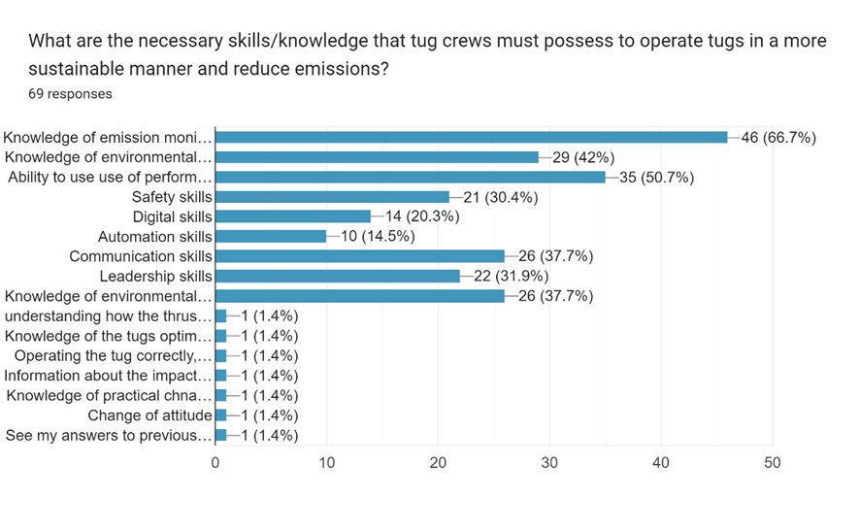
An overwhelming majority of respondents, 85%, strongly agree or agree with the relevance of training as one of the tools to reduce tugboat emissions. Only 2,9% of respondents disagree or strongly disagree with the idea of crew training as a way to reduce emissions.
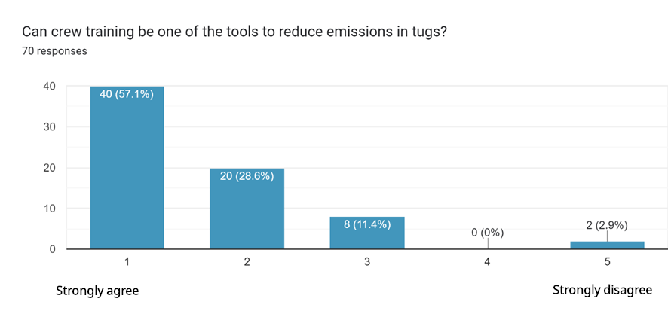
Respondents indicated that there is still room for improvement in the training provided to crews to reduce their emissions. More than a third of respondents affirm that their companies do not train these employees or give simple recommendations on fuel consumption.
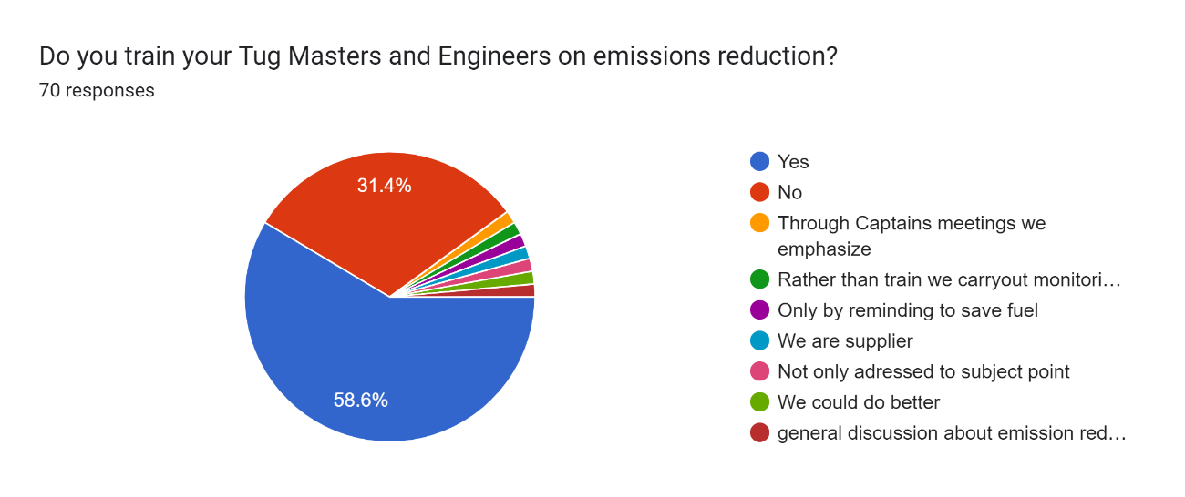
Asked whether the companies have regular training with other stakeholders in ports, 41,4% of respondents state that they do not have regular training with tug masters, pilots and other stakeholders. This measure could lead to the highest levels of safety in the operations and lower fuel consumption. The majority of respondents who answered yes to this question complement that information by describing the activities, mainly joint pilots and tug master’s coordination meetings and workshops to improve the safety of operations. Still, a minority of those who answered yes (13% of these) referred to training on fuel consumption reduction and sustainability.
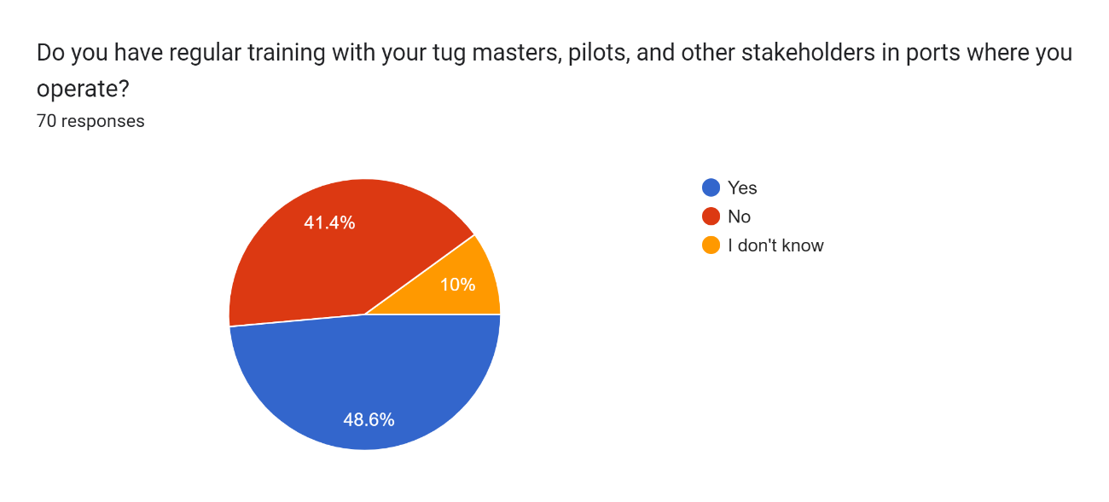
More than 90% of respondents said insufficient courses or training on environmental issues exist.
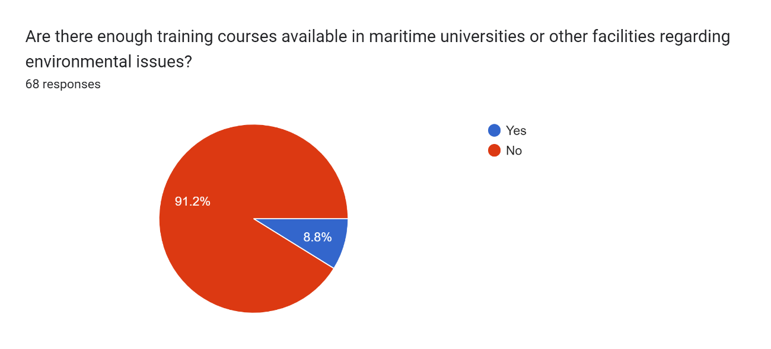

These 91,2% of respondents were asked what type of training should be available, and the answers varied. The responses to this open question show a clear preference for training on energy efficient operations, chosen by 31% of respondents. EU and IMO environmental legislation, general training on sustainability environmental awareness and instruction in new fuels and hybrid tugs were mentioned by 16% of respondents each. Surprisingly, 12% of respondents affirmed that there was no need to teach these types of content or that universities should not be responsible for that type of training.

Respondents were asked about the type of environmental initiatives that their companies had implemented. Only two answers surpass the 50%: reduction of greenhouse gas emissions (63,2%) and Responsible waste and wastewater management (75%). Protecting marine biodiversity (35,3%) and using fuels with low environmental impact (45,6%) are also popular measures.

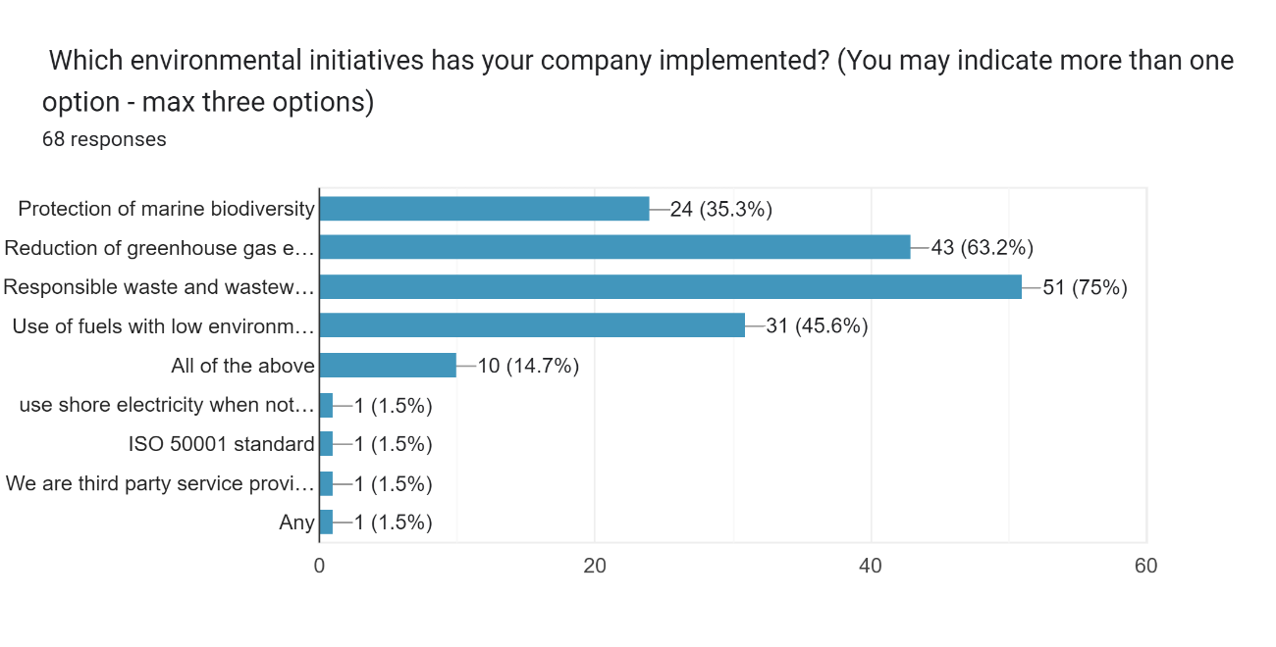
70,6% of the survey´s participants confirm their company has a policy to limit or reduce emissions, going in line with the previous one as they show that
.
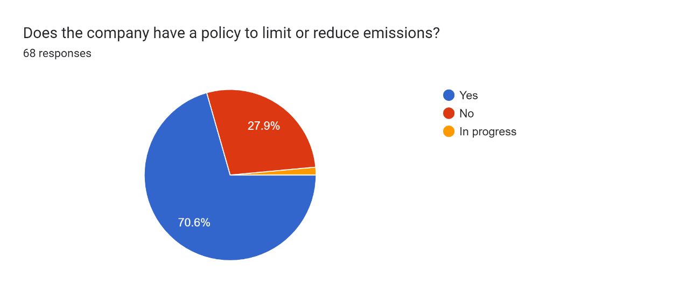
The most popular measure implemented by a quarter of the respondents´ companies is better planning of routes and speed to reduce fuel consumption. 18% of answers mentioned fuel monitoring and fuel consumption targets. Only 8% of respondents affirmed that their companies were not implementing any measures to reduce the CO2 footprint of their fleets.

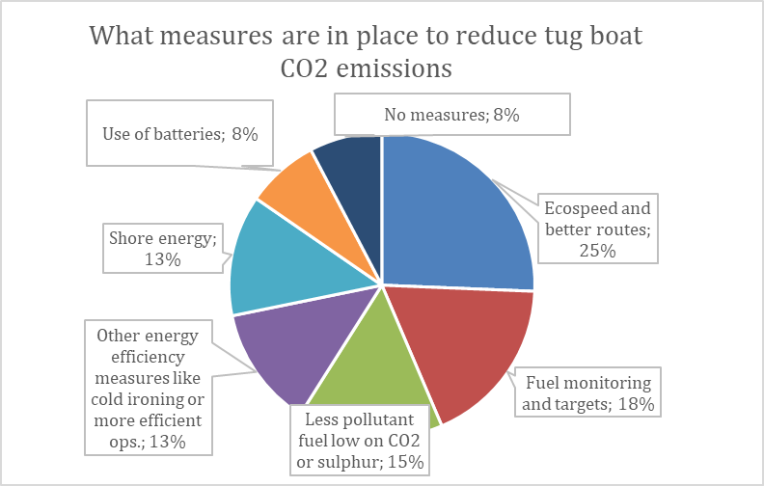

The questionnaire also addresses how respondents´ companies track their fleets' Energy Efficiency Existing Ship Index (EEXI). Only 44 answered this open-ended question, and ten respondents denied any tracking exercise. The most representative answer is manually or through specialised software monitoring speed, especially fuel consumption.

Regarding the types of air pollutants that the respondents´ companies monitor, the significant majority, 65,6%, monitor carbon dioxide, while only 25% report nitrogen oxides and 21,9% report sulphur dioxide. On the other hand, 29,7% of respondents replied that their companies do not monitor any of the air pollutants included in the list of options.

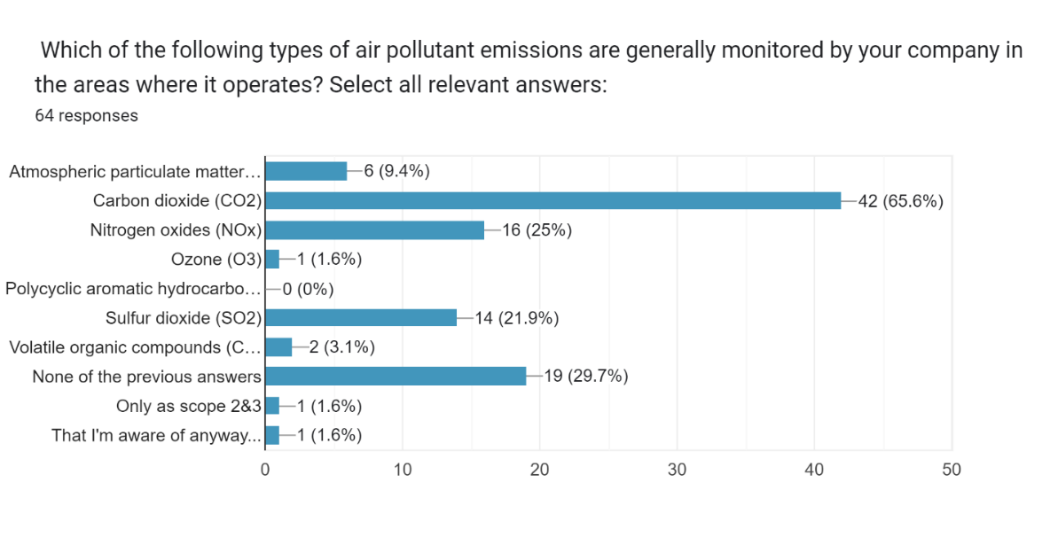

Conclusions of the towage industry questionnaire

The questionnaire´s results show general awareness of the efforts to decarbonise the port towage sector. However, this is not always translated into daily practices and behaviours aiming at that, even if the employees understand the environmental impact of these. The industry´s respondents clearly understand the skills the sector´s workers need to acquire. They generally believe these competencies would improve the industry's environmental standards and reduce emissions. Still, some participants highlighted safety standards as the most important factor in the industry, which cannot be disregarded in favour of emissions reduction goals.
Regarding the current training and educational opportunities in the sector, the answers show a clear lack of these in the market. Respondents called for developing courses and materials in different areas, such as energy-efficient operations, environmental legislation, or tugboats using greener fuels or batteries. Finally, the questionnaire´s answers show a clear sectoral effort to reduce its emissions and improve its environmental credentials through many measures like the transition to cleaner fuels, more energy-efficient manoeuvres, or the use of onshore power.

Survey for Pilots

EMPA collected 26 responses, all directly from pilots or managers of pilotage services companies, members of the Association, and its international stakeholders. While this number of responses covers the requirements of the work package, it is worth noting that statistically, 26 responses cannot be seen as a statistically representative sample of pilots in Europe since the margin of error is quite large. The answers below should be read as the views of 26 pilots who responded, not necessarily as a representative sample of all European pilots.

The answers on pilots' general awareness of the need to be more sustainable in their daily work give mixed results. A clear majority of 57,7% of respondents strongly agree or disagree with the statement, 11,5% strongly disagree, and 26,9% are in between. If we compare these answers with those given by the port towage industry, this could indicate a slightly lower awareness regarding the sustainability of daily pilotage operations.

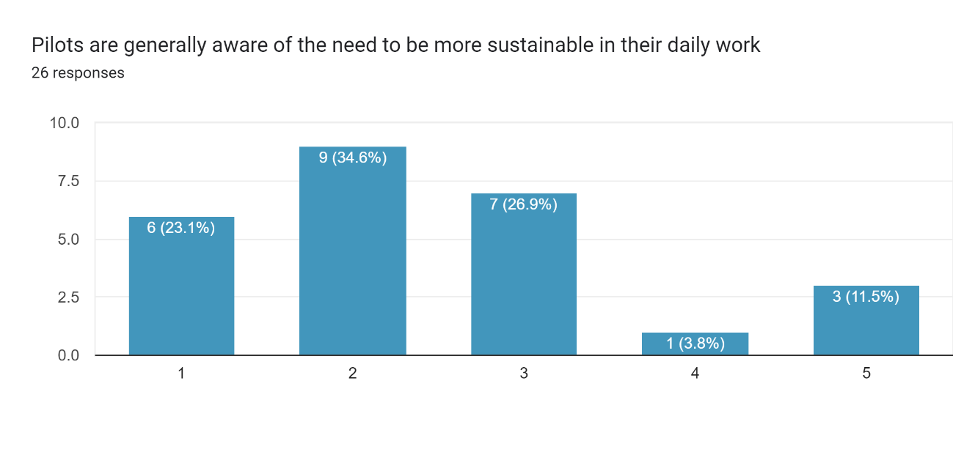
Answers on whether pilots consider the environmental impact of their daily tasks give a different result, with up to almost two-thirds of respondents (65,4%) strongly agreeing or agreeing with the statement and only 23% disagreeing or strongly disagreeing. These results show a higher awareness if we compare them with those collected through the towage industry questionnaire (only 55,7% agree or strongly agree with the statement).

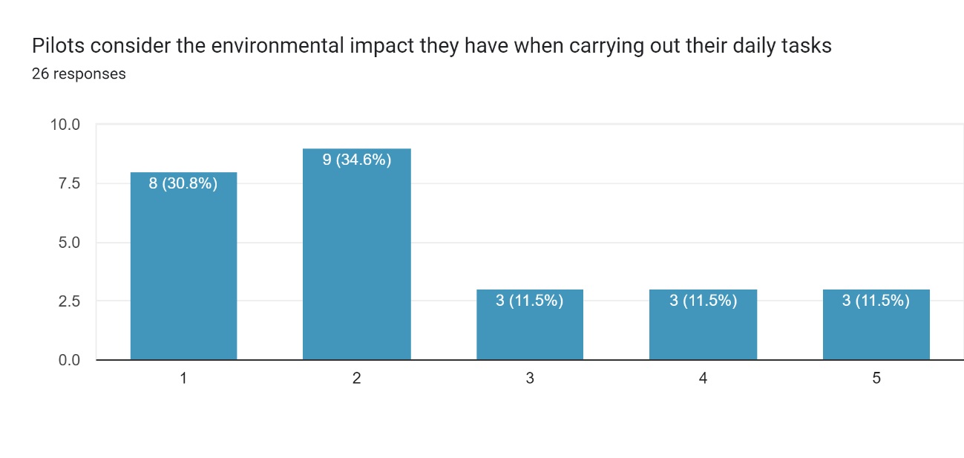
Most pilots believe that how they manoeuvre the vessel impacts fuel consumption and emissions. 69,3% strongly agree or agree with this statement, and only 10,5% disagree or strongly disagree.
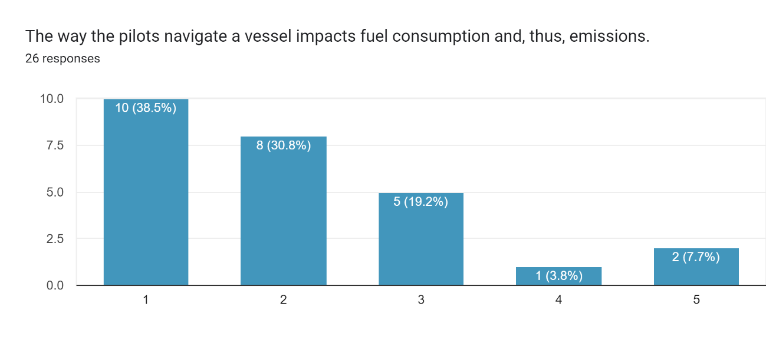
Those respondents who strongly agreed or agreed with the question´s statement gave a series of reasons about how pilots' navigation of a vessel affects fuel consumption. Most mentioned speed (67% of respondents), but this factor is difficult to correct as the economic model of pilotage services depends on the number of services and port traffic. The overuse of tugboat power was chosen by 16,5% of respondents, and another 16,5% selected coordination and poor planning (especially in tidal ports). In addition to that, some respondents underlined that keeping the highest safety standards should be the main priority despite higher fuel consumption.
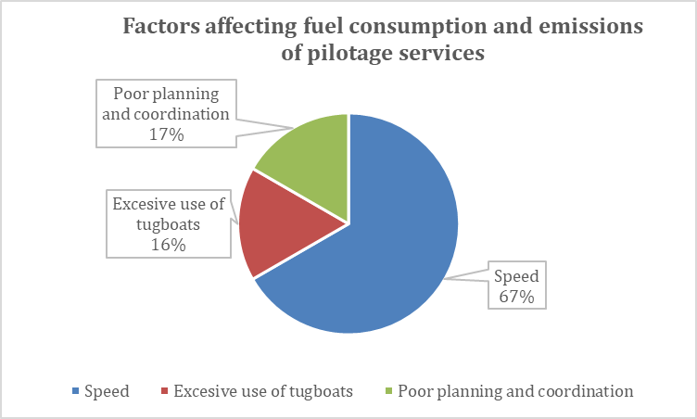

The answers to what skills pilots need to develop to carry out their duties more sustainably offer similar results to the question posed to the port towage industry. Most respondents give priority to improving their knowledge of environmental legislation (53,8%), emission monitoring and documentation (46,2%), environmental economics (38,5%) and the ability to use performance management systems (38,5). More general skills like digital, automation, communication or leadership competences were considered less relevant.
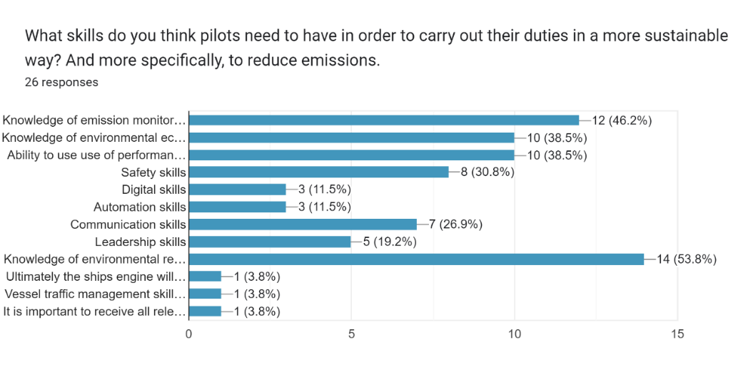
The answers to whether pilots´ training could reduce emissions are mainly positive (53,8% strongly agree or agree), although more than a quarter (26,9%) are in between.
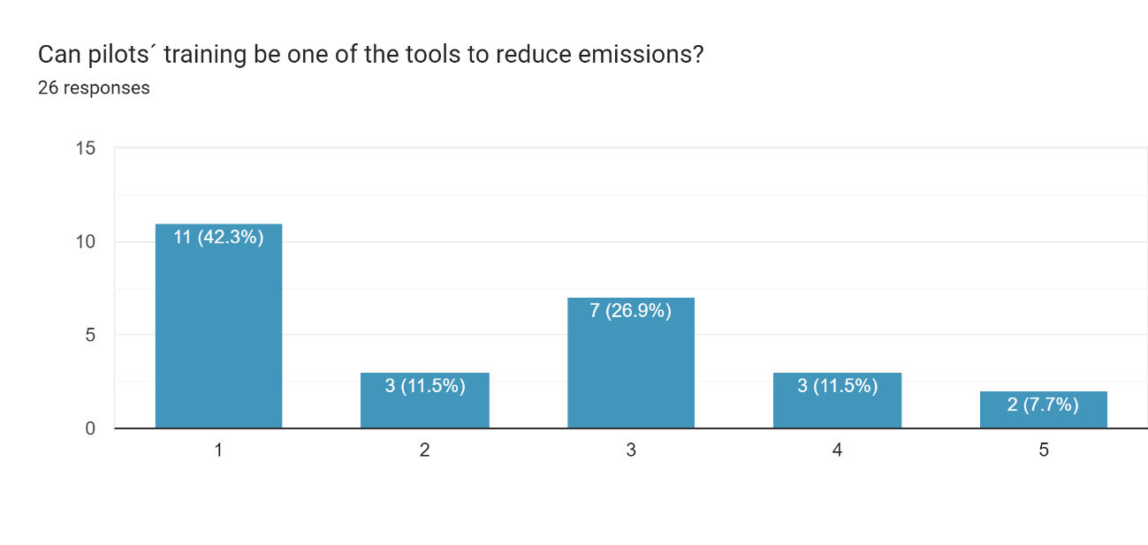
Despite the majority of industry representatives seeing training as a tool to reduce emissions, 76,9% of respondents answered that they do not carry out any training on energy efficiency or emissions reduction during pilotage or are aware of such training.
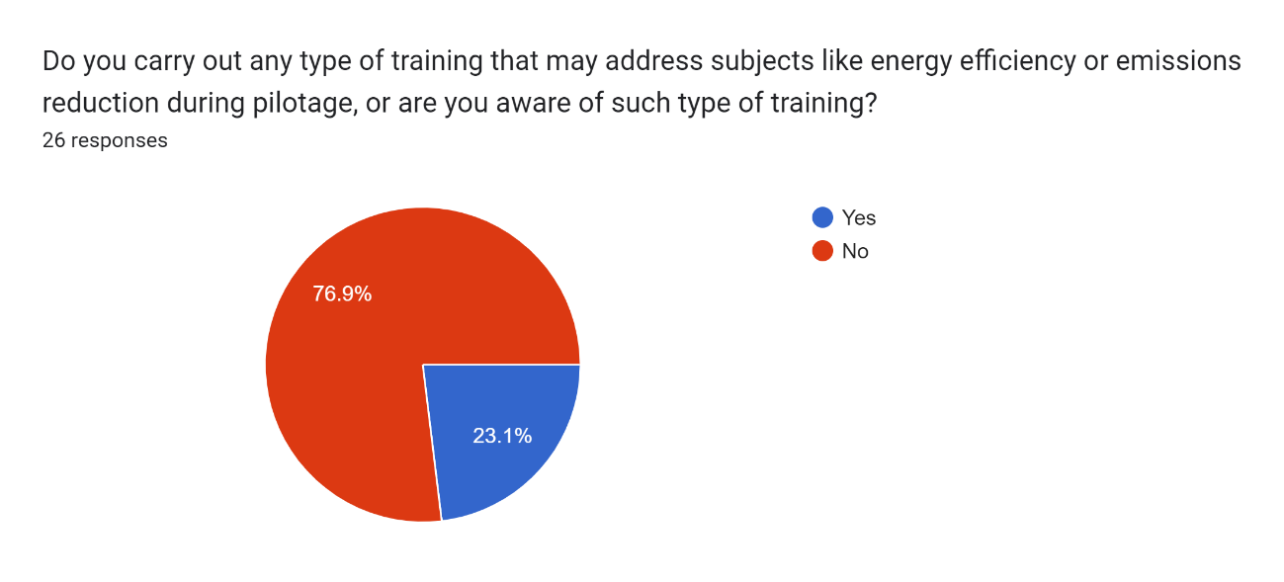
Pilots indicated that there is still room for improvement when it comes to training tug masters, harbour masters, and other stakeholders in ports. Half of the respondents affirm that their companies do not carry out these types of exercises. Those who responded yes to this question mentioned training with simulators and workshops to improve the efficiency and coordination of operations. Only one respondent alludes to training on pilot boats to improve fuel efficiency.
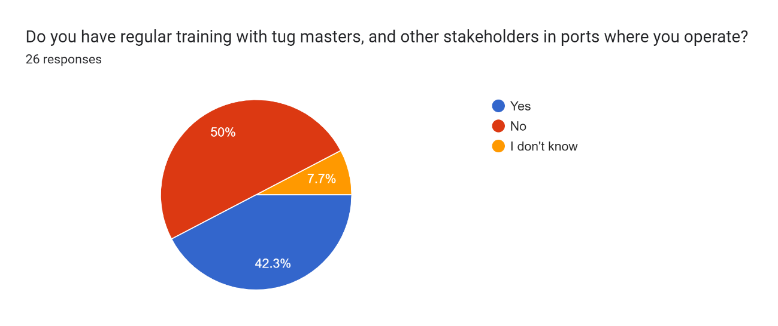

87,5% of respondents confirm no available training courses regarding environmental issues, addressing a core aim of the Greenport Alliance project and confirming the need for its implementation.

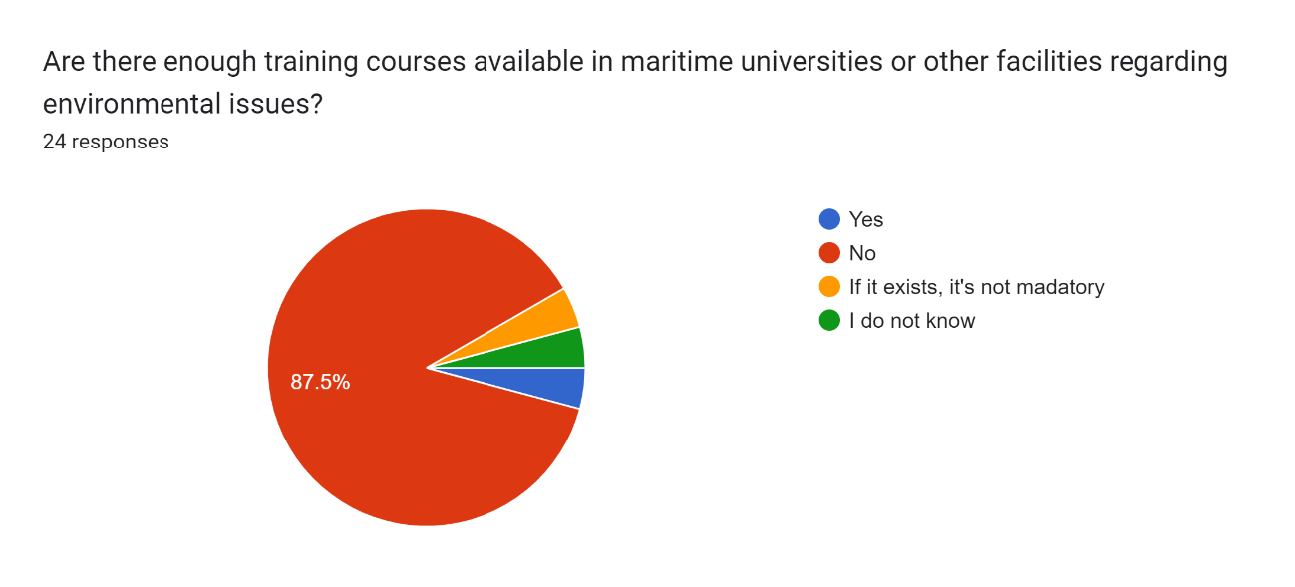

Half of the respondents (46,2%) affirmed that cross-industry training covering ports and port services should be created, and a similar number (42,3%) rejected that idea.

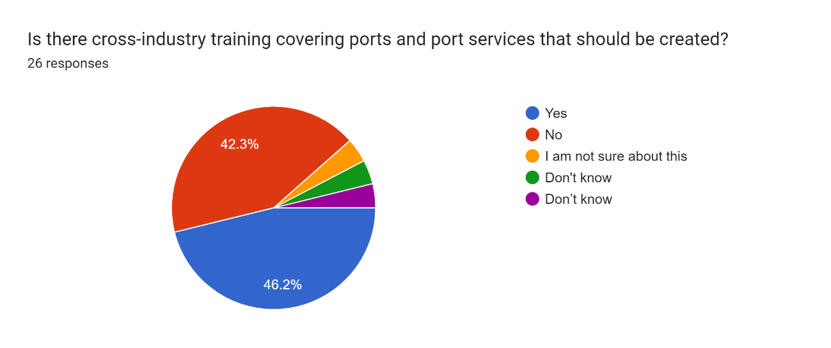
When asked what areas training to increase the sustainability of pilotage operations Greenport Alliance could focus on, the answers are very varied, ranging from speed management to fuel consumption monitoring to the use of alternative fuels and better coordination with vessels and tugboats.

Pilotage services companies are implementing measures to improve their environmental sustainability. Almost half of respondents´ companies (47,8%) use fuels with low ecological impact, and 34,8% have a policy to manage waste and wastewater and reduce greenhouse gases. On the other hand, 17,3% of the respondents´ companies do not implement any environmental initiative.
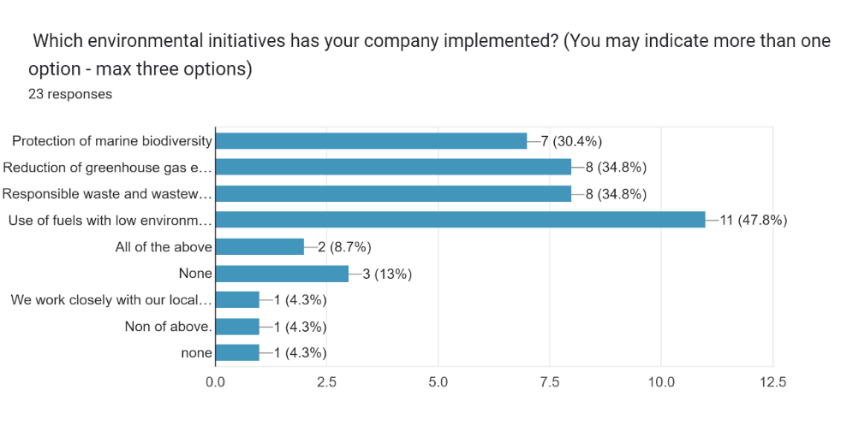
However, there is still much to do when measuring pilot boat emissions, as 61,5% of the respondents´ companies have not yet implemented that measure.
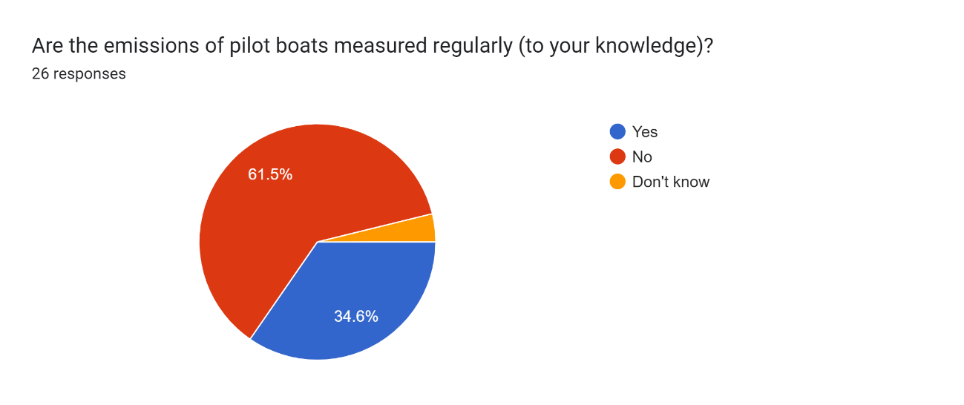
42,3% of the respondents' companies do not have a policy to limit or reduce their emissions. Regarding actions or plans to reduce emissions, 13 of the respondents´ companies have implemented measures or are planning to take action to reduce the pilot boats´ emissions through the use of HVO and other biofuels, batteries or the operation of pilot vessels at efficient speeds. Six respondents stated that their companies have no emissions reduction plan.

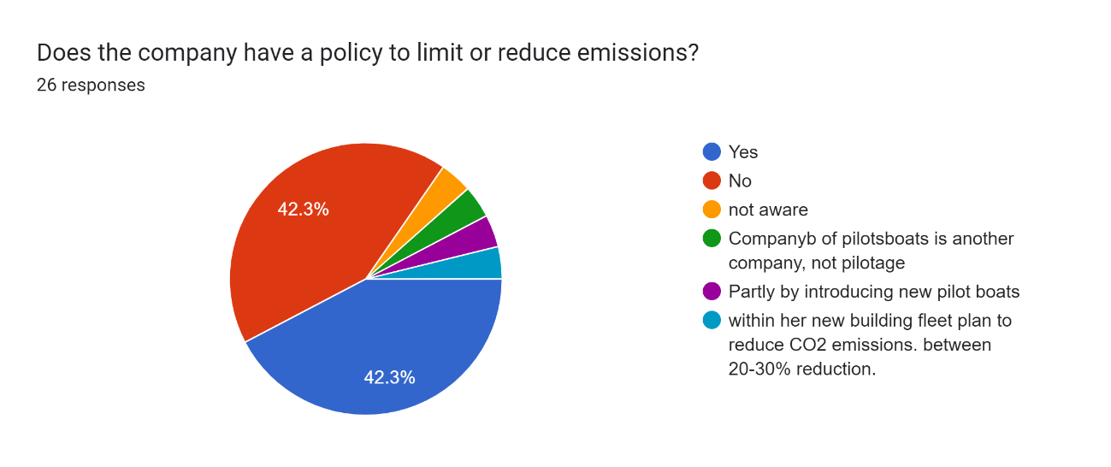

Finally, when asked what type of air pollution emissions are generally monitored in the areas where pilots operate, 43,5% of respondents stated that atmospheric particulate matter and carbon dioxide are monitored. In comparison, 30,4% of respondents chose sulphur dioxide as well.

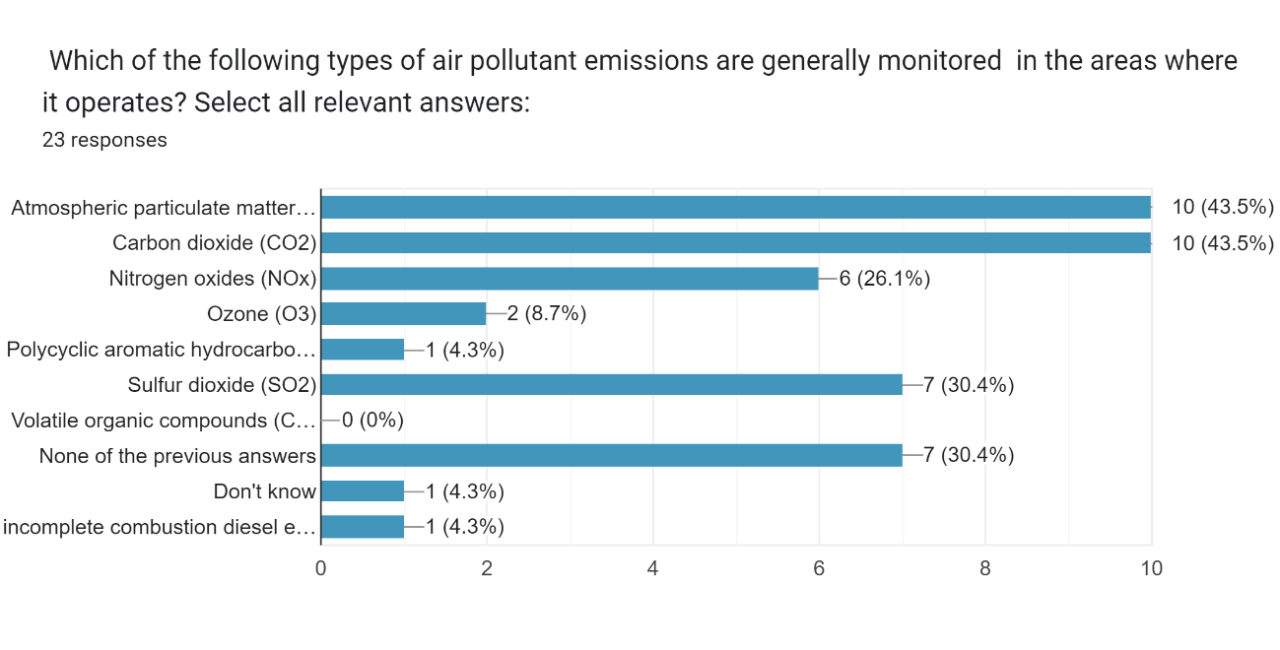

Conclusions from the pilots’ survey

The questionnaire´s answers prove a strong awareness concerning the efforts to decarbonise the pilotage sector. Still, as in the case of the port towage industry, this does not always imply an attempt to change daily practices and behaviours, even when the employees understand the environmental impact of these. As in the case of the port towage industry, the pilotage sector´s respondents generally believe that emissions can be reduced by training and have a clear view of the type of skills that the workers need to acquire, but in the questionnaire, some respondents highlighted that our primary objective is to ensure the safe movements of ships in and out of ports; doing so in a sustainable manner is desirable.
Concerning the current training on sustainable pilotage, the answers show that most companies do not carry out these kinds of activities and that there is an apparent lack of these types of training. However, the responses show that there is not such a strong demand for developing courses and materials, probably due to a lack of awareness and environmental sensitivities. Finally, the questionnaire´s answers show a sectoral effort to reduce its emissions and improve its environmental credentials through some actions like the use of biodiesel and cleaner fuels.

The views of academia

Academic partners designed a survey and exploited their connections to identify current educators’ commitment and understanding towards sustainability principles, academia’s awareness of the specific issues relating to port service sustainability and current capacity to integrate behavioural change approaches to their educational offerings.

Methodology

The Piri Reis University team designed a questionnaire for maritime educators, following the examples of several academic publications (see annexes) and after implementing the feedback received by the project partners. The Piri Reis University team disseminated the questionnaire through a link via email to several academics with which they have worked during the last years. The project partners shared the survey with their academic networks as well. In addition to this, the communication team of Greenport Alliance disseminated the survey on social media.

The questionnaire contains 44 questions. Seven of them focus on the respondents' personal profiles. Thirty-six questions are closed single-select, seven are open, and 1 is a closed multiple-choice question.

Results

Survey for academia

Piri Reis University reached 76 answers from academics, professors, associated professors and lecturers.
The answers to the question of whether sustainability principles in maritime education are important give a very clear view of the academia's position in this debate. 62% of respondents strongly agreed with that statement, and 37% agreed. Only the remaining 1% had a neutral attitude.
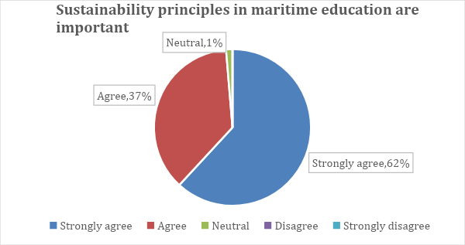
Results of the question on how knowledgeable respondents are about sustainable practices in maritime operations assess themselves show fewer clear results. A majority of 75% strongly agree or agree, but 17% of respondents are neutral, and 8% disagree or strongly disagree, proving there is still room for improvement.
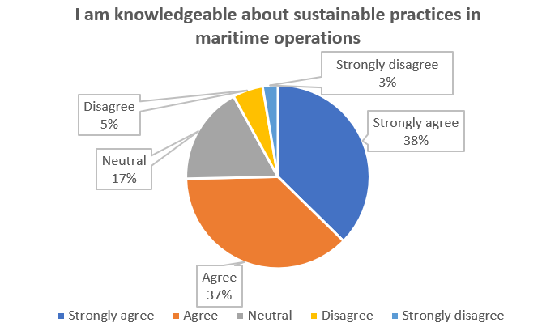

Survey participants were asked whether they incorporate sustainability topics into their courses when possible. The answers show that a strong majority of respondents are willing to do so. 74% strongly agree or agree with this statement, while 22% remain neutral, and only 4% strongly disagree or disagree.
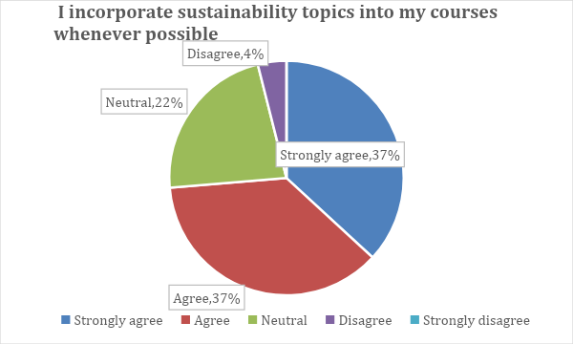

Responses to the next question on whether the participants have participated in training or workshops related to sustainability in the maritime sector give more mixed reality and prove that the level of participation in training or workshops about sustainability in the maritime sector is far from widespread. 46% of respondents agree or strongly agree with the question´s statement, while 34% strongly disagree or disagree, and 20% remain neutral.
The answers to this question, in connection with the previous ones, show that even if the respondents value the sustainability of maritime operations and are keen to include this topic in the courses they teach, they do not always participate in educational activities addressing the matter.

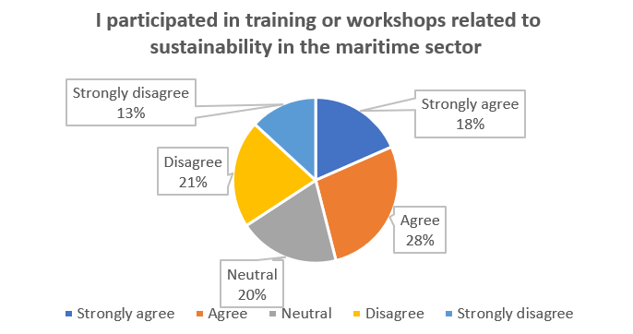

The answers to the relevance of integrating sustainability principles into maritime education give a clear picture, as 80% of respondents strongly agree or agree with the question´s premise, and only 1% strongly disagree or disagree with the statement.

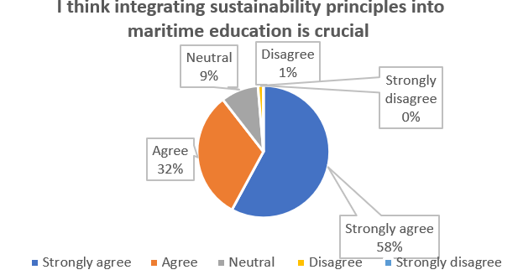

The results to the next question on the respondents´ confidence in explaining the environmental, social and economic dimensions of maritime sustainability to students are mixed, even if a majority of 51% of respondents state that they are confident (29% strongly disagree and 22% disagree), 32% strongly agree or agree with the statement and a 17% of them are in between. These numbers show that there is still a need for action to update and improve educators' knowledge of maritime sustainability.
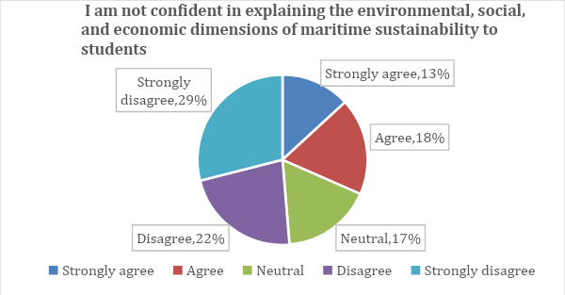
The next question focuses on the respondents’ efforts to seek opportunities to include guest speakers or industry experts with sustainability knowledge in their educational activities. The results show that a clear majority of respondents strongly agree or agree with the statement (55% of them), while only 17% disagree or strongly disagree.
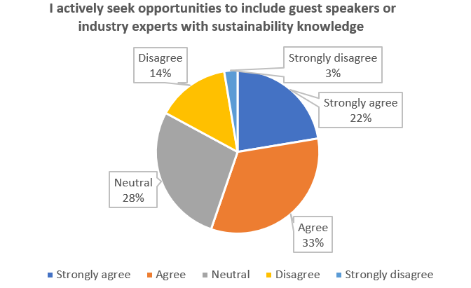

The survey´s participants were asked about their understanding of the concept of sustainability, which, according to the results, is quite high: 82% of them chose the agree and strongly agree options, while only 3% would disagree or strongly disagree with the question´s statement.

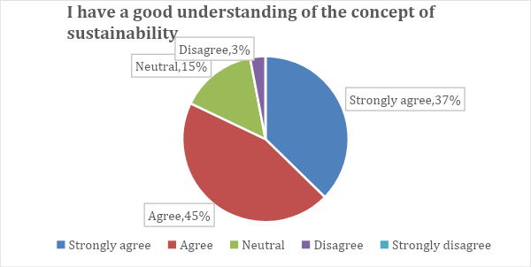

The answers to whether respondents´ curriculum effectively covers current maritime sustainability challenges and solutions show that a majority, 51%, agree or strongly agree with the statement. In comparison, 17% believe the opposite (13% disagree and 4% strongly disagree), and a strong 32% are in between, proving that there could still be room to improve the curriculum of many educators, including maritime sustainability topics.

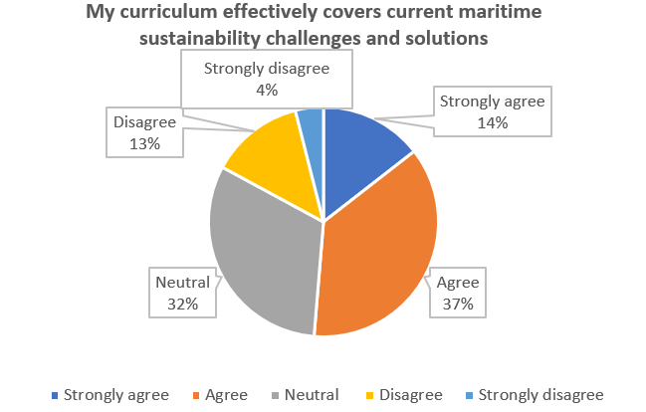

Respondents were asked whether they encourage students to critically evaluate the environmental impact of maritime operations, and the results are quite clear: A very strong majority of 84% agreed or strongly agreed with the question´s statement, while only 4% chose the opposite answer.

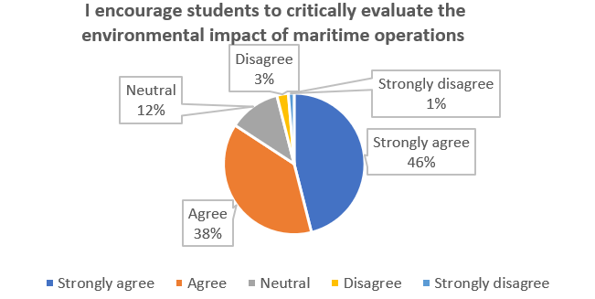

The next question asks respondents to self-assess their abilities to explain sustainability principles in relation to maritime education. The results are quite positive: 73% strongly agree or agree with the proposed statement, and only 11% disagree or strongly disagree.

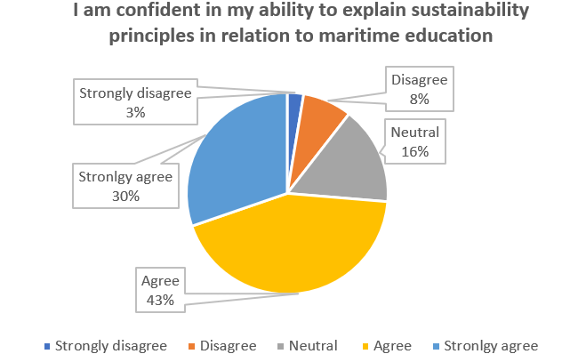

The answers to whether respondents are very aware of the environmental impact of port operations show that 79% of them agree or strongly agree with the question´s statement, and only 6% disagree or strongly disagree with it.

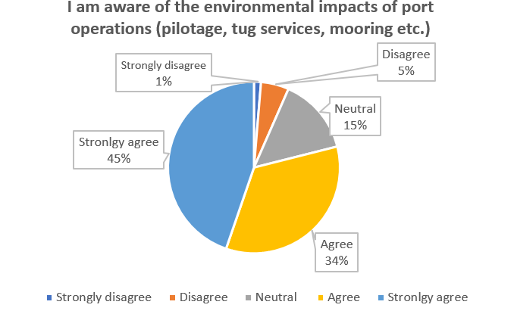

The next question´s results give a similar positive snapshot of the respondents’ views on the role academia should play in addressing sustainability in port services. 79% of them agree or strongly agree that academia has a relevant role in finding solutions to sustainability challenges in the sector, while only 6% of respondents chose the opposite answer.
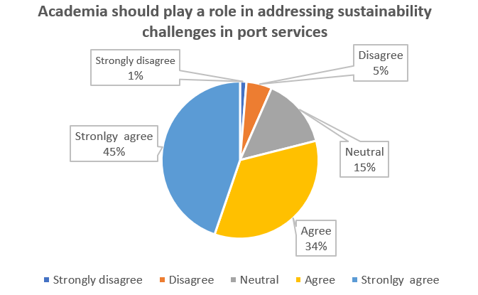
The survey ́s participants were asked to assess their familiarity with key sustainability challenges faced by port operations. The answers prove that the big majority of respondents are familiar as two thirds of them strongly agree or agree with the question´s statement and only a 13% of them chose the opposite options.
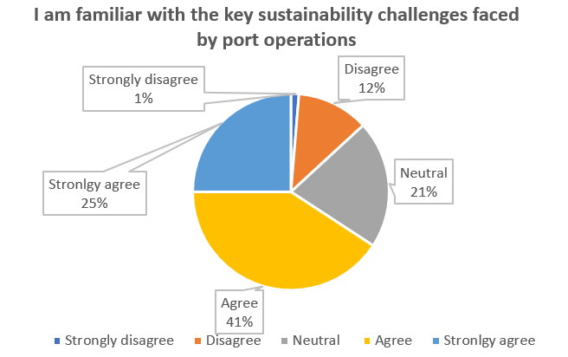

The answers to next question on whether the participants discuss sustainability issues related to port services in their academic circles are not so positive but display that these issues are a topic generally discussed, as 54% of respondents agree or strongly agree with the question´s statement, while only a 20% strongly disagree or disagree with it. 26% of respondents are neutral. These data show us that even if the matter is part of academic discussions, there is still an important number of academics that have not addressed these topics with their colleagues.

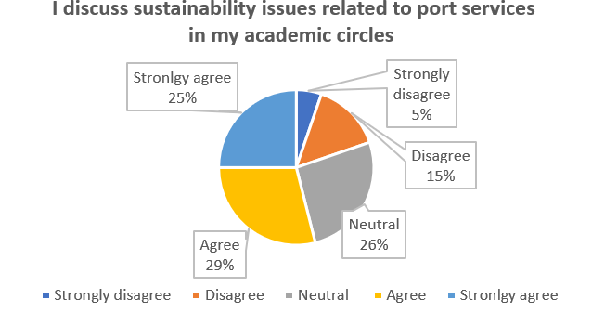

When it comes to the knowledge that respondents possess on the economic dimension of sustainability practices in port operations, the next question´s results are very mixed. There is almost the same number of respondents who strongly agree or disagree with the statement as those who answered the opposite (37% affirm they are not knowledgeable, and 38% reject that statement). 25% of respondents are in between. These results show that there are still some knowledge gaps among academics concerning the economic dimensions of sustainability practices in port operations.

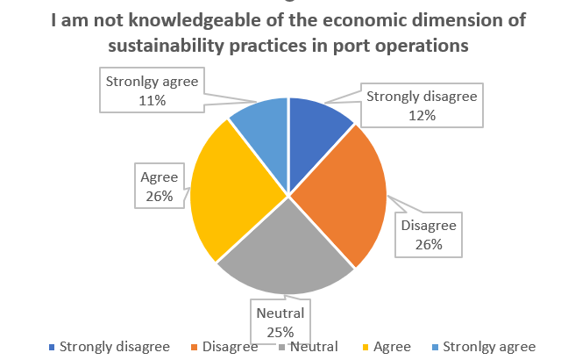

Respondents gave quite positive answers regarding their self-assessment regarding their curriculum and whether it addresses the environmental impact of port activities. 59% of respondents agree with the question´s statement (22% strongly agree and 37% agree), while only 16% believe the opposite.
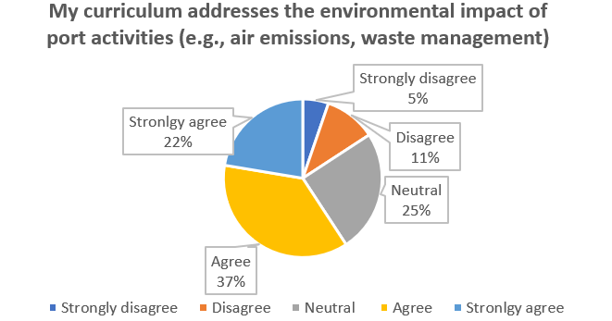

Regarding the respondents´ awareness of emerging green technologies in the port services sector, the respondents show quite strong knowledge and awareness, as 75% strongly agree or agree with the question´s statement. In comparison, only 6% chose the opposite options.
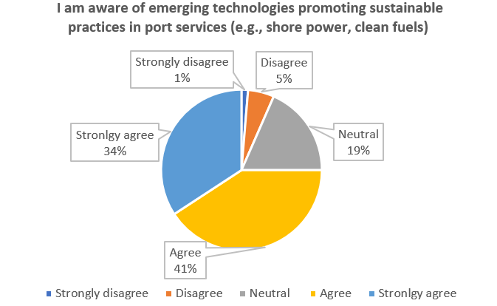
The questionnaire´s participants were also asked to self-assess their knowledge regarding the social dimensions of port sustainability. Two-thirds agree with the question statement and consider themselves knowledgeable (40% agree and 26% strongly agree). Only 12% of respondents chose the opposite options, proving that most consider themselves knowledgeable of the environmental aspects of port services operations and their social dimensions.

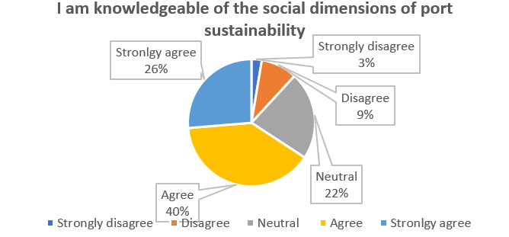

Regarding the relevance of collaboration between education institutions and industry stakeholders as a factor in addressing port services sustainability, there is an almost complete consensus as 92% of respondents to question 20 strongly agree or agree on its importance, and only 8% chose the neutral option.

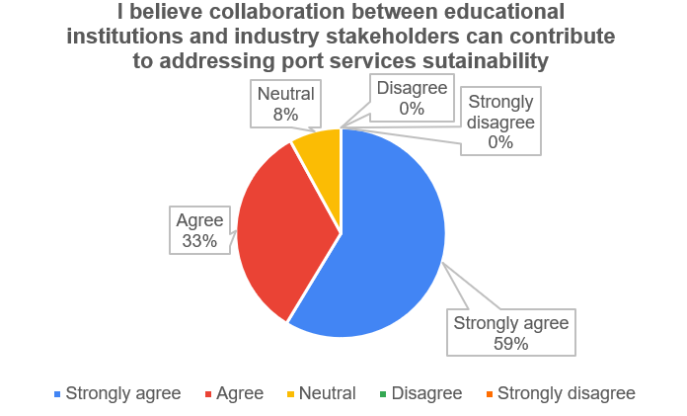

The answers to whether respondents see behavioural change approaches as effective in teaching sustainability concepts show a similar quasi-unanimous view. 91% of respondents agree or strongly agree with the question´s statement, and only 1% strongly disagree with it.

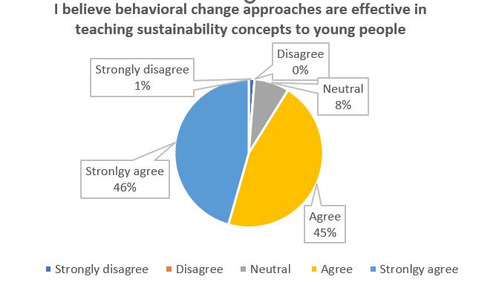
The respondents clearly showed, with their answers, that there is still room for improvement regarding how effectively their institutions integrate behavioural change approaches into the curriculum. The responses show that the most chosen option, 41% of answers, is the neutral one, while the positive ones, strongly agree and agree, only reach 49% of the answers.

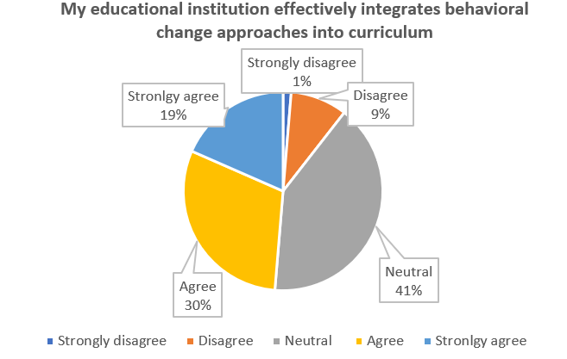
The next question asked the survey participants whether they were open to integrating behavioural change approaches related to sustainability into their teaching methods. The answers were very supportive: 90% of respondents agreed or strongly agreed with the question´s statement, and only 4% chose the opposite option.

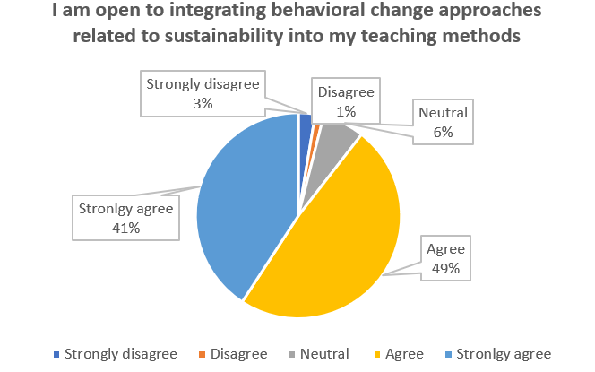

Despite the results of the previous question showing that respondents are willing to integrate behavioural change approaches, the answers to the next one prove that many questionnaire participants still need to receive training or resources on incorporating these techniques in education. 49% of respondents strongly agree or agree with the question´s statement, and 25% chose the opposite. This proves there is still much to do regarding training and resources on behavioural change techniques for educators.
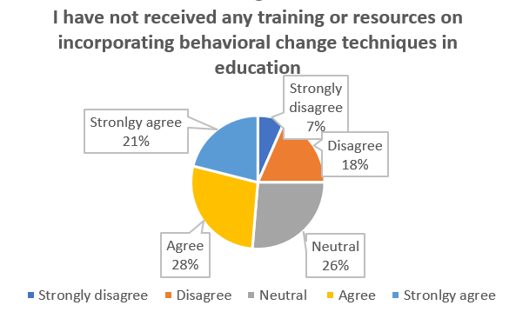

The results of whether the respondents´ curriculum includes case studies or projects that highlight successful examples of behavioural change in maritime sustainability give a mixed picture. 40% of the answers agree or strongly agree with the question´s statement, while 30% strongly disagree or agree. A large share of respondents, 26%, remain neutral. Thus, there is still room for improvement when it comes to including specific practical cases in educators' curriculums.

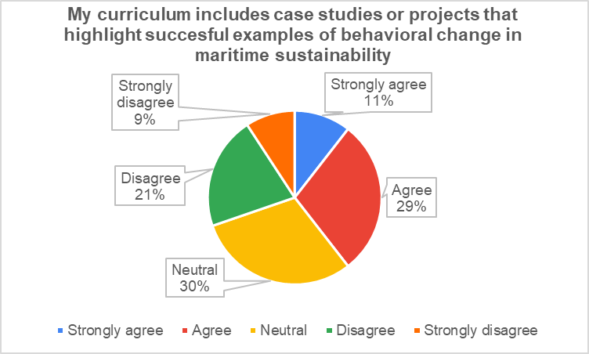

Participants were also asked whether they were comfortable using methods to encourage students to adopt sustainable behaviours in the maritime industry. The answers are generally supportive (66% of them agree or strongly agree), but 21% seem undecided, and 13% do not feel comfortable using those methods.

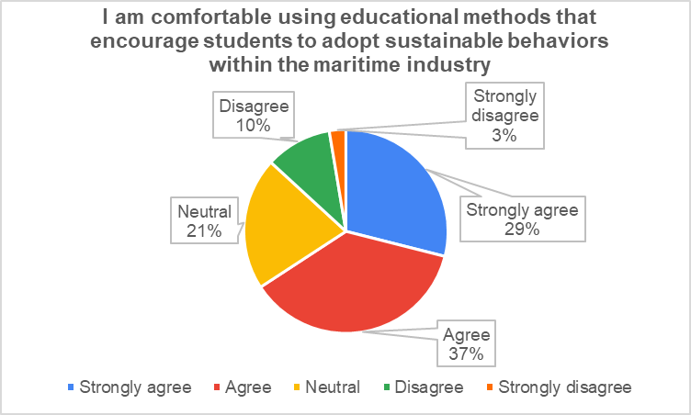

The next question addresses respondents' confidence in facilitating discussions about the psychological barriers to adopting sustainable practices at sea. The answers give a positive image, with 59% of them supporting the question´s statement and only 11% disagreeing with it. Still, an important proportion of respondents, 30%, chose the neutral option.

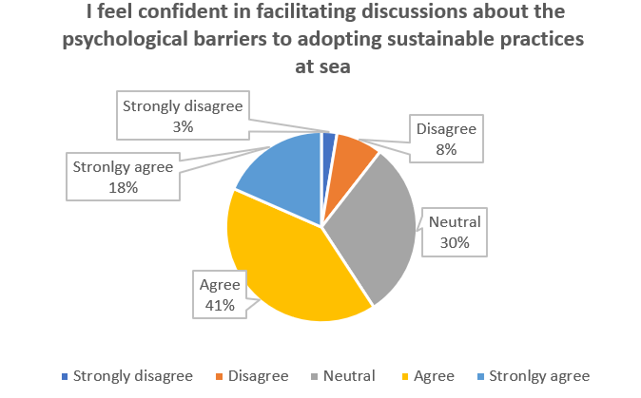
The answers to whether respondents´ access to resources or training programs integrating behavioural change techniques into their teaching are mixed. 42% of the answers strongly agree or agree with the question´s statement, 24% express a lack of access to those resources or training, and 34% are neutral.

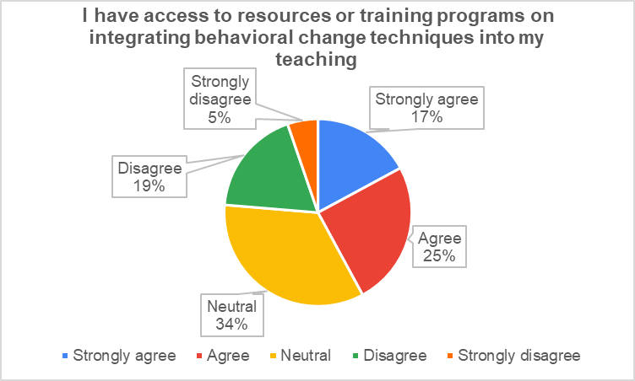

Respondents´ answers to whether they believe behavioural change approaches are effective in teaching sustainability concepts to professionals show strong support for this idea. 78% of respondents agree or strongly agree with that statement, and only 1% disagree. The remaining 21% remain in between both positions.

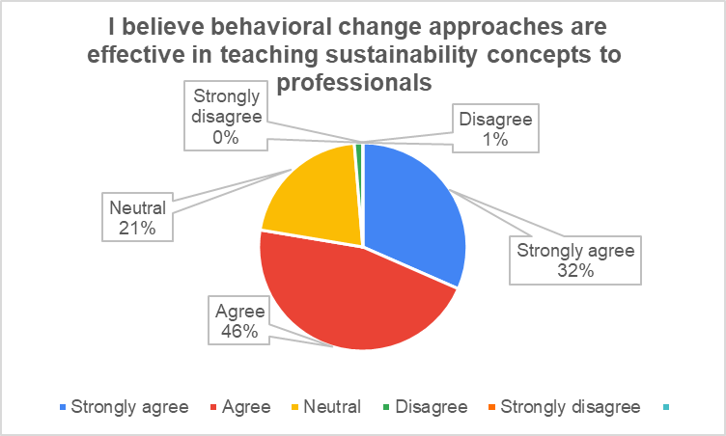
The next question is an open text one, and it asks the survey´s participants about the most significant challenges they face in motivating learners to adopt behavioural change in their maritime careers. The responses are very varied but can be grouped into three different main challenges: 1) The general resistance to change, which, according to some respondents, is quite common in the maritime sector; 2) a lack of expertise, resources and materials on behavioural change and 3) a lack of awareness on the matter among the educators and students.

The next four questions are connected with the previous one as they ask how significant several barriers are to learners adopting sustainable practices in port operations. The survey gives the following barriers:
- Lack of awareness or understanding of sustainable practices. 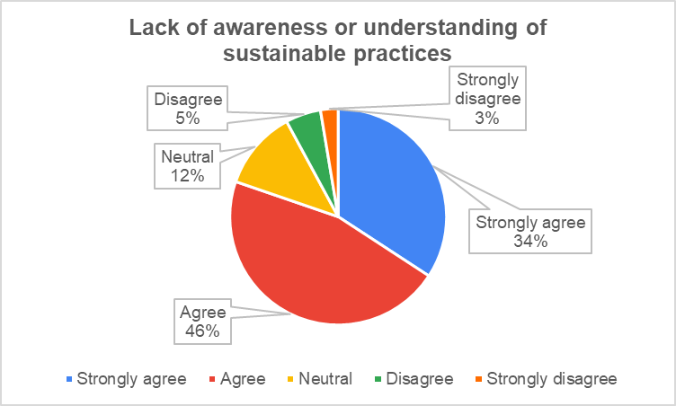

- Perceived difficulty or impracticality of implementing sustainable practices.
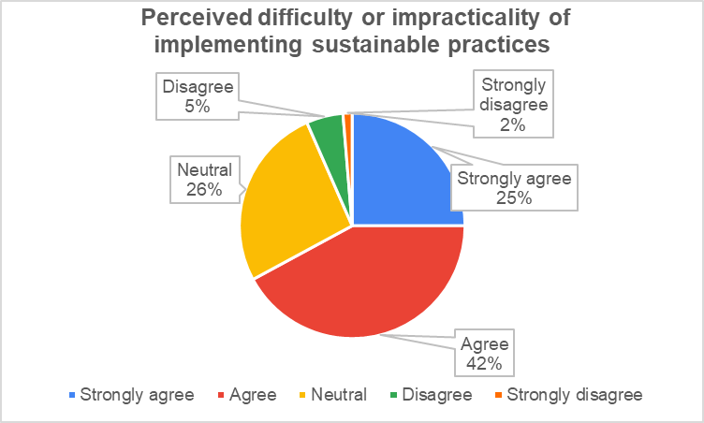

- Organisational culture that does not prioritise sustainability
- 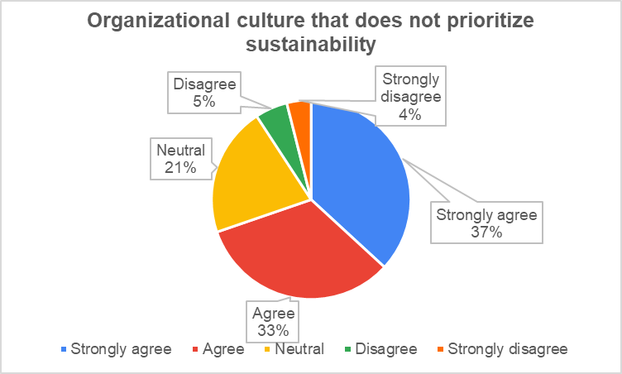

- Limited resources or infrastructure for sustainable practices on board
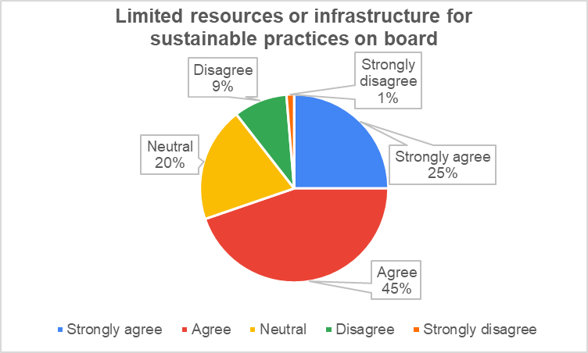

The answers to these 4 questions show how the respondents from academia generally agree with the questionnaire designers on the barriers students and educators might face. Agree or strongly agree options were chosen by between 67% and 80% of respondents. These questions were complemented by an open answer one asking for other barriers to learner adoption of sustainable practices in port operations but the few respondents to this question only could identify a lack of investment and policies.

These previous questions were complemented with a multi select multiple choice one and addresses the effectiveness of a series of methods in motivating learners to adopt sustainable practices into their behaviours. The 5 possible answers were selected by more than half of the respondents. The most popular one was real-world case studies focusing on the impact of unsustainable practices chosen by 79,1% of the respondents while the least popular, still voted by 59,3% of the participants was connecting sustainability to personal and professional growth.
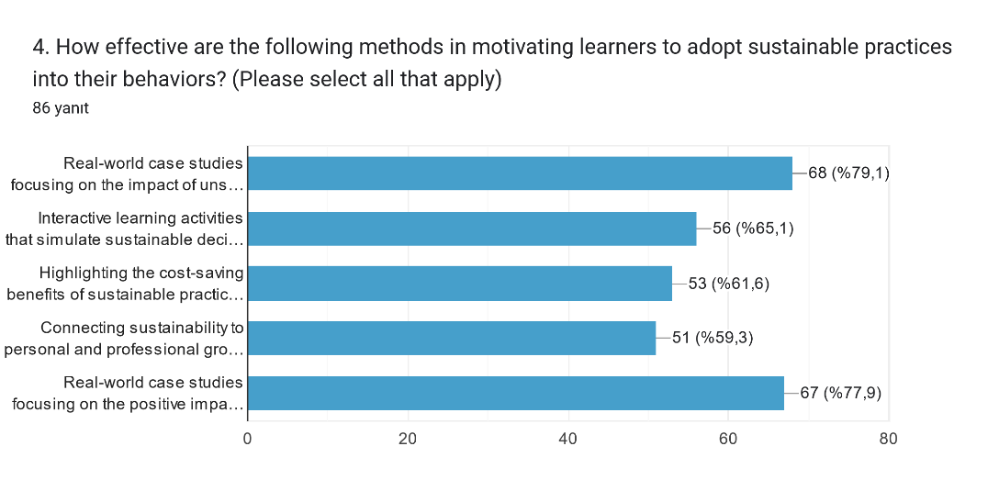

In addition, respondents could complement these answers by writing any other methods in motivating learners to adopt sustainable practices into their behaviours. Just a minority of respondents answered that open question and the responses are quite varied: Training on simulation techniques with AI glasses, discussing the application on negative and positive effects, showing the real impact using real case studies, utilising e-learning platforms to provide accessible and flexible training on sustainability topics, awareness campaigns, community engagement and involving learners in community projects that foster a sense of responsibility, role models and mentorship and discussions on the choice of sustainable and unsustainable behaviour.

The following questions are basically statistical and give us information about the profile of the respondents. 28% of them are female and 82% male and their average age is 47 years. 68% of respondents have a PhD degree, 26% a Master’s degree and 6% a Bachelor's degree. 14% of participants were professors, 58% assistant professors and 28% lecturers. The respondents’ average years of professional experience in teaching is 14. The countries where the questionnaire´s participants have been teaching are quite varied and cover different European regions, although the majority of respondents come from the countries where the consortium members are located, Turkey, Bulgaria, Croatia and Belgium.
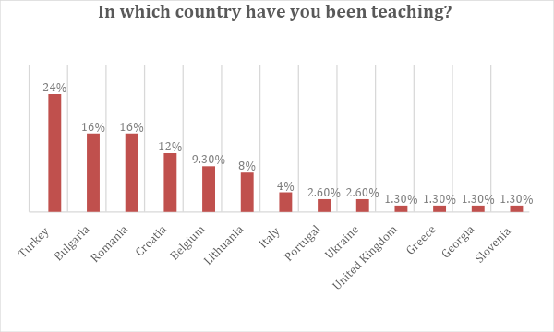

Conclusions from Academic survey

The survey´s results show that academics value sustainability principles in maritime education, believe that including them in daily teaching is essential and thus they try to include these topics in their courses. Actually, there is a general consensus about the added value academia could have in addressing sustainability challenges in port services but in spite of this, the results show that the participation of academics in training or workshops on this matter is not that common, which could suggest that there is a lack of these in academia. This explains the mixed results regarding the respondents´ confidence at explaining these subjects. As a matter of fact, even if the majority of participants in the survey believe their curriculum effectively covers current maritime sustainability challenges, there is still room for improvement in this aspect. There are also some knowledge gaps in areas like the economic and specially the social dimensions of sustainability practices in port operations. Furthermore, the respondents view positively behavioural change as a tool to improve the sustainability of port services and are generally keen to introduce these methods in their courses. Still, many of them identified a series of challenges when motivating learners to adopt behavioural changes, mainly the general resistance to change, a lack of expertise, resources and materials on behavioural change and a lack of awareness on the matter among the educators and students.

Review of existing literature on port services emissions

Understanding the emissions the port services industry generates is essential to analysing its needs to improve sustainability. For that purpose, both industry and academia carried out desk-based research on the existing literature and data on port services emissions to benchmark what is currently known about the sector’s impact on the environment and identify knowledge gaps that will be addressed in the work package.

Methodology
The European Tugowners Association´s Secretariat drafted a guidelines document, which was shared with the consortium partners. This served as a theoretical reference for the stakeholders on the parameters to be used when carrying out the desk research.

These guidelines contained examples of data to report, sources to analyse and deadlines. The consortium partners shared the information collected in their research on the matter, such as data on the emissions generated in several European and global ports and information received from their members on the studied matter. Moreover, the consortium members selected and summarised several relevant academic papers published in academic journals and articles in sectoral magazines.

Overview
A significant focus across the literature is on the air emissions generated by port activities and shipping operations. Ports are identified as critical contributors to air pollution, primarily through emissions from vessels during various operational phases, including hotelling, manoeuvring, and cruising. Studies have shown that emissions from ships in ports can significantly affect local air quality, with regulations playing a crucial role in mitigating these impacts. For instance, the effectiveness of regulations aimed at reducing emissions from ships is highlighted, demonstrating that stricter compliance can lead to measurable decreases in pollutants like NOx and PM10 (Henrik Sornn-Friese et al 2021)
The relationship between port operations and air quality is further explored through emission inventories, essential for tracking and managing emissions. These inventories help port authorities develop targeted emission reduction plans, enabling them to monitor the effectiveness of implemented measures and adjust strategies accordingly. Nonetheless, data specific to port operations, such as pilotage and towage, is still somewhat scarce.
Furthermore, the data that exists related to towage, covers the full range of towage and not necessarily harbour towage. So, when data is offered from a global perspective, one should bear in mind that this also covers offshore towage, which in the far east, for example, covers long distances. Hence, emissions at a global level would transpire to be high and not necessarily representative of the emissions of harbour tugs in European ports.

General overview of the study of port vessels
Emissions from maritime vessels, particularly pilot boats or port tugs, contribute to air pollution. Below is a summary of recent findings on NOx emissions, the effectiveness of emission reduction strategies, sustainability practices, and the operational characteristics of port tugs carried out by the Nikola Vaptsarov Naval Academy (2024).

Main findings and EPA Regulations
The tugboat's average NOx emission factor was 70 ± 4.2 kg of NOx per ton of fuel, like larger marine engines. This indicates that towboats and larger marine engines have comparable NOx emission profiles relative to fuel consumption. However, the EPA-prescribed ISO E3 duty cycle, a standardised test cycle for estimating emissions, overestimated the actual NOx emissions from the towboat by 14%. Only 41% of the towboat's operations also fell within the EPA's Not-To-Exceed (NTE) emissions zone. This suggests that the current EPA regulations may not be fully effective for vessels with similar operational profiles and highlights the need for revised or additional measures to accurately capture emissions from these vessels. The cost-effectiveness of emission reduction strategies varies significantly between ports, up to 8-fold, due to differences in local tugboat fleet characteristics. No single strategy effectively reduces all pollutants, necessitating a bundle of strategies to address various emissions. Different strategies are most effective for reducing specific pollutants: vessel repowering is best for NOx, Diesel Particulate Filters (DPFs) for PM10, and B100 or Vessel Speed Reduction (VSR) for CO2. Port tugs produce high emissions of harmful substances such as CO2, SOX, NOX, PM, VOC, and CO due to their powerful machinery and diesel engines. For instance, port tugs in Izmit Bay produced 7,598.65 tonnes of pollutant emissions over 3 months, accounting for around 10% of all ship emissions in port areas.

Advances in Emission Calculation and Tugboat Operations
The most used Eulerian air quality models for ship emission calculations are WRF/CMAQ and WRF/CHEM, while the most common Lagrangian models are CALPUFF and AERMOD. The first study using Automatic Identification System (AIS) data in air quality models for ship emission calculations was published in 2012. Since then, the use of AIS data in these studies has generally shown an increasing trend, with China being the dominant location for these studies, followed by Italy, Spain, and the USA. A two-stage algorithm has been developed to identify tugboat activities using AIS data, which can be readily implemented in other ports. This algorithm analysed important features of tugboat operations in the Tianjin port, including tugboat assignment, service time distribution, and spatial distribution of tugboat jobs, to help evaluate fleet efficiency and optimise tugboat schedules. The study found that berthing operations require more tugboats and longer service times than un-berthing operations, with service time increasing with the size of large vessels. Significant emission reductions were observed for hybrid tugs compared to conventional tugs, including 73% for PM2.5, 51% for NOx, and 27% for CO2. The primary cause of these emission reductions was the diesel-electric drive train on the hybrid tug, which allowed the use of auxiliary power for propulsion rather than the batteries. The transit operating mode was the largest contributor to the overall emission reductions.

Industry Research Gaps in Maritime Emissions and Sustainability Practices
Understanding and mitigating emissions from various vessel types has become crucial with increasingly stringent environmental regulations. Despite progress in this field, numerous research gaps remain that hinder the effective implementation of regulations and strategies aimed at reducing environmental impacts. Additionally, understanding the influence of sustainability practices on consumer behaviour and the operational decisions of towing companies is vital for creating a sustainable maritime industry. The presented information on this topic outlines the key research gaps in these domains, emphasising the need for comprehensive studies to inform policy and practice.

Emissions Characterisation and Vessel Operations
Accurate characterisation of emissions from different types of vessels is essential for developing effective regulatory policies. Current data is often insufficient or generalised, failing to capture the variability between vessel types such as container ships, bulk carriers, and port tugs. More detailed and frequent measurements are needed to understand the specific emission profiles of these vessels under various operating conditions. This knowledge will enable the formulation of targeted regulations and technologies to reduce emissions effectively. Inland river vessels, which operate primarily on rivers and inland waterways, are an understudied segment of the maritime fleet. These vessels have distinct operational patterns compared to oceangoing vessels, often involving frequent stops and lower engine loads. Existing regulations are primarily designed for oceangoing vessels, and their applicability to inland river vessels is questionable.
Comprehensive data on the operations and emissions of inland river vessels is necessary to determine whether current regulatory frameworks are suitable or if new, tailored regulations are required. There is a significant need to understand the operational differences between oceangoing and inland river vessels. Oceangoing vessels typically follow standard duty cycles that may not accurately represent the operations of inland river vessels, which could lead to inappropriate regulatory applications and inefficiencies in emission control strategies. Research should compare these operational patterns and evaluate whether the standard duty cycles used for oceangoing vessels are appropriate for inland river vessels. This understanding will help in designing better regulatory measures and operational guidelines. Tugboats, which are essential for manoeuvring larger vessels within ports, have a unique emission profile that has not been extensively studied. These vessels often operate under high engine loads for short periods, leading to emissions of pollutants such as NOx, SOx, and particulate matter. Long-term studies monitoring ship traffic and port tug movements are essential to accurately illustrate port tug emissions and their environmental impact. Understanding the emissions from tugboats will aid in developing targeted emission reduction strategies and technologies for these critical support vessels.

Sustainability Practices, Consumer Behaviour of Tugboat Activities and Port Operations
The rise in social and environmental sustainability awareness among consumers has a notable influence on their purchasing behaviour, particularly impulse buying. Research should focus on how these practices influence consumer behaviour and the mechanisms through which sustainability awareness translates into purchasing decisions. This understanding will help companies design better marketing strategies that align with consumer values and drive sales. Additional research is needed to explore how sustainability practices encourage consumers to purchase products from organisations that prioritise environmental and social responsibility. This includes examining the major influences of altruism’s pro-social and pro-environmental features on impulse buying. Understanding these influences will help companies design sustainability initiatives that resonate with consumers and drive engagement and loyalty. Several empirical studies have investigated the specific features of tugboat activities in seaports.
These studies are crucial for understanding the operational dynamics of tugboats, such as assignment patterns, service time distribution, and the spatial distribution of tugboat jobs. Detailed empirical research could provide insights into how tugboats operate within ports and help identify areas for improving efficiency and reducing emissions. Proposed methods for identifying tugboat activities using AIS (Automatic Identification System) data need to be calibrated and validated using log data from tugboat companies. Testing these methods with AIS data from various ports and considering additional factors like tugboat horsepower, weather conditions, and vessel types is essential for improving accuracy and reliability.
This research will help develop robust algorithms that can be used to monitor and optimise tugboat operations in real-time. Investigating safety issues associated with tugboat activities within port areas and proposing additional performance measures to evaluate tugboat fleet efficiency are important areas for future research. Understanding the safety challenges and developing metrics for fleet efficiency will aid in enhancing the overall performance and environmental sustainability of tugboat operations. Hybrid tugboats, which use a combination of diesel and electric power, offer potential for reducing emissions. However, the emission benefits of hybrid tugs, particularly when operated as plug-in hybrids, have not been thoroughly evaluated. Longer-term data collection is necessary to confirm that the diesel-electric drive train, rather than batteries, is the primary cause of emission reductions. Research should focus on understanding the operational performance and environmental benefits of hybrid tugs under different operating conditions.

Technological and Methodological Advancements
Encouraging the use of AIS data in combination with air quality models is crucial for accurate ship emission calculations. AIS data provides real-time information on ship movements, which can be integrated with air quality models to estimate emissions more accurately. Creating a reference source for future studies using individual ship activity data (like AIS) will provide valuable insights and help develop better emission inventories and regulatory measures. Further investigation is needed into the relationship between exhaust temperature and engine load, with concurrent measurements of both parameters for the same test period. This research will help understand how operational parameters influence emissions and identify strategies to optimise engine performance for reduced emissions. More ECM (Engine Control Module) data samples of various harbour craft should be gathered and coupled with real-world emission testing to understand the limitations of the E3 certification cycle. This research will provide a clearer picture of real-world emissions and help refine certification processes to better reflect actual operational conditions.

There is a need to further characterise off-road emissions, such as those from marine vessels. This includes understanding the relationship between fuel sulphur content and black carbon (BC) emissions, as well as the impact of engine load on BC emissions. Research in this area will help develop better fuel standards and emission control technologies for marine vessels.

Understanding how individual towing companies make decisions about upgrading, selling, or decommissioning vessels is essential. Research should focus on the factors influencing these decisions, including economic and environmental considerations. This will help develop strategies and incentives to encourage the adoption of cleaner and more efficient technologies.

Considering the Life-cycle Costs of Shipping Methods, there is a lack of quantifiable data on the full life-cycle environmental and economic costs of different shipping methods. Comprehensive studies are needed to provide a clearer picture of these costs, enabling better decision-making and policy development to promote sustainable shipping practices.
Addressing the above research gaps is critical for advancing our understanding of maritime emissions, improving regulatory frameworks, and promoting sustainable practices in the industry. By conducting targeted studies in these areas, the maritime sector can better manage its environmental impact, enhance operational efficiency, and meet the growing demands for sustainability. Comprehensive research will not only inform policy and regulatory decisions but also drive innovation and adoption of cleaner technologies in the maritime industry.

Port Services emission

Towage

Although tugboats are smaller contributors than other port activities, they still release GHGs. Effective scheduling and retrofitting of older tugboats with cleaner technologies are desirable to mitigate emissions. Advanced scheduling algorithms can optimise tugboat routes and reduce idle times, lowering fuel consumption and emissions (Jameson, 2022).

The study by Ortega-Piris, A.; Diaz-Ruiz-Navamuel, E.; Martinez, A.H.; Gutierrez, M.A.; Lopez-Diaz, A.-I. Analysis of the Concentration of Emissions from the Spanish Fleet of Tugboats. Atmosphere 2022, 13, 2109, aims to determine the greenhouse gas (GHG) emissions caused by the Spanish tugboat fleet from 2004 to 2017, and their impact on the carbon footprint of the country's shipping sector.

Emissions were estimated using the International Maritime Organization's methodology for merchant ships. Also, the Gini concentration index was applied to analyse the concentration of emissions by region, age, and size of tugboats.

The Key Findings show the Emission Trends from 2004 to 2017, the number of tugboats increased by 29.01%, while emissions increased by 42.54%. The average emissions ranged from 143 to 168 tons of CO2 equivalent per year. The regions with the highest emissions are Galicia, Canary Islands, Community of Valencia, and Andalusia, with average values over 3000 tons of CO2 equivalent.

Until 2015, younger tugboats (under 10 years) emitted the most. Post-2015, older tugboats (over 15 years) emitted more. Tugboats between 300 and 400 GT produced the most emissions, except in 2017 when larger tugboats (>400 GT) were the most polluting. The tugboats with power between 2000 and 4000 kW produced the largest emissions.

From 2008 to 2015, the tugboat fleet's carbon footprint increased, contributing more to the overall carbon footprint of Spain's marine transport sector. The emission concentration increased by 14.26% by region, while it decreased by age and size, indicating regional differences in tugboat activity but homogeneous evolution in age and size characteristics.

This study concluded that the methodologies used are effective and can be applied to other sectors and areas. The profile of the most polluting tugboat is under 15 years old, weighs between 300 and 400 GT, has 2000-4000 kW power, and operates in Andalusia. The economic activity level correlates with the concentration of emissions: during economic recessions, port activity and emissions concentrate more in efficient ports, while in growth periods, activity and emissions are more spread out.

The study Analysis and Measurement of SOx, CO2, PM and NOx Emissions in Port Auxiliary Vessels (Martınez de Os and J.C. Murci Gonzalez, 2020) aimed to estimate air emissions (SOx, CO2, PM, and NOx) from port auxiliary vessels, particularly tug ships, using a "full bottom-up" approach. It focuses on fuel consumption during port operations in a significant Mediterranean port. The methodology used was data collected from AIS, IHS Sea-web database, and engine certificates; monitored seven auxiliary vessels for 407 calls; established emission inventories per dock and type of manoeuvre; and developed an action protocol for assessing emissions from tug ships.

The data sets below refer to tug built after January 2000 but before January 2011, thus belonging to the Tier I group (IMO regulation MARPOL Annex VI 2010).

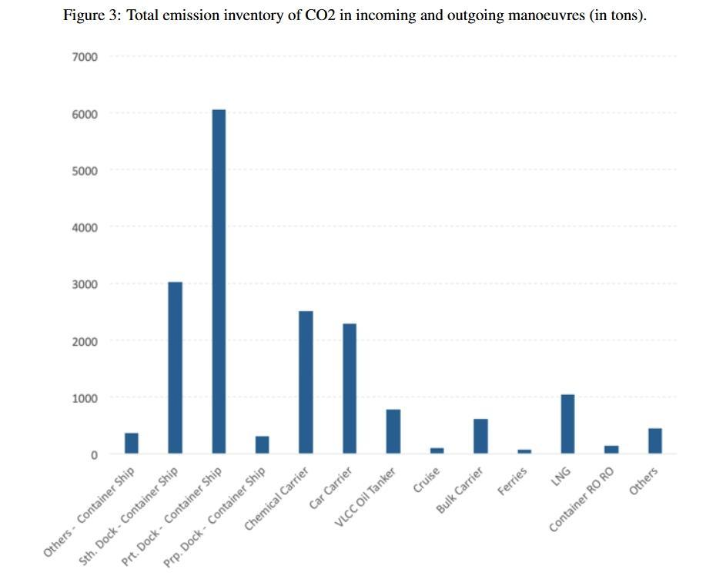
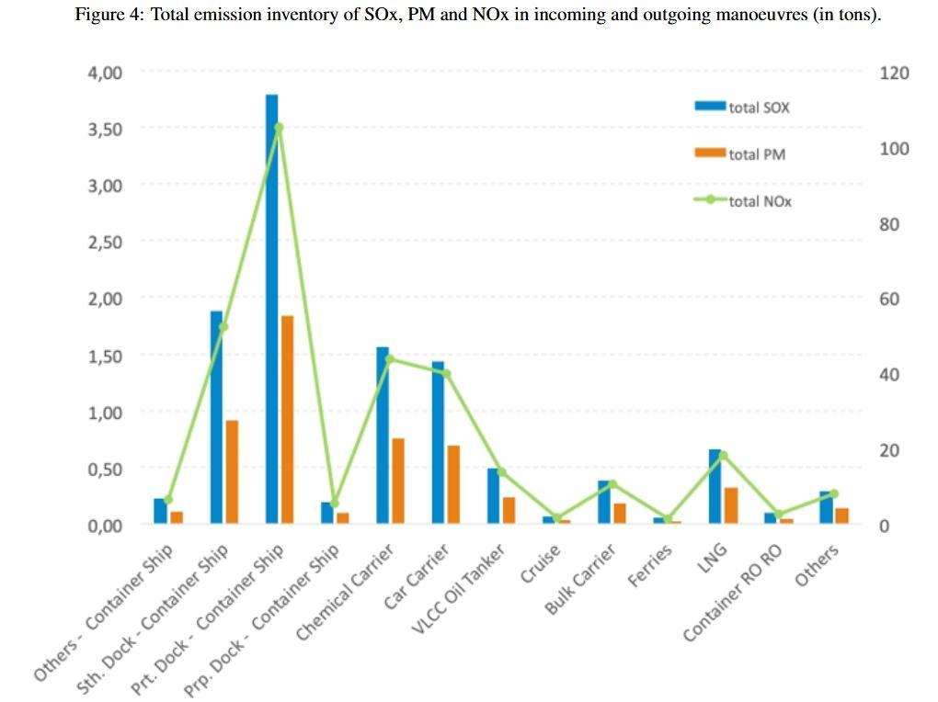

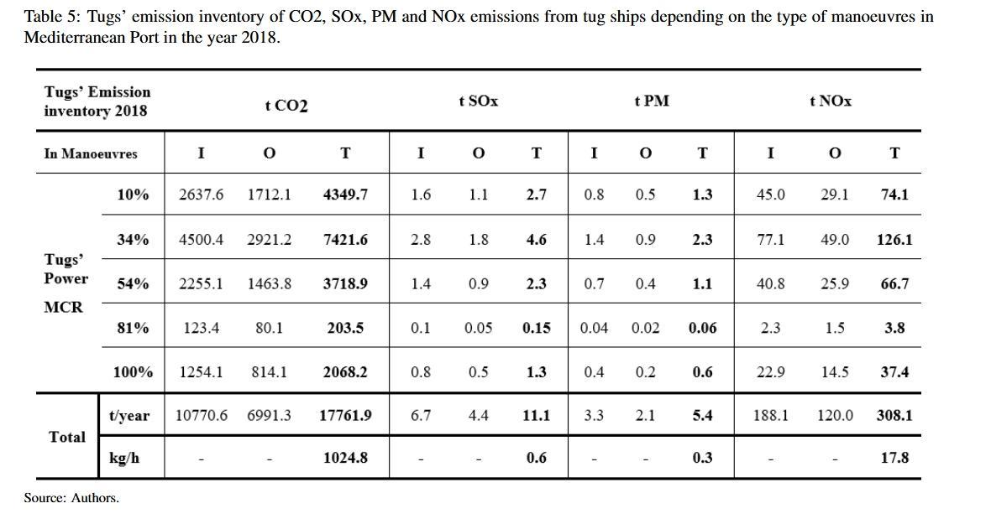
Where I is Incoming, O is outgoing, T is total (referring to tug service manoeuvres) and MCR is the maximum Continuous Rating of the Engine.

The highest pollution emitted by tugs (42%) is produced at an 18% Maximum Continuous Rate, followed by 34% Maximum Continuous Rate (40% pollution emitted), 54% Maximum Continuous Rate (14% pollution emitted), 81% Maximum Continuous Rate (0.5% pollution emitted), and finally 100% Maximum Continuous Rate (3.5% pollution emitted).

The literature review shows that the impact of tugboats has been little researched in the literature. Tugboats play a vital role in maritime operations and contribute to port emissions by releasing engine exhaust gases. The emissions are principally caused by the burning of diesel fuel, producing a variety of GHG. More than 21,000 tugboats are in operation worldwide, which collectively release 40 million metric tons of carbon dioxide annually. Despite its apparent insignificance, it is worth noting that this accounts for just 4% of the overall shipping emissions (Jameson, 2022). The EU ETS System, which entered into force on January 1, 2024, will initially be applied to ships carrying cargo and passengers with a gross tonnage of 5000 and above. Therefore, tugboats are exempt from this for now due to their small size (EU Climate Action, 2024). Currently, 40% of the tugboats in the worldwide fleet are 15 years old or younger. Since tugboats may work for more than 30 years, retrofitting will be necessary to reduce carbon emissions from the whole fleet of tugboats (Jameson, 2022).

There is an increasing concern regarding port emissions, likely because major commercial ports are in densely populated cities. It is crucial to understand the impact of port activities on the health of citizens and its global ramifications. This issue is of utmost importance to the public. Ortega et al. (2022) made a study to determine GHG emissions caused by the Spanish tugboat fleet from 2004 to 2017 and their impact on the country's shipping sector. The methodology used by the International Maritime Organization and Gini concentration index was applied to the fleet. Results showed that emissions concentration increased by region and decreased by age and size, indicating that tugboat activity varied by region but evolved more homogeneously with age and size. Ergüven et al. (2023) analysed GHG emissions of tugboats in Izmit Bay, Türkiye. Their study shows that tugboat emissions account for an average of 10% of all ship emissions for port areas.

The operation of tugboats is a crucial component of port operations, and effective scheduling and planning of tugboat operations directly and substantially influence the timely arrival and departure of vessels at the port. Moreover, effective planning of tugboats reduces unnecessary manoeuvres, thus reducing energy consumption and carbon emissions. Hence, mentioning some of the current prominent studies on the subject is useful. The tugboat operation involves providing tug services to a single vessel simultaneously by several tugboats. Therefore, scheduling the tugboat operation is an uncommon scheduling challenge. For this purpose, various studies have been conducted in the literature for effective planning and scheduling of tugboats. Liu (2009) proposed a hybrid evolutionary strategy algorithm to optimise the tugboat scheduling problem, using a multi-dimension integer encoding and a local search strategy based on crossing-over. The algorithm effectively solves the tugboat operation scheduling problem, combining parallel and dedicated processors in a general set of multiprocessor task scheduling. Wang et al. (2014) addressed the tugboat assignment problem in container terminals using a hybrid scheduling rule (TAP-HSR) to minimise ship turnaround time. In that study, a mixed-integer programming model and scheduling method were described, and an improved discrete PSO algorithm was proposed, showing better solutions than GA and basic discrete PSO.

Kang et al. (2020) addressed the tugboat scheduling problem that involves uncertainty in container ships' arrival and towing processing times for major ports. The authors formulated a mixed integer linear programming model and developed a special algorithm for large-scale problems. Extensive numerical experiments demonstrate the practical importance of the models and algorithms. Zhu et al. (2021) proposed a mixed integer programming model and a variable neighbourhood search algorithm to minimise carbon emissions. Numerical experiments show that the model reduces emissions by 46.93% compared to dispatching rules and 10.46% with barge transhipment. Zhong et al. (2022) introduced a bi-objective, mixed-integer linear programming model for scheduling green tugboats. The first objective of the model minimises the maximum completion time of the tugboats, whereas the second objective minimises the total fuel consumption of the tugboats. The model aims to enhance port service levels, decrease operating expenses, and reduce emissions. A case study conducted in Guangzhou Port shows the model's validity. The results demonstrate the trade-off between different objectives and serve as a foundation for developing scheduling plans for port tugboats. Tugboats are mostly not considered in berth allocation and crane assignment problems. An exception to this is a study by Jiang et al. (2024) on dry bulk ports. The researchers considered ship-borne emissions and the availability of tugboats in optimising port operations. However, the emissions of tugboats were not considered.

Hybrid tugboats show significant emission reductions compared to conventional diesel tugboats. They achieve a 73% reduction in PM2.5, a 51% reduction in NOx, and a 27% reduction in CO2. These reductions are primarily due to the diesel-electric drive train, which allows the use of electric power for propulsion during low-power operations (Ergüven et al., 2023).

Pilotage
Pilot boats contribute to maritime mode emissions, particularly during manoeuvring operations. Quantifying these emissions includes the fuel consumed during these operations and the auxiliary power needed for onboard equipment. Strategies to reduce these emissions include adopting more efficient engines and using alternative fuels (Barata et al., 2024).

The French Pilot Association conducted a detailed study on the fuel consumption involved in ship movements, focusing on three entities: piloting, ships, and tugboats. It evaluates four types of vessels: a 180m oil tanker, a 190m container ship, a 285m container ship, and a 400m container ship.

Scenarios for Ship Movement:
Usual Trip Scenario: Includes 20 minutes full ahead, 5 minutes half ahead, 10 minutes slow ahead, and 20 minutes before dead slow ahead.

Economic Conduct Scenario: Includes 30 minutes half ahead, 10 minutes slow ahead, and 20 minutes dead slow ahead. The time difference between scenarios is about 5 minutes.
Key findings:

Pilotage Consumption: Average consumption per movement: 564 litres (Pilot boat: 553 litres, Car 1: 5 litres, Car 2: 6 litres).
Ship Consumption:
400m Container Ship:
    - Scenario 1: 1850 litres
    - Scenario 2: 1410 litres
    - Difference: 440 litres
285m Container Ship:
    - Scenario 1: 1107 litres
    - Scenario 2: 774 litres
    - Difference: 333 litres
190m Container Ship:
    - Scenario 1: 475 litres
    - Scenario 2: 270 litres
    - Difference: 205 litres
180m Tanker:
    - Scenario 1: 490 litres
    - Scenario 2: 400 litres
    - Difference: 90 litres

Tugboats Consumption:
Average consumption per manoeuvre: 400 litres.
Consumption by power:
    - Half: 210 litres/hour
    - Three-quarters: 340 litres/hour
    - Full mobilisation: 550 litres/hour

The study reveals that economic driving (reducing speed) can significantly reduce fuel consumption. For example, with a more economical driving style, the fuel gain for a 400m container ship can reach 440 litres per movement.

The overall consumption savings vary between 14% and 22% depending on the vessel size and type, with larger savings seen in larger vessels. The steering part of the movement represents a minor portion of the total fuel consumption, ranging from 1.8% for a 400m vessel to 8% for a 200m vessel. Implementing economical driving on 10% of large ship manoeuvres could save approximately 440,000 litres annually. Optimising tugs during ship manoeuvring can further enhance fuel efficiency without compromising the safety or effectiveness of the manoeuvres.

These findings emphasise the potential for significant fuel savings through optimised driving practices and efficient pilotage and tugboat operations management.

A study conducted by EMPA, one of the Greenport Alliance partners, shows that from 23 respondents, the following Emission Reduction strategies had been adopted:
Retrofitting Emission Reduction Technology: 8 have retrofitted their fleet, and 15 have not.
Use of Alternative Fuels: 1 office uses alternative fuels, and 18 do not.
CO2 Footprint Calculation: 13 offices have calculated their CO2 footprint.
NOx Emissions Calculation: 6 offices have calculated NOx emissions.
Speed Monitoring and Eco Speed Use: 14 offices monitor speed and use eco speed.

The main recommendations from this study are as follows:
Ashore: Promoting sustainable energy use, alternative fuels, energy management systems, self-generated power, and waste management.
At Sea: Promoting eco speeds, energy-efficient engines, engine monitoring, crew training, and clean hull maintenance.
Information Management: Speed monitoring, efficient scheduling, and appropriate tugboat use.

Port equipment

Quantification of CO2 emissions from non-road cargo handling equipment, such as cranes, forklifts, and reach stackers, is essential for understanding their impact. Studies have shown that alternative scenarios considering biofuels and electrification of port equipment can lead to substantial emissions reduction. For example, replacing diesel-powered equipment with electric alternatives can significantly decrease CO2 emissions and improve air quality within port areas (Barbosa et al., 2024).

Port environmental research centres on examining energy usage and emissions inventory in order to apply specific actions to reduce emissions. Compared to studies on emissions caused by ships, there is less study on emissions from in-port handling equipment. However, the number of studies conducted in this field has recently increased.

Yang and Cheng (2013) compared RTG cranes and electric RTGs for energy savings and carbon emission reduction in container terminals. Their results showed that electric RTGs offer significant performance improvements, achieving 86.60% energy savings and 67.79% carbon emission reduction. A study conducted by Yu et al. (2017) has indicated a strong correlation between emissions from yard tractors and the placement of export containers. Sim et al. (2018) evaluated the carbon emissions of five operations at a container terminal in South Korea, including ship manoeuvring, ship at berth, container loading and unloading, container transportation, and container receiving and delivery, using the system dynamics method. Yun et al. (2018) proposed a simulation model to address complex stochastic processes in container terminals. Simulation experiments show that reduced speed in waterway channels can reduce emissions by 48.4% and 32.9%, while LNG use can reduce emissions by 11% for ships and 8% for total emissions.

The study by Martinez-Moya et al. (2019) presented crucial data on the actual energy usage and carbon emissions of Port of Valencia, Spain. According to the findings, yard terminal tractors and RTGs are the primary contributors to emissions, making up 68.1% of the total carbon emissions from the terminal. Okşaş (2023) estimated the total carbon emissions produced by container handling equipment at Ambarlı container port, which handles 30% of Turkey's total container volume. The study revealed that yard tractors caused the most carbon emissions in the port.

In recent literature reviews, there are studies on the effect of alternative fuel, renewable energy and new technologies on reducing greenhouse gases in ports. Alzahrani et al. (2021) reviewed existing research on digital technologies for decarbonising seaports, focusing on carbon reduction, renewable energy use, cost-performance optimisation, smart control technologies, and green port practices. Hoang et al. (2022) examined advanced renewable energy technologies, clean fuels, and smart grid strategies for port-to-ship interactions. In their study, Fadiga et al. (2024) highlighted the necessity of technological innovations, regulatory structures, and cooperation among stakeholders in order to attain viable marine ports.

In the literature, when port handling equipment is mentioned, the first thing that comes to mind is the optimization of the operations in which this equipment is used. Planning port inland operations, berth assignment to ships and optimisation of crane scheduling problems can be examples. Thanks to mathematical models developed to solve such problems, energy savings can be achieved in port operations optimization and therefore carbon emissions can be reduced. However, in many cases, too much equipment movement occurs in both shore operations and yard area operations to reduce the time that ships stay in port, resulting in excess energy consumption and carbon emissions. In this regard, it will become more important to develop multi-purpose mathematical models that, on the one hand, maximise the service quality and speed for ships and, on the other hand, minimise GHG emissions.

Specific Port data

Bulgarian Black Sea emissions ports over the period 2018- 2023.
The study, carried out by Nikola Vaptsarov Naval Academy (2024) employed the latest EMEP/EEA air pollutant emission inventory guidebook (CORINAIR) and IPCC Guidelines for National Greenhouse Gas Inventories for calculating emissions. Data was collected and analysed using standardised methodologies and technological equipment.
The cargo turnover at the seaports was categorised by type from 2018 to 2023:
Available Cargo: Varied yearly, with the highest in 2022 (13,356,414 tonnes) and the lowest in 2021 (8,406,178 tonnes).
Bulk Cargo: Consistently high, peaking at 12,220,223 tonnes in 2023.
General Cargo: Fluctuated with a low of 2,411,918 tonnes in 2022.
Containers (Gross and TEU): Remained relatively stable.
Ro-Ro (Gross and Count): Showed an increasing trend, particularly in 2023.
The correlation coefficients indicated that Bulk Cargo had the strongest correlation with total gross freight (0.9651), followed by Ro-Ro Count (0.8316).
Pollutants from cargo turnover were analysed from 2018-2023:
∙ SOx, NOx, NMVOC, CH4, CO, CO2, N2O, NH3: CO2 had the highest emissions, peaking at 49,065,000 tonnes in 2023.
∙ Correlation with Total Cargo: CO had the highest correlation with total gross cargo (0.7159), followed by NOx (0.7141).
The analysis extended to emissions from other transport modes (rail, water, air, and off-road equipment):
∙ CO2: Showed the highest emissions, with a peak of 607,880 tonnes in 2023.
∙ Correlation with Total Cargo: CO2 had the highest correlation (0.6230), indicating significant influence from other transport modes.
The study revealed several key points:
Strong Correlation: There is a very strong correlation between total cargo and Bulk Cargo. Ro-Ro (count) also shows a very strong correlation.
Pollutant Emissions: CO and NOx emissions show a strong correlation with total cargo. Emissions from other transport modes significantly contribute to the total pollutants, especially CO2.
Environmental Impact: Increased cargo turnover directly impacts the emission of pollutants. The data suggests the need for better emission management and sustainable practices in cargo handling and transportation.

Port of Naples and Salerno

MAR.TE., one of the GREEPORT Alliance partners, owns the Port Authority Dashboard (PAD), a technological tool designed to monitor port activities and evaluate port performance. The PAD software processes a set of data provided by a large and heterogeneous number of sources (e.g., concessionaires, Port System Authority (AdSP), harbour master’s office, monitoring units). By combining these data, the software processes Key Performance Indicators (KPIs), designed by MAR.TE., which rationalise the data into an easy-to-read graphic (or table) format, providing helpful information in a clear and organised manner.

The PAD plays an essential role in supporting the decision-making process of port management, providing crucial information to optimise the use of port areas. Thanks to continuous monitoring of the performance related to port activities, the PAD allows all necessary information to be displayed on a single screen, enabling informed decision-making. By processing KPIs, the PAD provides various analyses and statistics concerning four main topics, namely four pillars: 1. Market Trends; 2. Logistics & Operation; 3. Port Authority & Concessionaires; 4. Green Challenge. This approach allows for more efficient management of port resources, improving the effectiveness of the decision-making process and enabling better allocation of state concessions to port operators.

Port of Naples

Emission Data and Trends:
Reporting Period: 2020, 2021, and January to July 2022.
Pollutants Monitored: PM10, NO₂, Benzene, SO₂, O₃, and CO.
Key Observations:
  - Significant maritime traffic, including passenger vessels, cruise ships, tankers, bulk carriers, container ships, and tugboats.
  - Emissions from cruise ships are particularly notable due to engines running while docked.
  - High frequency of data collection (daily) allows for detailed monitoring and identification of pollution spikes.
Measured Emissions:
- PM10: High levels, particularly during peak cruise ship activity.
- NO₂: Elevated levels, correlating with high traffic periods.
- Benzene, SO₂, O₃, and CO: Variable levels, with spikes during specific high-traffic events.
Port Calls in 2023:
Total Port Calls: 2,860
  - Container Ships: 429 (15%)
  - Cruise Ships: 343 (12%)
  - Dry Bulk Ships: 286 (10%)
  - Liquid Bulk Ships: 543 (19%)
  - Passenger Ships: 1,258 (44%)

Measures Implemented:
- Emission Control: Adoption of emission control measures such as gas cleaning systems, onshore power supplies, and use of greener alternative fuels like LNG and biofuels.
- Monitoring and Reporting: Use of the Port Authority Dashboard (PAD) to process and display emission data, enabling real-time monitoring and decision-making.
- Policy and Coordination: Coordination of abatement efforts and implementation of specific bundles of measures combining pricing and new energy sources.

Port of Salerno
Emission Data and Trends:
Reporting Period: 2020, 2021, and January to July 2022.
Pollutants Monitored: PM10, NO₂, Benzene, SO₂, O₃, and CO.
Key Observations:
  - Diverse maritime traffic with a focus on commercial activities.
  - Emissions from container ships and car carriers are significant due to frequent port calls.
  - High frequency of data collection (daily) provides a comprehensive overview of environmental conditions.
Measured Emissions:
    - PM10: Consistently high, especially near loading and unloading areas.
    - NO₂: High levels, particularly during peak container ship activities.
    - Benzene, SO₂, O₃, and CO: Variable levels, with spikes during specific high-traffic events.
Port Calls in 2023:
Total Port Calls: 2,175
  - Car Carrier Ships: 109 (5%)
  - Container Ships: 805 (37%)
  - Cruise Ships: 44 (2%)
  - Dry Bulk Ships: 239 (11%)
  - Passenger Ships: 979 (45%)
Measures Implemented:
- Emission Control: Implementation of emission reduction measures such as gas cleaning systems, onshore power supplies, and use of alternative fuels.
- Monitoring and Reporting: Utilisation of the PAD to process and display emission data, facilitating real-time monitoring and decision-making.
- Policy and Coordination: Emphasis on long-term policies like the designation of a local emission control area (ECA) and the establishment of an emission management platform.

Aspect | Port of Naples | Port of Salerno
Total Port Calls (2023) | 2,860 | 2,175
Dominant Ship Type | Passenger Ships (44%) | Passenger Ships (45%)
Significant Emissions | Cruise ships, tankers, container ships | Container ships, car carriers
Proximity to Urban Area | High | Moderate
Emission Monitoring Frequency | Daily | Daily
Emission Control Measures | Gas cleaning systems, onshore power, alternative fuels | Gas cleaning systems, onshore power, alternative fuels
Policy and Coordination | Coordination of abatement efforts, specific bundles of measures | Long-term policies, emission management platform

Both ports exhibit significant maritime traffic and diverse ship types contributing to emissions. The Port of Naples has a higher total number of port calls, with a notable impact from cruise ships. The Port of Salerno, while having fewer total calls, shows a significant presence of container ships and car carriers. The high frequency of data collection at both ports allows for detailed monitoring and timely interventions to manage and reduce pollution levels. Both ports have implemented various emission control measures and policies to address environmental concerns effectively

Port of Vigo
As part of the EU PutForward Project “Towards a green and sustainable ecosystem for the EU Port of the Future” the sustainability assessment of the container terminal was conducted using the Life Cycle Assessment (LCA) methodology.
The findings are highlighted hereunder:

Environmental Impact Contributions:
- Vessels Loading/Unloading Operations: The highest environmental impact, primarily due to fuel consumption during berthing. Carbon footprint (kg CO2 eq./TEU) decreased from 2.639 (2018) to 2.076 (2020).
- Maritime Cranes: The second highest contributor due to electricity consumption. Carbon footprint (kg CO2 eq./TEU) remained at 0.336 (2018) to 0.209 (2019-2020).
- External Trucks and Internal Vehicles (Mafis): Both had moderate contributions. External trucks had a carbon footprint of 0.0730 to 0.0703 kg CO2 eq./TEU, while mafis contributed 0.0712 to 0.0689 kg CO2 eq./TEU.
- Sub-contractor Trucks: Lower contributions with a carbon footprint of 0.0211 to 0.0141 kg CO2 eq./TEU.
- Transtainers and Reachstackers: The lowest contributions with carbon footprints of 0.0004 to 0.0003 kg CO2 eq./TEU.

Economic Impact Assessment:
  - Transtainers: Highest economic impact contributor with costs ranging from 2.664 to 2.397 per year.
  - Reachstackers and Mafis: Followed with significant economic impacts. Reachstackers ranged from 0.902 to 0.975, and mafis from 0.631 to 0.676 per year.
  - Maritime Cranes: The lowest economic expenses among the operations assessed.

Efficiency Improvements with Green Yard Scheduler (GYS):
- The implementation of GYS modules (Housekeeping Module, Inspection Container Positioning Module, Yard Crane Scheduling Module) resulted in substantial environmental and economic savings:
    - Housekeeping Module (HKM): Estimated savings of 6 kg CO2 eq. per month and 73 kg CO2 eq. per year.
    - Inspection Container Positioning Module (ICPM): Estimated savings of 13 kg CO2 eq. per month and 152 kg CO2 eq. per year.
    - Yard Crane Scheduling Module (YCSM): Estimated savings of 679 kg CO2 eq. per month and 8,150 kg CO2 eq. per year.

These findings demonstrate the significant environmental impacts of fuel consumption and electricity use in container terminal operations and highlight the potential benefits of implementing efficiency-improving technologies like the GYS​​.

Port of Klaipeda
This study aims to evaluate emissions from ships in port by combining ships’ technical, AIS and EMEP data that allow us to evaluate emissions in port, not as a singular area source but enables individual ship emissions evaluation at any given point in time. To achieve this emission calculation, an algorithm was compiled by using EMEP/EEA Tier 3 methodology.

Relating to ships in the port of Klaipeda in the year of 2022 hereunder are the findings which includes port vessels:

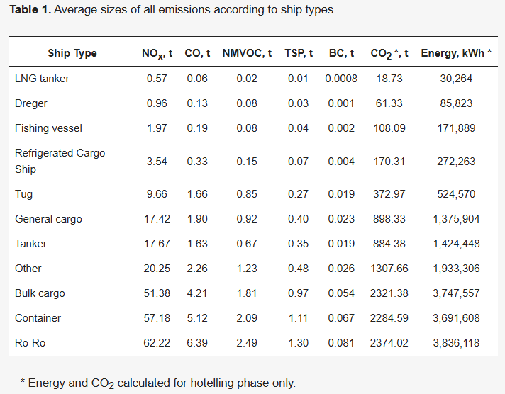

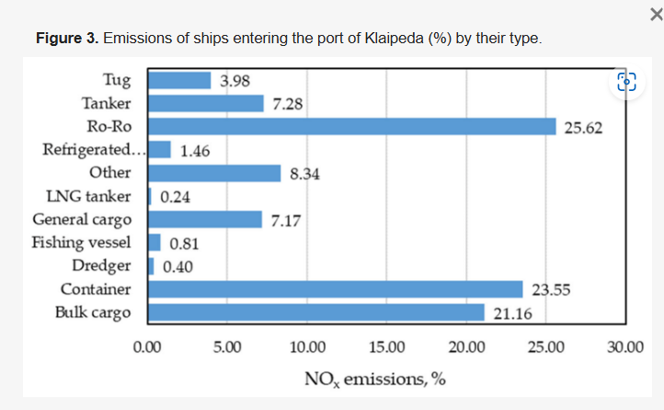
The conclusions derived are that the proposed method uses AIS data to create detailed emission estimations with greater insight into their distribution in port areas, allowing for a better understanding of the effects on neighbouring populated areas.

Average emissions of NOx 5.28 t/day, TSP 0.52 t/day, NMVOC 0.22 t/day, BC 0.064 t/day, CO2 235 t/day were estimated based on AIS data in Klaipeda port during the period of 25 November 2020 to 9 January 2021. The difference between the maximum and average emissions was 37.8%. The greatest part of total emissions was undertaken by Ro-Ro and container cargo vessels.

The emission estimation showed that although the average emissions from ships in port are similar to studies undertaken by other researchers, the detailed estimate shows that some locations in port may have significantly higher emissions than other areas.

Adapting the same methodology to evaluate the power used by diesel generators at quays provided insight into quays where most power is used and what average and peak consumption of power is by ships in port, presenting a potential goal for CO2, another pollutant reduction estimation.

Port of Aveiro and Port of Figueira da Foz
Studies at these ports focused on quantifying emissions and formulating a comprehensive Mobility Decarbonization Plan. Key measures in the plan include:
- Alternative Fuels: Adoption of alternative fuels to replace conventional fossil fuels, thereby reducing the carbon footprint.
- Electrification: Electrification of port equipment, such as cranes and forklifts, to cut down on emissions from diesel-powered machinery.
- Intermodality Promotion: Encouraging a shift in cargo transport from road to rail to lower emissions associated with road transport. These measures are projected to result in significant emissions reductions, thereby contributing to the overall decarbonization efforts (Barata et al., 2024, Barbosa et al., 2024).

Port of Dubrovnik
Cruise Ship Emissions: This study identified CO2 and NOx as the dominant pollutants from cruise traffic in the port of Dubrovnik. Key findings include:
- Environmental Impact: Cruise ships significantly impact the port's air quality.
- Emission Reduction Strategies: Emphasised the need for targeted strategies such as implementing shore power (allowing ships to turn off their engines while docked) and using cleaner fuel alternatives to reduce emissions (Damic & Radonja, 2022).

Port of Zadar
Passenger Ship Emissions: Approximately 80% of total emissions in the port of Zadar are attributed to passenger ships. The primary pollutants include NOx, SOx, PM, VOC, and CO2. The study recommends:
- Stricter Emission Standards: Implementing stricter standards for passenger ships.
- Cleaner Fuels: Encouraging the use of cleaner fuels to reduce overall emissions (Knežević et al., 2018).

Port of Šibenik
Passenger and Cargo Ships: The emission breakdown shows that passenger ships contribute about 70% of total emissions, with cargo ships contributing the remaining 30%. The pollutants include NOx, SOx, PM, VOCs, and CO2. Recommendations include:
- Regulatory Measures: Implementing new regulations to control emissions.
- Technological Upgrades: Upgrading technology on both passenger and cargo ships to reduce emissions (Pastorčić et al., 2020).

Port of Rijeka
The study at the port of Rijeka aimed to estimate emissions of CO2, NOx, SOx, and PM. The goal was to:
- Prepare Basic Records: Establish baseline records for future monitoring.
- Compliance with Regulations: Ensure the port complies with environmental regulations by emphasising the importance of accurate data collection and reporting (Radonja et al., 2020).

Port of Split
The emission inventory for the port of Split includes CO2, SOx, PM, VOC, and NOx emissions, with a significant impact noted from cruise ships. Mitigation strategies include:
- Adoption of Shore Power: Encouraging the use of shore power to reduce emissions from ships docked at the port.
- Stricter Emission Standards: Implementing stricter emission standards for cruise ships to improve air quality (Stazić et al., 2020).

Specific research articles worth noting
Research article #1

What drives ports around the world to adopt air emissions abatement measures? (2021)
Authors: Henrik Sornn-Friese, René Taudal Poulsen, Agnieszka Urszula Nowinska, Peter de Langen.
Abstract
The reduction of Greenhouse gases (GHG) and other air emissions represents a major challenge for ports. The world over, however, ports vary considerably in their efforts to reduce air emissions, and the causes for this variation remain under-researched. This paper examines the drivers for the adoption of air emissions abatement measures in a sample of 93 of the world’s largest ports, covering all continents and mobile emitters.
We test five hypotheses with a Linear Probability Model to disentangle the impacts of key port characteristics on the current adoption of abatement measures and identify three key drivers for adoption: Population density, the port landlord business model, and a specialisation in servicing container shipping. We also find that ports are more likely to implement specific bundles of measures, in particular combining pricing and new energy sources. Our work has implications for ports, as we suggest that they should coordinate abatement efforts to achieve effectiveness in their work.

https://www.sciencedirect.com/science/article/pii/S1361920920308294#:~:text=Population%20density%2C%20port%20business%20model%2C%20and%20container%20specialization%20drive%20adoption.

Research article #2
Government Subsidies and Revenue Sharing Decisions for Port and Shipping Service Supply Chain in Emission Control Areas (2020)
Authors: Bing Han, Xia Pan, and Yu Zhou.
Abstract
As the core of the port and shipping service supply chain system, the port and shipping companies must urgently solve the problem of how to balance emissions, costs, and benefits with the gradual extension of China’s emission control area (ECA) and the stringent emission requirements. From the perspective of system optimization, this research constructs a revenue sharing model of the port and shipping service supply chain and deals with the revenue sharing decision-making problem of the secondary service supply chain after port enterprises and shipping enterprises joining the government subsidy mechanism driven by ECA’s policy. Research shows that the government subsidy mechanism directly affects the profit of the port and shipping service supply chain, which is the key factor in implementing the ECA’s policy and promoting the emission reduction of the port and shipping enterprises. The revenue sharing of the port and shipping enterprises plays a decisive role in the revenue of the shipping enterprises. Cooperative emission reduction mechanisms should be led by port enterprises to promote the balance between revenue and emission reduction in the supply chain system. Results provide a reference for the Chinese government to formulate corresponding incentives and subsidy policy under the new ECA’s regulations as well as solving the problems of how to balance emissions reduction and cost improvement for port and shipping enterprises.
https://onlinelibrary.wiley.com/doi/10.1155/2020/8892781

Research article #3
Estimation of the Non-Greenhouse Gas Emissions Inventory from Ships in the Port of Incheon (2020)
Authors: Hyangsook Lee, Dongjoo Park, Sangho Choo, and Hoang T. Pham.
Abstract
Nowadays, maritime air pollution is regarded as a severe threat to coastal communities’ health. Therefore, many policies to reduce air pollution have been established worldwide. Moreover, there has been a shift in policy and research attention from greenhouse gases, especially CO2, to other air pollutants. To address the current local environmental challenges, this research analyses the non-greenhouse gas emissions inventory (CO, NOx, SOx, PM, VOC, and NH3) from ships in the second biggest port in Korea, the Port of Incheon (POI). A bottom-up activity-based methodology with real-time vessel activity data produced by the Vessel Traffic Service (VTS) is applied to obtain reliable estimations. NOx and SOx dominated the amount of emission emitted from ships. Tankers, general cargo ships, cruise ships, and container ships were identified as the highest sources of pollution.
Based on the above results, this study discusses the need for long-term policies, such as the designation of a local emission control area (ECA) and the establishment of an emission management platform to reduce ship-source emissions. Furthermore, this study elucidates that significant emissions come from the docking process, ranging from 33.9% to 42.0% depending on the type of pollutant when only the auxiliary engines were being operated. Therefore, short-term solutions like applying gas cleaning systems, using onshore power supplies, reducing docking time, or using greener alternative fuels (e.g., liquefied natural gas or biofuels) should be applied and motivated at the POI. These timely results could be useful for air quality management decision-making processes for local port operators and public agencies.

https://www.mdpi.com/2071-1050/12/19/8231

Research article #4
Measurement and Modelling of Particulate Matter Emissions from Harbor Activities at a Port Area: A Case Study of Trabzon, Turkey (2020)
Author: Süleyman Köse.
Abstract
Due to the versatile activities caused by the services provided at the harbour, a large amount of particulate matter emanated. The health of living things is seriously threatened by the spread of these substances in the air due to the effect of many environmental factors. The size of this threat may reach much higher levels, especially at ports located close to city centres. In this study, at the Trabzon Port area, PM10 and PM (deposited dust) measurements from the harbour activities were carried out at 9 different points between February 2019 and April 2019 and the dispersion of these particulate matter into the environment is analysed utilising the ISCST3 (Industrial Source Complex - Short Term) model program.
It is detected that the highest amount of measured PM10 (suspended particulate matter) is at the dock 3 with 1.84 mg/Nm3 and the highest amount of PM (deposited dust) is in the dock loading area with 203 mg/m2-day. In the modelling study, it is determined that the particulate matter dispersed around an area of 25 km2 in the south direction of the port, and it is concluded that port air quality management will focus on precautions for docks where intensive loading-unloading activities take place.

https://jemsjournal.org/jvi.aspx?un=JEMS-49389&volume=8&issue=4

Research article #5
GHG emission accounting and mitigation strategies to reduce the carbon footprint in conventional port activities – a case of the Port of Chennai (2017)
Authors: Atulya Misra, Karthik Panchabikesan, Senthil Kumar Gowrishankar, Elayaperumal Ayyasamy and Velraj Ramalingam.
Abstract
Ports as an industry account for 3% of the total greenhouse gas (GHG) emissions worldwide. The Port of Chennai, India, uses an enormous amount of electricity and diesel for intermodal transportation of goods and for other essential services. The inventory of GHG emissions in the Port of Chennai is made by accounting the various facilities of the port along with the housing colony and fishing harbour which come under the management of the Port of Chennai.
Quantification of GHG emissions is made following the guidelines of the Intergovernmental Panel on Climate Change (IPCC) and World Port Climate Initiative (WPCI). The estimation of GHG emissions showed that 280,558 tonnes of CO2e/year was generated from the port and port related facilities. Several GHG mitigation strategies and their impact are quantified and discussed.
The technology suggestions presented in the paper will be very useful to plan effective mitigation strategies incorporating technological advancement and management policies.

https://www.tandfonline.com/doi/full/10.1080/17583004.2016.1275815

Research article #6
The Carbon Footprint of Valencia Port: A Case Study of the Port Authority of Valencia (Spain) (2020)
Authors: Víctor Cloquell Ballester, Vanesa G. Lo-Iacono-Ferreira, Miguel Ángel Artacho-Ramírez and Salvador F. Capuz-Rizo.
Abstract
Maritime transport is responsible for 13% of the Greenhouse Gases (GHG) emissions of the transport sector. Port authorities, terminals, shipping companies, and other stakeholders have joined efforts to improve this sector’s environmental performance. In Spain, the Ministry for Ecological Transition and Demographic Challenge has developed a methodology to assess the carbon footprint.
This methodology has been adapted to ports and applied to processes under the Port Authority of Valencia’s umbrella achieving scopes 1, 2, and 3. The results highlight that ship traffic, within the port, of containers and cruises (categorised in scope 3) had a major impact on the carbon footprint. Building lighting managed by the terminals has a significant effect on scope 2. Diesel consumption shares with gasoline consumption the primary representation in scope 1. The carbon footprint between 2008 and 2016 was maintained, although traffic in the port increased by 24% during this period. The results show a decrease of 17% when emissions are compared using the base year’s emissions factors to avoid external factors. Future projects that include self-consumption or renewable energy policies seem to be the next step in a port that shows good results but still has room for improvement in activities of scope 3.

https://www.ncbi.nlm.nih.gov/pmc/articles/PMC7662751/
Research article #7
Analysis of the Concentration of Emissions from the Spanish Fleet of Tugboats (2022)
Authors: Ortega-Piris, A., Diaz-Ruiz-Navamuel, E., Martinez, A. H., Gutierrez, M. A., & Lopez-Diaz, A. I.
Abstract
At present, the sensitivity of society towards emissions in commercial maritime ports is increasing, which is reflected in the large number of studies on the control of emissions in them, perhaps because the most important commercial ports are located in cities with high population density. The objective of this work was to determine the greenhouse gas emissions caused by the activity of the Spanish tugboat fleet, studying the tugboat fleet of the eleven autonomous coastal Spanish communities from 2004 to 2017 and their impact on the carbon footprint of the country’s shipping sector.
To do this, the methodology used by the International Maritime Organization for merchant ships to estimate the emissions of a tugboat fleet is formalised, and Gini concentration index methodology was applied to the concentration of emissions from this fleet. This has made it possible to obtain results on the distribution of the concentration of emissions from Spanish ports by region, age, and size, as well as to establish the profile of the tugboat port that pollutes the most and its carbon footprint. One of the results is that in the period analysed, the concentration of emissions from the Spanish tugboat fleet increased if we looked at its distribution by region, and decreased if we look at its distribution by age and size. This is because tugboat activity was very different by region; however, their characteristics related to age and size evolved in a more homogeneous way.

https://www.mdpi.com/2073-4433/13/12/2109

Research article #8
Role of Port Tugs in Ship-Borne Emissions: An Analysis in Turkey's Izmit Bay (2023)
Authors: Ergüven, O, Bayırhan, İ., Deniz, C., Gazioğlu C.
Abstract
Thanks to the awareness created by the concrete effects of global warming and climatic irregularities, concepts such as carbon emissions, polluting gases, internal combustion engines, and energy efficiency are gaining more and more importance in our lives globally. In this context, the maritime sector, which provides the transfer of 90% of global trade, has become the centre of attention with its ships boasting huge machinery and has also been a subject of exhaust emission studies. The fact that approximately 70% of ship emissions occur in coastal areas requires more scrutiny of ships operating in these areas.
Providing docking and departing services for ports, having small hull sizes compared to other ships but featuring big machinery in terms of power output (kW), port tugboats are a serious source of emissions. As a first in this literature, the present study aimed to make a 3-month emission inventory of port tugs in Izmit Bay, where Turkey’s largest shipping activities take place, and to compare it with emission studies for other ships. In the study period, port tugs’ emissions of CO2, NOX, SOX, VOC, PM, CO were calculated to be 7,398.88 tonnes, 121.09 tonnes, 66.43 tonnes, 2.13 tonnes, 4.27 tonnes, and 5.77 tonnes, respectively. This suggests that port tugs have a significant place among ship types in terms of producing exhaust emissions.

https://www.researchgate.net/publication/371596457_Role_of_Port_Tugs_in_Ship-Borne_Emissions_An_Analysis_in_Turkey's_Izmit_Bay

Research article #9
Port-of-Entry Simulation Model for Potential Wait Time Reduction and Air Quality Improvement: A Case Study at the Gateway International Bridge in Brownsville, Texas, USA (2023)
Authors: Benjamin Stewart, Hiram Moya, Amit U. Raysoni, Esmeralda Mendez and Matthew Vechione
Abstract
The mathematical study known as queueing theory has recently become a major point of interest for many government agencies and private companies for increasing efficiency. One such application is vehicle queueing at an international port-of-entry (POE). When queuing, fumes from idling vehicles negatively affect the overall health and well-being of the community, especially the U.S. Customs and Border Protection (CBP) agents that work at the POEs. As such, there is a need to analyse and optimise the border crossing queuing operations to minimise wait times and number of vehicles in the queue and, thus, reduce the vehicle emissions.
For this research, the U.S.–Mexico POE located at The Gateway International Bridge in Brownsville, Texas, is used as a case study. Due to data privacy concerns, the hourly wait times for vehicles arriving at the border had to be extracted manually each day using a live wait time tracker online. The data extraction was performed for the month of March 2022. Using these wait times, a queueing simulation software, SIMIO, was used to develop an interactive simulation model and calibrate the service rates. The output from the SIMIO model was then used to develop an artificial neural network (ANN) to predict hourly particulate matter content with an R2 of 0.402. From the ANN, a predictive equation has been developed, which may be used by CBP to make operational decisions and improve the overall efficiency of this POE. Thus, lowering the average wait times and the emissions from idling vehicles in the queue.

https://www.mdpi.com/2673-4109/4/1/20

Research article #10
Reducing Shipping Greenhouse Gas Emissions: Lessons from Port-Based Incentives (2018)
Authors: International Transport Forum and Organisation for Economic Cooperation and Development
Abstract
This report reviews port-based incentive schemes to reduce shipping emissions, such as environmentally differentiated port fees. Greenhouse gas emissions from shipping currently represent around 2.6% of total global emissions, but this share could more than triple by 2050. Ports have a crucial role to play in facilitating the reduction of shipping emissions, alongside the ship operators themselves.
Which incentives are currently used? What are their impacts? How could positive effects be increased? The report also explores lessons learned that could inform international negotiations on the reduction of shipping greenhouse gas emissions.

https://www.itf-oecd.org/sites/default/files/docs/reducing-shipping-greenhouse-gas-emissions.pdf

Research article #11
Port environmental efficiency assessment using the one‑stage and two‑stage model DEA: comparison of Koper and Dublin ports (2023)
Authors: Evelin Krmac, Boban Djordjević
Abstract
Ports are important and central hubs for logistical activities in transportation chains that contribute to economic growth. Nevertheless, port activities are associated with undesirable impacts such as energy consumption and air pollutant emissions. Various policy instruments and measures have been developed and adopted to reduce energy consumption and emissions from ports. In an effort to manage all undesirable impacts of port operations, the search for best practices has proven to be an effective approach.
This study examines one - and two-stage Data Envelopment Analysis (DEA) models for measuring port environmental efficiency. The adequacy of the models was analysed using two case studies, i.e., the port of Koper and port of Dublin. The results of the study provided the best practices and the main differences between one-stage and two-stage models. Distance metrics were used to identify the necessary improvements of inefficient decision-making units (DMUs) to achieve the best practices.

https://www.researchgate.net/publication/369854369_Port_environmental_efficiency_assessment_using_the_one-stage_and_two-stage_model_DEA_comparison_of_Koper_and_Dublin_ports

Research article #12
Container Terminal Performance: System Dynamic Approach with Port Capacity Constraints and ESG Integration (2024)
Authors: Fajar Kurniawana, Siti Nurmaya Musab, Bambang Nurfauzic, Rendiyatna Ferdiand, Fauzi Khaire
Abstract
Each container terminal has attempted to improve its performance through effective strategic and tactical management. Therefore, performance measurement is needed due to the long waiting time of the service process within container terminal operations. We have utilised the system dynamics methodology to assess container terminal performance. Container port enterprises have been influenced by governance, environmental and social components, therefore, the management of those components has significant impacts on the service port's performance. Therefore, the objective of the research is to model the dynamic performance of the container terminal with consideration of environmental, social, and governance components. Furthermore, this dynamic model has presented practical value for increasing the performance of the container terminal operation under capacity constraints.
The case study focused on the Indonesia Port Corporation of Jakarta, Indonesia. As a result, the research has identified the influence of container terminal decision variables, such as emissions, employee satisfaction, and good corporate governance, on container terminals, implying their significance in reducing berthing time as the main indicator of container terminal performance. The novelty of this research is to provide a system dynamic model which combines tactical and strategic levels for container terminal operation.

https://jjmie.hu.edu.jo/vol18/vol18-1/05-JJMIE-292-23.pdf

Research article #13
Bottom-Up Approach Ship Emission Inventory in Port of Incheon Based on VTS Data (2021)
Authors: Hyangsook Lee, Hoang T. Pham, Maowei Chen, and Sangho Choo.
Abstract
As a result of the rapid growth of international trade, atmospheric pollution from transportation has been more topical than ever, especially in dense hub port-cities. -e shipping industry should pay more attention corresponding to its contribution to local atmospheric pollution. This paper supports the application of data collected from the vessel tracking service system with a bottom-up approach to generate a comprehensive 2019 local ship emission inventory at Port of Incheon. -e calculated emission inventory presented the dominance of CO2 emission and the considerable contribution of NOx and SOx emissions, the significant contribution of auxiliary engines during the hotelling at berth during the year of 2019. Then, based on calculated emission inventory, this study suggested and simulated applicable green policies in the practice: (1) local emission control area realisation, (2) vessel speed reduction program, (3) application of cold ironing, and (4) establishment of a national integrated emission platform. The combination of the three first policies could help reduce the significant volume of emitted CO (29%), NOx (30%), SOx (93%), PM10 and PM2.5 (64%), VOC (28%), NH3 (30%), and CO2 (30%).

https://www.researchgate.net/publication/350798209_Bottom-Up_Approach_Ship_Emission_Inventory_in_Port_of_Incheon_Based_on_VTS_Data

Research article #14
Air Quality Modelling in the City of Mytilene, Greece (2013)
Authors: A.M. Kotrikla, K. Dimou, M. Korras – Carraca and G. Biskos.
Abstract
Gaussian plume dispersion models traditionally have been used for estimating the spatial distribution of air pollutants close to point sources. Modifications over the past decades have enabled these models to determine pollutant concentrations around line as well as area sources. AERMOD, an open-source Gaussian plume model recommended by the US Environmental Protection Agency (EPA), is one of the most widely used models for regulatory purposes. In this work we employ AERMOD to investigate how the spatial distribution of PM10 in the city of Mytilene is affected by the activity at the port of the city and a nearby power plant that serves the needs of the whole island.
The emissions by the ships approaching the port of Mytilene were calculated using the Tier 3 EMEP/EEA methodology. It is a bottom-up technique, based on the tracking of the movements of ships (cruising and manoeuvring) or their dockside mooring (berthing) and the application of appropriate emission factors depending on the engine type, the fuel type and the different phases of the trip. The emissions by the power plant were calculated using Tier 1 EMEP/EEA methodology for public electricity and heat production which is based on the amount of energy production and emission factor per unit of energy. Predictions of the spatial distribution of PM10 emitted by the ships and the power plant were performed for the period between 10 and 20 of August 2012. The meteorological data required for the simulation were obtained from the Hellenic National Meteorological Service (HNMS) weather station of Mytilene International Airport (surface data) and European Centre for Medium-Range Weather Forecasts (ECMWF) reanalysis (upper air data).
The emissions of the power plant exceeded the emissions generated by the port. Although the ships use less of their engines´ power inside the port (manoeuvring, at berth) compared to cruising, the emissions within the port are higher because the ships remain more time there. AERMOD results revealed low concentration levels of PM10 originating from both port activity and PPC. The pollution is significantly influenced by the region's topography (hilly terrain) and the prevailing north winds.

https://www.researchgate.net/publication/277076320_AIR_QUALITY_MODELLING_IN_THE_CITY_OF_MYTILENE_GREECE

Research Article #15
Green logistics-oriented tug scheduling for inland waterway logistics (2021)
Authors: Shengyan Zhu, Jiajing Gao, Xueting He, Shuanglu Zhang, Ying Jin, Zheyi Tan
Abstract
Under the global consensus on reducing emissions, shipping companies are undertaking the social responsibility of greenhouse gas emission reduction. Meanwhile, it is a top priority for shipping companies to arrange the tugs and barges reasonably and achieve the goal of energy saving as well as emission reduction. Based on the above problem, this paper proposes a Mixed Integer Programming (MIP) model to jointly optimise the transport routes of tugs considering the barge transshipment, with the objective of minimising the sum of the carbon emissions for barges handling, tugs travelling and waiting. In the view of specific problems, a Variable Neighbourhood Search (VNS) algorithm is designed to solve this MIP model effectively. Numerical experiments based on different sizes of instances are implemented to validate the effectiveness of the proposed algorithm. Computational results indicate that the proposed model reduces carbon emissions by about 46.93% compared to the dispatching rule.
Moreover, the consideration of barge transshipment in the model can reduce carbon emissions by about 10.46%. In addition, the VNS algorithm yields solutions with optimality gaps about 0.29% in a short time.

https://www.sciencedirect.com/science/article/abs/pii/S1474034621000768

Research Article #16
Technological and Economic Advancement of Tugboats (2016)
Authors: Pramod K. Balakrishnan, Sarathbabu Sasi.
Abstract
Tugboats are one of the most important components of the maritime industry. With the increase in effective usage of tugboats and timely delivery of cargo effective saving of finance in the maritime industry can be achieved. Today, our Indian ports are challenged with better ship handling facilities and increased number of ship movements day by day in order to meet ever increasing demand for trade. This work analyses on how the operation and design of a tug can be done more effectively on the basis of technological and economic factors.
The presence of tugboats in different forms for different operations brings the importance of technological factors into existence. The main example is Escort tugboats, which are different in form and performance, leading to a great step in the maritime industry. The economical factor leads to the financial performance of the tugboats and its various operations. Main aspect of this paper to show how effectively can optimise the time and investment over the operation of tugboats.
Technological factors:
1) Usage
2) Power generation
3) Propulsion system
4) Hull form
5) Operational ability
Economic factors:
1) Cost of operation
2) Risk factor
3) Other usage includes rescue and salvage
4) Optimisation of working time

https://www.researchgate.net/publication/290429429_Technological_and_Economic_Advancement_of_Tug_Boats

Research Article #17
Reviewing tools and technologies for sustainable ports: Does research enable decision making in ports? (2019)
Authors: Kristin Ystmark Bjerkan, Hanne Seter.
Abstract: Ports are experiencing increased pressure to reduce negative impacts on climate and environment, and their roles and functions in transport systems and economy make them a key factor in promoting sustainability. There is substantial research on strategies and measures for mitigating emissions and pollution.
This paper reviews literature on tools and technologies for sustainable ports and presents a typology based on 70 publications published in peer-reviewed journals. The paper outlines 26 tools and technologies, across four main categories (i) port management and plans, (ii) power and fuels, (iii) sea activities and (iv) land activities.
The paper further discusses to what extent existing research supports port decision makers in their effort towards sustainability. We suggest that the literature gives an insufficient foundation for decision making in ports. The main reason is that few papers are based on empirical findings. We therefore suggest several avenues for addressing port sustainability in future research to enable port decision makers to select and prioritise tools or technologies: increased use of empirical data, port engagement, and understanding actors and processes in port decision making.

https://www.sciencedirect.com/science/article/pii/S1361920919300549

Research Article #18
Improving Transport Performance and Decarbonization Potential in Small-Medium Ports (2024)
Authors: Ricardo Barata1, Maria Manuel Cruz, Joaquim Macedo and Margarida C. Coelho
Abstract
Port areas play a key role in the economic well-being of modern societies by facilitating trade, creating jobs, generating revenue, improving sea transport efficiency and promoting regional development. One of the biggest concerns associated with this is related to high levels of greenhouse gases emissions. The present work aimed at quantifying the emissions generated by several mobility alternatives (road, maritime and rail modes) carried out in Aveiro and Figueira da Foz ports, located in the Centre region of Portugal and propose a Mobility Decarbonization Plan in small-medium size Ports. PTV VISSIM microscopic model was used to assess vehicle´s flows to/from/inside the Ports. Using the methodology EMEP/ EEA, the results indicate that 19 600 t and 6 750 t of CO2 were emitted in Aveiro Port, and 4 900 t and 1 900 t of CO2 emissions in Figueira da Foz Port for the years 2022 and 1990, respectively.
Subsequently, alternative scenarios concerning alternative fuels, electrification and intermodality were analysed. Among the measures studied with the greatest potential for reducing CO2 emissions are onshore power, electrification of cargo handling equipment, cargo modal shift from road to rail transport and the use of B100 as alternative fuel. Finally, the mobility decarbonization plan based on the alternative scenarios was designed.

Research Article #19
Green mobility for small-medium size Ports: a GHG emissions web calculator
Authors: Sebastião Barbosa, Maria Manuel Cruz and Margarida C. Coelho
Abstract
Small and medium-sized ports are important hubs in logistics chains and support 90% of the world’s seaborne trade. It is therefore crucial to achieve the decarbonization targets set by the European Union through the European Green Deal, as well as other EU transport policy objectives.
The main objective of this work is to develop a web calculator of greenhouse gas (GHG) emissions related with the different transport modes to/from/in the ports of Aveiro and Figueira da Foz, located in the Centre region of Portugal. The calculator will follow the EMEP/EEA emissions calculation methodology, which is based on the energy consumption of transport and relates it to vehicle and fuel emission factors, thus providing reliable values for the GHG emissions released by vehicles during port operations. The calculator will be integrated into the website of the Port Administrations of these ports to be easily accessible to different types of users and to raise awareness of the consequences of the logistics and operational processes that take place in these ports.

Research Article #20
Digitalization and innovation in green ports: A review of current issues, contributions and the way forward in promoting sustainable ports and maritime logistics
Authors: Zhechen Zhang, Chenghong Song, Jiawen Zhang, Zhonghao Chen, Mingxin Liu, Faissal Aziz, Tonni Agustiono Kurniawan, Pow-Seng Yap
Abstract
As a fundamental transportation mode, maritime logistics has become an indispensable component on a global scale. However, there are multiple drawbacks associated with ports operating in traditional ways, such as higher
cost, lower efficiency and generating more environmental pollution. Digital technologies have been researched and implemented gradually in green ports, especially in data collection and real-time monitoring, and these advances help to promote higher work efficiency and reduce detrimental environmental impacts. It was found that green ports (e.g. ports of Raffina, Los Angeles, and Long Beach) generally perform better in energy conservation and pollutant emission reduction.
However, considering the variability in the level of digitalization, there are challenges in achieving effective communications between individual ports. Therefore, to optimise and update green port practices, a systematic review is necessary to comprehensively analyse the beneficial contributions of green ports. This review adopted bibliometric analysis to examine the shipping framework focusing on green ports digitalization and innovation. After that, with regards to the bibliometric results, five aspects were analysed, including environment, performance, policy, technology, and management.
Besides, intelligent life-cycle management was systematically discussed to improve green ports and maritime logistics performance and sustainability in three aspects, namely waste discharge, shipping management system and green ports management. The findings revealed that green ports and maritime logistics require digital cooperation, transformation, and management to achieve sustainable development goals, including route selection and control of ships’ numbers, weather prediction, and navigational effluent monitoring, albeit with some obstacles.

https://www.sciencedirect.com/science/article/abs/pii/S0048969723077057

Research Article #21
Decarbonisation of seaports: A review and directions for future research
Authors: Ateyah Alzahrani, Ioan Petri, Yacine Rezgui, Ali Ghoroghi
Abstract
Marine activities in seaports account for circa 3% of total carbon emissions worldwide, prompting several initiatives to decarbonise their energy systems and make seaports smarter and greener. This paper provides a thorough and authoritative review of the vast array of research in this field, including past and ongoing initiatives. The study reveals that existing research leverages recent advances in digital technologies while focusing on one or several of the following themes: carbon reduction, use of renewable energy resources, cost-performance optimisation, deployment of smart control technologies, the regulatory landscape for greening seaports, and implementing green port practices guidelines.
As such, the paper provides a critical review of existing technologies and concepts that promote and contribute to the decarbonisation of seaports, including Smart Grids and Virtual Power Plants. Several avenues for future research are then discussed, including (a) total life cycle approach to seaport energy management, (b) Semantic-based modelling, forecasting and optimisation of seaports energy systems, (c) Secure and reliable seaports energy services, and (d) Transition towards prosumer-driven seaport energy communities. The paper concludes by emphasising the importance of an adapted energy regulatory landscape at a national and EU-wide level to meet EU phased energy reduction targets.

https://www.sciencedirect.com/science/article/pii/S2211467X21001139

Research article #22
Emission footprint of 2019 cruise traffic in the port of Dubrovnik (2022)
Authors: Damic, Drazen; Radonja, Radoslav.
Abstract
In this study, the environmental footprint within a designated area is determined by an inventory of air pollutants (including toxic and greenhouse gases) emissions generated. The designated area of concern is the port of Dubrovnik, a well-known cruise ship destination, where a major source of pollutant emissions is the diesel engines of the ships operating in the port. This research was undertaken for the port of Dubrovnik in connection with the development of the national strategy and the need for determining the inventory of air pollutants. It was conducted for the last pre – COVID- 19 year, 2019. In this paper, after a short introduction, the basic data of the port of Dubrovnik and the marine traffic (predominantly cruisers) in 2019 are provided, obtained from publicly available data. Next, the emission estimate methodology based on a bottom-up approach is described. The inventory analysis was undertaken from the port boundary to the PWD (pier/wharf/dock) and back. The basic equations for evaluation during cruising, manoeuvring, and hoteling are given along with the corresponding data. The aggregated results are presented in the form of tables and column charts. These results show that the generation of CO2 highly dominates. Regarding the pollution analysed NOx dominates. The results of this study could be of interest for later studies on environmental pollution in the region of Dubrovnik-Neretva County and the Croatian coast.

https://hrcak.srce.hr/file/416239

Research article #23
Emission Inventory of Marine Traffic for the Port of Zadar (2018)
Authors: Knežević, Vlatko; Radonja, Radoslav; Dundović, Čedomir.
Abstract
This paper estimates the exhaust gases emissions from ships in the international marine traffic in the port of Zadar. The emission results refer to the pollutants such as nitrogen oxides (NOx), sulphur oxides (SOx), particulate matter (PM), volatile organic compounds (VOC) and greenhouse gases such as carbon dioxide (CO2). The methodology that has been applied, so-called “bottom-up” approach, uses detailed data on ship’s characteristics (engine power, the load factor, fuel type, the emission factor) and time spent cruising and hotelling. The estimated inventory for the port of Zadar includes overall marine traffic from the passenger and cargo terminals. The exhaust gases emissions have been divided into three ship’s activities: cruising in the reduce, speed zone, hotelling (at berth) and manoeuvring. The results (tons/year) have shown that approximately 80% of total emissions come from passenger ships and 20% from cargo ships.

https://www.researchgate.net/publication/329812487_Emission_Inventory_of_Marine_Traffic_for_the_Port_of_Zadar

Research article #24
Emission Inventory of Marine Traffic for the Port of Šibenik (2020)
Authors: Pastorčić, Darko; Radonja, Radoslav; Knežević, Vlatko; Pelić, Vladimir.
Abstract
The paper estimates the exhaust emissions of marine traffic in the port of Šibenik. The results of the analysis were obtained by including the following gaseous pollutants: nitrogen oxide (NOX), sulphur oxide (SOX), particulate matter (PM), volatile organic compounds (VOCs) and carbon dioxide (CO2) as greenhouse gas. In order to gain results and estimate the emission of harmful gases in the port of Šibenik, the passenger and the cargo throughput were taken into account. The activities of the ship during which the exhaust gases are emitted into the atmosphere are slow cruising in the reduced speed zone, manoeuvring and hotelling. The “bottom-up” method used in the emission estimation takes into account the ship’s engine power, engine load factor, fuel type, the emission factor, time of cruising and time hoteling in the port of Šibenik. The results of the analysis have shown that approximately 70 % of total emissions come from passenger ships (cruise ships) and 30 % from cargo ships.

https://www.researchgate.net/publication/342568616_Emission_Inventory_of_Marine_Traffic_for_the_Port_of_Sibenik

Research article #25
Emission Inventory of Marine Traffic for the Port of Rijeka (2020)
Authors: Radonja, Radoslav; Ivče, Renato; Zekić, Astrid; Catela, Luka.
Abstract
The paper estimates the exhaust emissions of marine traffic in the Port of Rijeka based on the ship’s data obtained from the pilot company. The Port of Rijeka is the largest port in Croatia that includes several berthing locations with different terminals. The estimation is made for each of them respecting carbon dioxide (CO2), nitrogen oxides (NOx), sulphur oxides (Sox) and particulate matter (PM) as well as for the number of total emissions for the area. The aim is to prepare basic records for estimation and further monitoring with respect to changes in the ongoing environmental regulation and restrictions. This paper will contribute to the overall national strategy of preparing shipping emission inventories for the Republic of Croatia. The estimation method is based on the bottom–up approach widely used in such research that starts with ship characteristics and activities when approaching the port.

https://www.researchgate.net/publication/348086682_Emission_Inventory_of_Marine_Traffic_for_the_Port_of_Rijeka

Research article #26
The Port of Split international marine traffic emissions inventory (2020)
Authors: Stazić, Ladislav; Radonja, Radoslav; Pelić, Vladimir; Lalić, Branko.
Abstract
The Port of Split is one of the busiest marine traffic regions in the Adriatic Sea and the third largest passenger port in the Mediterranean. A significant number of the ships are going in and out of the Port, creating a major impact to the environment in the area. That impact is created mostly by emissions from ships, which can be divided into greenhouse gases (predominantly Carbon dioxide – CO2) and the pollutants (Nitrogen oxides – NOX, Sulphur oxides – SOX, Particulate matter – PM and Volatile organic compounds – VOC). This paper presents the emission inventory of international marine traffic in the Port of Split for the year 2017, which amounts to 19065.8 tons of CO2, 12 tons of SOX, 11.7 tons of PM, 14.6 tons of VOC and 338.7 tons of NOX. Emissions are presented in groups according to type of ships, thus enabling comparison of emissions coming from cargo and passenger traffic. Cruise ships activity in the Port of Split during 2018 is added to the paper to highlight the increase of the traffic and consequently emissions.

https://www.unirepository.svkri.uniri.hr/islandora/object/pfri%3A2571/datastream/FILE0/view

Research article #27
Concept of External Costs Calculation in the Ports: Environmental Impacts (2018)
Authors: Jugović, Alen; Slišković, Merica; Vukić, Luka.
Abstract
Calculation of external costs in ports is often based on the estimation of necessary input values. Such an approach leads to the large differences between results of different researchers and does not show exactly the share of the individual polluter. Internalisation of external costs as a tool of current European Union transport policy requires accurate data in order to realise the principle "polluter pays". Authors emphasise three main guidelines: air pollutant emission as a source of pollution, fixed number of people as an exposure to pollution and a certain way of interpretation of results. The calculation is based on values of emissions from ships rather than on values measured in air. Parameters for calculation are previously known from the ship registers, spreadsheets, and public documents, and only the fuel consumption measurement is desirable. The concept avoids the uncertainties in research as much as possible, enables identification of polluters and its share in total pollution, and could make valuation procedure more precise and fairer.

https://www.researchgate.net/publication/327868976_Concept_of_External_Costs_Calculation_in_the_Ports_Environmental_Impacts

Research article #28
A Bi-objective green tugboat scheduling problem with the tidal port time windows (2022)
Authors: Zhong, H., Zhang, Y., & Gu, Y.
Abstract
Tugboat assistance is essential when large ships are berthing and unberthing and requires ports to produce efficient tugboat schedules considering various constraints. Few studies optimise tugboat scheduling from multiple vectors simultaneously, however. This paper thus constructs a bi-objective, mixed-integer linear programming, green tugboat scheduling model in order to minimise the maximum completion time and total fuel consumption, which improves port service levels, decreases tugboat company operating expenditures and thus environmental pollution emissions.
The proposed model also considers the time window characteristics of the tidal port. We use the non-dominated sorting genetic algorithm II (NSGA-II) framework integrating the characteristics of tugboat scheduling to solve the model. Finally, we make a case study about Guangzhou Port to validate the model and the algorithm via a comparison of results solved by NSGA-II and CPLEX solver. The Pareto fronts obtained show the trade-off relationship between the two objectives and provide a basis for port tugboat scheduling plans.

https://www.sciencedirect.com/science/article/abs/pii/S1361920922002358

Research article #29
Simulation-based research on carbon emission mitigation strategies for green container terminals (2018)
Authors: Yun, P., Xiangda, L., Wenyuan, W., Ke, L., Chuan, L.
Abstract
This paper aims to solve the problem of how to quantify the impact of mitigation strategies on carbon emissions from port operations and shipping inside container terminals without real energy consumption data. In order to cope with complex stochastic processes in container terminals, the problem is carried out by establishing a carbon emission quantification simulation model. Firstly, the carbon emission formulation and mitigation strategies are introduced. Then, a container terminal operation simulation model is constructed considering four kinds of mitigation strategies as inputs: reduced speed in waterway channels, reduced auxiliary time at berth, onshore power supply and alternative fuels, and increased working efficiency of port equipment. Finally, based on a real container terminal, this paper carried out a variety of simulation experiments and discovered that (1) Reduced speed from 24 to 8 knots can achieve a 48.4% reduction of carbon emissions from ships in waterway channels, and 32.9% from the whole container terminal. (2) Compared with diesel in waterway channels and at berth, the use of LNG can reduce carbon emissions by about 11% for the emissions from ships and 8% for the total emissions.

https://www.researchgate.net/publication/326030228_A_simulation-based_research_on_carbon_emission_mitigation_strategies_for_green_container_terminals

Research article #30
Reducing GHG emissions from ships in port areas (2015)
Authors: Winnes, H., Styhre, L., & Fridell, E.
Abstract
Climate change has recently received more attention in the shipping sector. This is mainly due to a growing demand for reduced global emissions and the fact that shipping is one of the fastest growing sectors in terms of greenhouse gas (GHG) emissions. In parallel, ports have started to introduce programmes and policies to address these emissions.
This study aims at quantifying potential reductions of ships' emissions of GHG from efforts implemented by ports. Building on a model that calculates GHG emissions from ships in various scenarios for individual ports, different kinds of measures for emission reductions are investigated for diverse types of vessels and parts of the port area. A case study of the ship traffic to the Port of Gothenburg is performed. Projections of ship emissions in the port area for 2030 are made, and three scenarios, ‘1. Alternative fuel’, ‘2. Ship design’ and ‘3. Operation’, are analysed. These scenarios are related to a business-as-usual development. GHG emissions from ships in the port are projected to increase by 40% by 2030 in a business as usual (BAU) scenario. The highest reductions were seen in the ‘Operation’ scenario where GHG emissions were 10% lower than the BAU level.

https://www.sciencedirect.com/science/article/pii/S2210539515000590

Research article #31
The Method to Decrease Emissions from Ships in Port Areas
Authors: Paulauskas, V., Filina-Dawidowicz, L., & Paulauskas, D.
Abstract
Nowadays great attention is being paid to the ecological aspects of maritime transport functioning, including the problem of pollution and emission of poisonous substances from ships. Such emissions have a significant impact on the environment and sustainable operation of ports, especially those located close to intensive waterways. A decrease in emissions from ships may be achieved by implementing different methods, among others, through the use of environmentally friendly fuels, electrical and hybrid vehicles, as well as through the improvement of port approach and inside navigational channels, optimization of the transport processes organisation, etc. However, the size of the influence of ships’ crew and ports pilots’ qualification on the possibility to decrease the emissions from ships during manoeuvring in port areas remains a question.
This article aims to develop a method to assess the possible decrease of the emissions from ships in ports, considering human factor influence. The method has been developed and verified on the selected case study example. The influence of ships’ crew and ports pilots’ qualification on time spent on manoeuvring operations by ships in port areas and consequently the volume of emissions has been investigated. The research results show that for the set conditions it is possible to reduce emissions from ships up to 12.5%. For that reason, appropriate education and training are needed to improve the qualifications of decision-makers performing ship manoeuvres at ports areas.

https://www.mdpi.com/2071-1050/12/11/4374#:~:text=A%20decrease%20in%20emissions%20from,optimization%20of%20the%20transport%20processes

Research article #32
Vessel scheduling with pilotage and tugging considerations (2021)
Authors: V. Kasm, O. A., Diabat, A., & Bierlaire, M.
Abstract
This paper considers vessel scheduling with pilotage and tugging constraints in berthing operations with channel restrictions at seaports. To our knowledge, pilotage and tugging requirements have not been simultaneously considered in the literature. This work proposes a mixed integer programming (MIP) formulation and an exact solution approach, based on constraint separation techniques, to solve the problem. The solution approach is initiated with a heuristic that runs in polynomial time. The approach then adds separation cuts to a relaxed version of the MIP formulation and updates the bounds until an optimal solution has been found. A real case and simulated realistic cases are used to compare the proposed model against the first-come first-serve (FCFS) policy that is traditionally used in vessel scheduling. The results show that significant improvements can be obtained, especially during congestion periods. Finally, a computational study demonstrates that the proposed solution approach is capable of solving real-size cases in a reasonable time.

https://www.sciencedirect.com/science/article/abs/pii/S1366554521000090

Research article #33
Ports’ technical and operational measures to reduce greenhouse gas emission and improve energy efficiency (2020)
Authors: Alamoush, A. S., Ballini, F., & Ölçer, A. I.
Abstract
This study reviews and categorises ports' technical and operational measures to reduce greenhouse gas emission and improve energy efficiency. Through a systematic review, both measures in the portside including land transport, and in the ship-port interface, were identified and structured into 7 main categories and 19 subcategories based on 214 studies. The measures' characteristics, abatement potential, best practices and key issues were clarified.
The results show that there is insufficient research on ports in developing countries, as research is centred on developed countries' ports. Furthermore, it is unlikely that any single measure may lead to port decarbonisation owing to varying abatement potential, complexity, and cost. Therefore, assessments of feasibility and effectiveness to identify the best combination of measures are vital steps forward. In addition to the highlighted fertile research areas, the result of measures categorisation is considered a tool for policymakers and a basis for researchers to verify future agendas.

https://www.sciencedirect.com/science/article/abs/pii/S0025326X20306263

Research article #34
Port greenhouse gas emission reduction: Port and public authorities’ implementation schemes (2022)
Authors: Alamoush, A. S., Ölçer, A. I., & Ballini, F.
Abstract
Ports are unavoidable hubs of anthropogenic emissions owing to the dependence of landside and seaside operations on fossil fuels. Additionally, designing and implementing decarbonisation measures to mitigate climate change by reducing greenhouse gas (GHG) emissions in ports and beyond is a difficult issue. Therefore, this study aims to identify and analyse policy instruments and tools – implementation schemes – which ports implement to reduce GHG emissions, ultimately assisting in driving the uptake of technical and operational measures by port polluters, i.e. port, land transport, and shipping operators.
This study was conducted by means of a systematic literature review (112 studies), and informed by a four-dimensional conceptual framework, i.e. port policymakers, port polluters, uptake of GHG emission reduction technical and operational measures, and the implementation schemes. The study differentiated between the technical and operational measures on one hand, and implementation schemes on the other.
In addition to collating the schemes under five homogenous groups and nine categories; their characteristics, best practices, limitations and key issues, including opportunities, were discussed. Findings indicate that despite there being various challenges and issues in the implementation schemes, port policymakers, either public or port authorities, can utilise a variety of measures to reduce polluters' GHG emissions while at the same time maintaining business integrity. Nevertheless, monitoring of emissions, and identification of best performing combinations of implementation schemes along with inter-port and maritime stakeholders' and port policymakers' collaboration are the suggested way forward to better implement the measures and create a level playing field. While the results of this study contribute to improving the understanding of implementation of port GHG emission reduction, and enable port policymakers to make reliable decisions, it also contributes to academic knowledge and provides aspiring researchers with a fertile future research agenda.

https://www.sciencedirect.com/science/article/abs/pii/S2210539521000912

Research article #35
Energy-related approach for reduction of CO2 emissions: A strategic review on the port-to-ship pathway (2022)
Authors: Hoang, A.T., Foley, A.M., Nižetić, S., Huang, Z., Ong, H.C., Ölçer, A.I., Nguyen, X.P., et al.
Abstract
The maritime sector has been searching for efficient solutions to change energy consumption patterns of ports and ships to ensure sustainable operation and to reduce CO2 emissions to support sustainable transport in line with International Maritime Organization (IMO) policy guidelines. Therefore, pursuing smart strategies by utilising renewable energy sources, clean fuels, smart grid, as well as measures of efficient-energy use are beneficial towards attaining the core goals of the IMO, specifically CO2 emission reduction in the future. In this review work, the main methods and criteria for monitoring CO2 emission from ports and ships are meticulously presented. Advanced renewable energy technologies connected with sources such as solar, wind, tidal, wave, and alternative fuels and their application in ports to reduce CO2 are thoroughly examined. In addition, energy-saving techniques and strategies for alternative power and fuels in ships are comprehensively evaluated.
The key finding is that port-to-ship interactions such as using zero-emission energy sources or nearly zero-emission approaches could offer significant benefits for CO2 emission reduction. Finally, it is recommended that smart approaches associated with efficient and clean energy use for the port-to-ship pathways to generate net zero-CO2 emissions for the maritime shipping sector need further urgent investigation.

https://www.sciencedirect.com/science/article/abs/pii/S0959652622013841

Research into courses addressing the sustainability of port operations
As part of Work Package 2, the academic consortium partners carried out a desk-based review of current sustainability education offerings available in Europe, in order to identify more accurately the need gaps to be addressed by GREENPORT’s framework.

Methodology
The academic consortium partners, coordinated by the Piri Reis University team, used their resources and networks to identify education offerings in their own universities, countries and in the continent which may address the topics which are relevant for Greenport Alliance´s goals.

Results
Management of marine environment
Higher Education Institution: Piri Reis University (Türkiye).
Course level: Bachelor-MS- PhD.
Programme: Maritime Transportation and Management Engineering.
Course objectives: Students who successfully pass this course shall gain knowledge, skills and competency in the following subjects:
Basic concepts of marine and environmental pollution.
Marine and environmental pollution caused by ships.
Environmental policies, background of marine pollution response areas
Marine environment management.

Marine pollution & coastal management
Higher Education Institution: Piri Reis University (Türkiye).
Course level: Bachelor.
Programme: Maritime Business Management.
Course objectives: Accumulation of knowledge and training of skills necessary to prevent and combat maritime pollution by ensuring compliance with legislative requirements, application of procedures and use of pollution control systems
Specific Objectives:
1. Knowledge of the general notions associated with the protection of the marine
environment (terminology, legislation, impact) and of the main sources of pollution
related to the activities carried out in maritime transports and port operations
2. Taking precautions to prevent pollution of the marine environment (According to
the competence of STCW: 3.1.1 mentioned in the course model 7.03 / 2013)
3. Application of anti-pollution procedures and use of all associated equipment.
(According to STCW competence: 3.1.2 mentioned in the course model 7.03 / 2013)
4. Knowing the importance of proactive measures to protect the marine environment.
(According to STCW competence: 3.1.3 mentioned in the course model 7.03 / 2013)
5. Development of skills for the elaboration of reports specific to the field.

Sustainability in maritime sector
Higher Education Institution: Piri Reis University (Türkiye).
Course level: Bachelor.
Programme: Maritime Business Management.
Course objectives: The primary objective of this course is to provide students with a comprehensive understanding of sustainability principles and practices within the maritime sector. By the end of this course, students will be able to:
1. Understand the Concept of Sustainability: Define and explain the fundamental concepts of sustainability and their relevance to the maritime industry.
2. Analyse Environmental Impacts: Identify and evaluate the environmental impacts of maritime operations, including pollution, resource consumption, and ecosystem disruption.
3. Examine Regulatory Frameworks: Understand international, regional, and national regulations and policies aimed at promoting sustainability in the maritime sector.
4. Evaluate Sustainable Practices: Assess various sustainable practices and technologies used in the maritime industry, including alternative fuels, energy-efficient ship design, waste management, and emission reduction strategies.

Port management
Higher Education Institution: Piri Reis University (Türkiye).
Course level: Bachelor.
Programme: Maritime Business Management.
Course objectives: 1. To build a body of knowledge about the ports and terminals, various port’ structures, and handling equipment used in port operations.
2. To have a deep understanding of container terminal planning and operations.
3. To have a deep understanding of port and terminal performance and be able to interpret this body of knowledge within the scope of customer satisfaction and port competitiveness.

Maritime management and operations
Higher Education Institution: Piri Reis University (Türkiye).
Course level: Bachelor.
Programme: Maritime Business Management.
Course objectives: This course covers the various aspects of maritime management and operations, providing students with a comprehensive understanding of the shipping industry. Students will learn about the fundamental principles of ship management, including the ship's dimensions, capacity, tonnage, and different types of ships, configurations, and cargoes. Course objectives are:
1. Develop a comprehensive understanding of the fundamental principles and practices of ship management, including ship types, configuration, cargoes, dimensions, capacity, tonnage, crew and technical operations, and maritime energy management.
2. Analyse the key factors affecting the safety, security, and regulatory compliance of shipping operations, and develop strategies to mitigate risks and enhance operational efficiency and sustainability.
3. Evaluate the organisational structures, departmentalization strategies, and key parties involved in the shipping industry, and their impact on company performance, culture, and strategic decision-making.
4. Apply critical thinking and problem-solving skills to real-world shipping industry scenarios, and develop effective communication, teamwork, and leadership skills necessary for success in the global shipping industry.

Green and reverse logistics
Higher Education Institution: Piri Reis University (Türkiye).
Course level: Bachelor.
Programme: Logistics Management.
Course objectives: Students who succeed in this course will be able to:
1. define reverse logistics and basic elements of it.
2. tie the reverse logistics processes into supply chains.
3. explain the value that could be recovered by reverse logistics.
4. define the effects of supply chains on the environment.
5. define the precautions that should be taken in terms of ensuring environmental sustainability.

Social responsibility and sustainability
Higher Education Institution: Piri Reis University (Türkiye).
Course level: Bachelor.
Programme: International Trade and Business.
Course objectives: In consideration of this relatively new role of businesses, this course aims to help students in developing an understanding of the importance of professional ethics and corporate social responsibility for sustainable growth and human development. Students will have the opportunity to explore theoretical concepts in business ethics, corporate social responsibility and sustainability as well as recent cases and success stories from the business world.

Maritime Environmental Management
Higher Education Institution: Istanbul Technical University.
Course level: Undergraduate.
Programme: -
Course objectives: The aim of the course:
1. Acquiring knowledge about ecological structure and pollution of marine environment.
2. Learning about marine environment policies.
3. Comprehending the structural and operating characteristics of the ship parts which cause marine and environment pollution.
4. Familiarising with environmental management and impact assessment elements.

Marine environmental protection
Higher Education Institution: University of Rijeka (Croatia).
Course level: Undergraduate.
Programme: Nautical Studies and Maritime Transport Technology and Marine Electronic Engineering and Information Technology.
Course objectives: The aim of the course is to acquaint students with the principles, regulations and measures of environmental protection, and especially the part related to the protection of the marine environment from pollution from ships. Therefore, the subject contains material pertaining to theoretical, technical and legislative framework, i.e. relations of organisms and sources of pollution, in accordance with the requirements of the STCW Convention.

Maritime administrative law and Law of the Sea
Higher Education Institution: University of Rijeka (Croatia).
Course level: Undergraduate.
Programme: Nautical Studies and Maritime Transport Technology.
Course objectives: Students should become familiar with international and national legal framework regulating the boundaries of national jurisdiction at sea, rights and duties of states at sea, their mutual relations related to exploration and exploitation of marine and submarine resources and their protection, their relations concerning war and neutrality in armed conflicts at sea, as well as safety of navigation and protection of the marine environment, organisation of maritime administration, labour relations of seafarers, flag state and port state control, maintenance of order in ports and harbours, and regime of maritime domain.

Coastal zone management
Higher Education Institution: University of Rijeka (Croatia).
Course level: Graduate.
Programme: Nautical Studies and Maritime Transport Technology
Course objectives: Training students to understand the elements of coastal zone management, identify tasks and problems, planning, implementation, monitoring and evaluation in international and national development domains and in accordance with modern technological solutions and the latest recommendations and rules in the field.

Port economics
Higher Education Institution: University of Rijeka (Croatia).
Course level: Graduate.
Programme: Nautical Studies and Maritime Transport Technology.
Course objectives: Acquiring the necessary knowledge in the field of organisation and management of seaports, paying particular attention to introducing students to:
▪ regulations determining situation on the market,
▪ port functions,
▪ designing the organisation,
▪ economic indicators and other factors that depend on the performance of each port.

Technology of removing the contamination of the sea
Higher Education Institution: University of Rijeka (Croatia).
Course level: Graduate.
Programme: Nautical Studies and Maritime Transport Technology.
Course objectives: Introducing students to all kinds of marine pollution, techniques and equipment available today to control and remove the resulting pollution.

Sea and marine environment protection
Higher Education Institution: University of Rijeka (Croatia).
Course level: Undergraduate.
Programme: Marine Engineering.
Course objectives: Acquiring knowledge about the principles and laws of environmental protection, and understanding of theoretical, technical and legislative considerations of the relationship between organisms, biotopes and sources of pollution in traffic, and especially the part related to marine environment.

Ecology in maritime transport
Higher Education Institution: University of Rijeka (Croatia).
Course level: Graduate.
Programme: Marine Engineering.
Course objectives: The main goal of the course is to acquire knowledge about the principles and laws of environmental protection, and to understand the theoretical, technical and legislative considerations of pollution.

Ship propulsion optimization
Higher Education Institution: University of Rijeka (Croatia).
Course level: Graduate.
Programme: Marine Engineering.
Course objectives: The main goal of the course is to acquire knowledge about the principles and laws of optimal use and management of ship resources.

Marine environmental protection
Higher Education Institution: University of Rijeka (Croatia).
Course level: Undergraduate.
Programme: Technology and Organization of Transport.
Course objectives: The main goal of the course is to acquire knowledge about the principles and laws of environmental protection, and understanding of theoretical, technical and legislative considerations of the relationship between organisms, biotopes and sources of pollution in traffic, and especially the part related to marine environment.

Sustainable marinas
Higher Education Institution: University of Rijeka (Croatia).
Course level: Graduate.
Programme: Technology and Organization of Transport.
Course objectives: Acquiring knowledge of the principles of environmentally sustainable management, eco-labels, environmental and energy certificates, and innovative technologies used to achieve environmental sustainability in marinas.

Maritime and transport policy
Higher Education Institution: University of Rijeka (Croatia).
Course level: Graduate.
Programme: Technology and Organization of Transport.
Course objectives: The aim of this course is to get acquainted with the meaning and content of maritime and transport policy, guidelines of the European maritime and transport policy and with the strategies of maritime and transport development of the Republic of Croatia.

Multimodal transport and motorways of the sea
Higher Education Institution: University of Rijeka (Croatia).
Course level: Graduate.
Programme: Technology and Organization of Transport.
Course objectives: Introducing the students to different technologies of the multimodal transport, technologies, and organisation of the Short Sea Shipping and Motorways of the Sea, legal and market conditions, as well as to its environmental contribution.

Sustainable logistics
Higher Education Institution: University of Rijeka (Croatia).
Course level: Undergraduate.
Programme: Logistics and Management in Maritime Industry and Transport.
Course objectives: The aim of this course is to acquaint students with the principles of sustainable development and ecological approach to logistics. Students will be able to understand and analyse the impact of logistics and supply chains on reducing greenhouse gas emissions.

Alternative fuels and emissions of harmful substances from marine energy systems
Higher Education Institution: University of Rijeka (Croatia).
Course level: PhD.
Programme: Maritime Studies.
Course objectives: Students should acquire knowledge about world trends in the application of alternative fuels and new concepts of ship's energy systems, the definition of alternative fuels and criteria for emission of harmful substances from energy systems on board, defining criteria for the eligibility of energy systems for energy, safety and environmental protection, selection of criteria and characteristics of the ship's energy system when using alternative fuels and permitted emissions of pollutants, achieving safety, profitability, ecological acceptability, exploitation manageability and ship’s readiness for different alternative fuels and energy systems, the emission of harmful substances from the ship’s energy systems when using conventional and alternative fuel and measures and procedures for reducing emissions of harmful substances when applying classical and alternative fuels.

Battery and hybrid power plants on marine vessels
Higher Education Institution: University of Rijeka (Croatia).
Course level: PhD.
Programme: Maritime Studies.
Course objectives: Students should gain knowledge to carry out research in the field of battery and hybrid propulsion systems on board marine vessels, as well as other systems with a significant share of fuel cells, batteries, and energy storage technologies. With that aim, students shall be introduced to the methods of battery and hybrid drives modelling and optimization with a focus on fuel saving, reduction of greenhouse gas emissions and increasing the power plant availability. The final goal of the course is to enable PhD students to contribute to the scientific component of vessel power system design.

Sustainable development of ports
Higher Education Institution: University of Rijeka (Croatia).
Course level: PhD.
Programme: Maritime Studies.
Course objectives: Acquiring the knowledge and skills necessary to understand and develop port strategic plans based on familiarity with state-of-the-art equipment and approaches to seaport operations, and the ability to think critically about various aspects of port development under conditions of limited resources and an unstable market.

Ballast water management and risk assessment
Higher Education Institution: University of Rijeka (Croatia).
Course level: PhD.
Programme: Maritime Studies.
Course objectives: Familiarising the student with the principles, methods, and limitations of ballast water management on ships and terminals, focusing on management policy and risk assessment methods.

Sustainable fleet management
Higher Education Institution: University of Rijeka (Croatia).
Course level: PhD.
Programme: Maritime Studies.
Course objectives: The course aims to familiarise students with a systematic approach to sustainability in shipping, principles of sustainable ship management or shipping, optimisation methods in shipping management, available technological solutions and development trends, and the effects of new technologies (especially AI) on maritime development.

Sustainable navigation management
Higher Education Institution: University of Rijeka (Croatia).
Course level: PhD.
Programme: Maritime Studies.
Course objectives: The main course objective is to familiarise students with a sustainable approach to planning and process of ships’ navigation, coastal and auxiliary systems that affect the organisation of navigation, the principles of sustainable navigation management, optimization methods, technological and organisational solutions and new technologies in navigation management.

Emission limitation – electrical propulsion systems
Higher Education Institution: University of Rijeka (Croatia).
Course level: PhD.
Programme: Maritime Studies.
Course objectives: The aim of the course is to provide students with the necessary knowledge in the field of electric propulsion systems and related technologies, which enable the realisation of modern ships with reduced or completely reduced emissions of carbon dioxide and other products harmful to the environment and health. All the dominant factors from the point of view of the ship and the necessary supporting infrastructure on shore, which are necessary for the development of environmentally friendly and sustainable ships, are analysed, taking into account the type, purpose and specifics of the operation. The safety aspects of the application of these technologies on board are also considered.

Pollution prevention by solid and liquid substances
Higher Education Institution: University of Rijeka (Croatia).
Course level: PhD.
Programme: Maritime Studies.
Course objectives: Familiarisation of PhD students with international and national legal regulations related to such pollution. Study of pollution sources and hazardous practices and shipboard practices in the handling of solid and liquid substances. Introducing the equipment and devices on ships for the prevention of marine pollution as well as their practical application but also the examples of improper use.
The course aims at the presentation of practical procedures for the purpose of managing solid and liquid substances on ships, either as cargo or as waste.
PhD students will develop an awareness of the procedures and practices for disposing of solid and liquid substances from ships in an environmentally friendly manner

Pollution prevention by solid and liquid substances
Higher Education Institution: University of Rijeka (Croatia).
Course level: PhD.
Programme: Maritime Studies.
Course objectives: Familiarisation of PhD students with international and national legal regulations related to such pollution. Study of pollution sources and hazardous practices and shipboard practices in the handling of solid and liquid substances. Introducing the equipment and devices on ships for the prevention of marine pollution as well as their practical application but also the examples of improper use.
The course aims at the presentation of practical procedures for the purpose of managing solid and liquid substances on ships, either as cargo or as waste.
PhD students will develop an awareness of the procedures and practices for disposing of solid and liquid substances from ships in an environmentally friendly manner

Environmental Protection
Higher Education Institution: Constanta Maritime University (Romania).
Course level: Undergraduate.
Programme: Navigation and Waterborne Transport
Course objectives: Acquiring knowledge on the legislative framework for the protection of marine waterways against pollution, sustainable transport strategies, port facilities for the collection of ship-generated waste and cargo residues, the importance of ballast water management for marine security, antifouling systems and ship recycling.

Decarbonisation in shipping
Higher Education Institution: Lloyd's Maritime Academy (online)
Course level: Lifelong learning course.
Programme: -
Course objectives: Familiarising students with the urgency for decarbonisation globally and in the maritime industry, the pathways required to meet the UN and IMO net zero targets, barriers to the use of new and emerging technologies in the maritime industry, the availability and suitability of alternative fuel options, regulations relating to emissions and pollutants, enforcement and compliance, naval architecture for alternative fuel ships, the benefits, challenges, feasibility and availability of current fuels and technologies and future development and decarbonisation options for various ship types.

Maritime emission manager
Higher Education Institution: Erasmus + project Greenship Consortium (online)
Course level: Lifelong learning course.
Programme: -
Course objectives: The course is designed specifically for the shipping industry in order to up-date and improve its energy and emissions management on board ships with the view to save energy, reduce pollution and to improve the overall management of energy and emissions management. The course is composed of six chapters:
Climate change,
Fuel management,
Energy efficiency and operational measures,
Efficient operations and maintenance of ships, engines and machinery,
E-navigation and weather routing and,
Port operations, energy and emissions efficiency.

Green ports
Higher Education Institution: APEC (Belgium).
Course level: Lifelong learning course.
Programme: -
Course objectives: This course focuses on sustainable development management, sustainable policy, energy transition and environmental protection in a port context. Additionally, it shows how to become a frontrunner in sustainable solutions and how to effectively reduce environmental impact through targeted initiatives.

Marine Environmental Awareness
Higher Education Institution: SQE Marine (Greece).
Course level: Lifelong learning course.
Programme: -
Course objectives: To provide training for implementation with new environmental regulations and to provide high quality information on the marine environment to marine professionals. Course Elements:
- MARPOL Implementation Status & Feedback
- Maritime Regulatory Framework
- Review of Rules & Regulation, codes, guidelines & standards
- Marine ecology
- Ballast water
- Air Emissions
- Biofouling
- Garbage handling on board

Sustainable Shipping
Higher Education Institution: ABOA MARE (Finland).
Course level: Lifelong learning course.
Programme: -
Course objectives: The Sustainable Shipping course will provide the participants with knowledge of sustainable development and its application on shipping. Course content:
- What is sustainability
- Global warming due to CO2 emissions
- Other air pollution
- Contamination of water & protecting the oceans
- Energy transition, renewable energy
- Urban development and mobility
- Extreme meteorological phenomena
- Sustainability impact of shipping, finding emission data
- Regulatory framework in shipping: IMO, EU, local
- IMO goals for 2030 and 2050
- EU goals for shipping sustainability

Sustainable Maritime Operations
Higher Education Institution: MLA College, United Kingdom.
Course level: Graduate.
Programme: Protecting the Marine Environment
Course objectives: Students will learn to express a systematic understanding of the key environmental risks within the maritime sector, describe, debate and critically analyse the current legislative and marine spatial planning framework, apply current marine legislation and regulation to complex maritime change scenarios, evaluate methodologies for solving environmental issues and creatively apply theories, models and solutions in a management context.

Certificate in Maritime Environmental Management
Higher Education Institution: Informa Connect (United Kingdom)
Course level: Lifelong learning course.
Programme: -
Course objectives: Students will be acquainted with the nature of the marine environment with regard to ecology and biodiversity, analyse the key threats facing the marine environment in general, and biodiversity in particular, critically review the nature and antecedence of contemporary maritime environmental management, including an understanding of the key principles and evaluate the role of science in maritime environmental management.

Conclusions

Desk based review of current sustainability education offerings available in Europe indicates that almost all maritime related faculties/schools are covering sustainability, environmental management and pollution prevention issues to some extent in different courses. It is evaluated that having more comprehensive and dedicated education and training modules in a holistic approach will be more beneficial for awareness raising and behavioural change.

Research into national, regional and European incentives for early adopters

As part of Work Package 2, the consortium partners, led by the European Tugowners Association carried out a thorough needs analysis of current national, regional and European incentives for good early Adopters of actions aiming at improving the sustainability of harbour operations and the reduction of the port services sector emissions. This will serve as a marker for the direction in which the market is moving as well as a best-practice repository for policy making. This effort, combined, both T2.2 and T2.3 build the market case for the GREENPORT framework needed.

Methodology

ETA Secretariat elaborated a document with guidelines on the task which was shared with the consortium partners. These contained a series of advice on the collection of this data and on the information that was supposed to be part of the report, and furthermore, it was complemented by an online form to easily structure the information regarding every specific incentive reported by the consortium partners. These used different means to find the requested information, from international and national sectoral magazines to governmental websites and especially a site with a repository of information: www.environmentalshipindex.org.

Results
The consortium partners collected a lot of examples of different types of incentives, sorting them out in seven categories: port discounts, green port national programmes, public financial guarantees, grants, awards, EU projects and certification schemes.

These measures complement European policies that directly address the greening of the maritime sector such as:

European Emissions Trading System: the world´s biggest carbon emission trading scheme. It is intended to lower greenhouse gas emissions in the EU. It works as a cap and trade scheme and allows companies to trade emissions rights within the EU. Under this scheme, a maximum (cap) is set on the total amount of greenhouse gases that can be emitted by all participating installations. EU Allowances for emissions are then auctioned off or allocated for free and can subsequently be traded. Since the beginning of 2024. The cap is reduced each year, ensuring that the EU’s emission target by 2030 of 55% reduction, relative to 1990, can be met while becoming climate-neutral by 2050.

From 2024 the EU ETS will include ships above 5000 GT transporting cargo or passengers for commercial purposes. All 100% of emissions on voyages and port calls within the EU/EEA, and 50% of emissions on voyages into or out of the EU/EEA are subject to the EU ETS.

Fuel EU Maritime: Its main objective of the FuelEU maritime initiative, as a key part of the EU’s Fit for 55 package, is to increase the demand for and consistent use of renewable and low-carbon fuels and reduce the greenhouse gas emissions from the shipping sector, while ensuring the smooth operation of maritime traffic and avoiding distortions in the internal market. Among other measures the regulation ensures that the greenhouse gas intensity of fuels used by the shipping sector will gradually decrease over time, by 2% in 2025 to as much as 80% by 2050 or an obligation for passenger ships and containers to use onshore power supply for all electricity needs while moored at the quayside in major EU ports as of 2030.

Alternative Fuels Infrastructure Regulation: This EU law provides for specific deployment targets that will have to be met in 2025 or 2030 by Member States, in particular maritime ports welcoming a minimum number of large passenger vessels, or container vessels, must provide shore-side electricity for such vessels by 2030 and Member States shall ensure TEN-T core maritime ports shall ensure that an appropriate number of refuelling points for liquefied methane are deployed at TEN-T core maritime ports by 31 December 2024.

Monitoring, Reporting and Verification Regulation: This EU law covers the monitoring, reporting and verification of CO2 emissions, cargo carried, miles travelled, and time spent at sea. It is applicable to vessels of all flags conducting commercial voyages into, out of and between EEA ports (the EU plus Norway and Iceland) and will require the submission of a verified ship annual emissions report to a central database and an annual public disclosure of the data on a ship basis. Irrespective of flag, the regulation applies to ships greater than 5,000 GT (with some exceptions) undertaking one or more voyages into, out of and between ports that are under the jurisdiction of an EEA Member State. It requires the per-voyage and yearly monitoring of CO2 emissions, as well as the monitoring of other parameters, including the quantities of cargo carried, distance travelled, and time spent at sea.

Port Discounts
A number of European ports, in most EU countries, have implemented discounts on the fees they charge to boats that meet environmental criteria, mainly their Environmental Ship Index (ESI), a voluntary system designed and used by ports. This Index has become the established global standard for ports to incentivise the ongoing improvement of shipping’s environmental performance.

Incentive for ships in the port of Koper

Ships included in the ESI with a score from 30 to 49.9 points will be charged the fee from point 1 of the price list (Fee paid by the ship) reduced by 5%. Ships included in the ESI with a score of 50 points or more will be charged the fee from point 1 of the price list (Fee paid by the ship) reduced by 10%. The maximum one-time incentive amount for the ship is 1.000,00 EUR.

https://www.luka-kp.si/en/services-terminals/tariffs-and-general-terms/

Incentive for ships in the HAROPA port

Any vessels with a minimum 44 pts score (when the shipowner has expressed the wish to apply for the award by signing an environmental charter with HAROPA) is granted an ''environmental reward'' of up to 10% of the port’s dues on the ship, according to conditions laid down by the port.

https://www.haropaport.com/sites/default/files/media/downloads/brochure_2024_vf.pdf

Incentive for ships in the port of Kolding

Port of Kolding provides discounts of 5% of port dues for all ships that are registered and with an ESI score of 30 or above.

https://koldinghavn.dk/wp-content/uploads/2021/01/Groen-Strategi-Kolding-Havn-Pixi-A5.pdf

Incentive for ships in Grand Port Maritime De La Réunion

For all vessels with a score at least of 32 ESI points, the port authority will grant an "environmental reward" making it possible for them to reduce their port dues on ships to a maximum of 10%.

https://reunion.port.fr/en/environmental-ship-index-esi/

Incentive for ships in the port of Bergen

Ships with a valid ESI certificate and a total ESI score of 30 and below 50 points are granted a 20% rebate on ship harbour dues. Ships with a total ESI score of 50 points or more are granted a 50% rebate.

https://lovdata.no/dokument/LFO/forskrift/2019-06-05-945

Incentive for ships in the port of Bordeaux

Port dues reductions for an ESI score from 30 to 36 (included) receive a 10% rebate, up to a maximum of € 700. Port dues reductions for an ESI score from 36 to 46 (included) receive a 12% rebate, up to a maximum of € 1000. Port dues reductions for an ESI above 46 15% rebate, up to a maximum of € 1500.

https://www.bordeaux-port.fr/sites/default/files/contributeurs/media/pdf/Tarifs%2043%20-%20Projet%20Droits%20de%20port%202019%20EN.pdf

Incentive for ships in the port of Helsinki

Discounts can be up to 3% off the vessel charge if the boat has a valid ESI certificate with an ESI score of 80 or more. Those vessels with an ESI score of up to 65 shall receive a 2% discount on the vessel charge. ESI points granted for the installation of onshore power supply systems are included in the calculation only if the vessel regularly uses onshore power while docked at the Port of Helsinki.

https://www.portofhelsinki.fi/

Incentive for ships in the port of Riga

The port of Riga applies discounts of 5% on canal and pilotage dues to ships with a “Green Award Certificate” and 5% discount on canal dues to vessels that use liquefied natural gas (LNG) as a motor fuel.

https://rop.lv/en/port-dues

Incentive for ships in the Port of Antwerp-Bruges

A discount on the tonnage dues is granted for each call of a sea going ship with the following ESI score: A score between 31 and 50 will be granted a discount of 4% on the tonnage dues. A score between 50.1 and 70 will be granted a discount of 10% on the tonnage dues. A score higher than 70.1 will be granted a discount of 15% on the tonnage dues. Vessels with construction year after 2010, as mentioned in the tonnage certificate, can’t benefit from the discount in the first category up to and including score 50. The discount is calculated based on the net invoiced tonnage dues, after deduction of any possible discounts. In order to get a discount, a ship must be registered and published on the public part of the ESI website.

Moreover, from 1 January 2024, barges with a Green Award Gold or Platinum will automatically receive a discount on the Port of Antwerp-Bruges barge dues. Vessels rated "Gold" receive a 10% discount, vessels rated "Platinum" receive a 15% discount. Currently, more than 150 barges calling at Antwerp are already registered with the "Gold" or "Platinum" rating.

https://www.portofantwerpbruges.com/en/shipping/rules-and-procedures/port-regulations-and-bylaws

Reduction on the port´s ship waste fees

According to the Directive (EU) 2019/883, Ports give reduction on ship waste fees and use a Green Award Ship Waste module as a verification body to base this reduction on. This module is in line with the EU Commission Implementing Regulation (EU) 2022/91 of 21 January 2022 defining the criteria for determining that a ship produces reduced quantities of waste and manages its waste in a sustainable and environmentally sound manner. Ships that meet a set of requirements and receive the “verification report” from Green Award Foundation can redeem reduction on the ship waste fee charged by ports and port reception facilities within the European Union member states.

https://www.greenaward.org/sea-shipping/collaboration/

Green Port National Programmes

States are starting to develop and implement Green Port Programmes with the aim of ensuring the integration of sustainable practices in the development and operations of the port, establishing an array of incentives and advantages that are granted to ports that meet a set of requirements.

Turkish Green Port Programme

The Turkish Green Port policy supports since 2012 the development of sustainable practices in the country's harbours by encouraging an organisational culture to increase environmental awareness.

Connected to this, Türkiye carries out the "Green Port Certificate Program'' to reduce carbon emissions in the maritime sector. Within the scope of this program, seaport facilities that meet certain environmental standards are given the title of "Green Port''. Terminals that receive this certificate gain advantages such as ease of compliance with environmental laws, increased operational efficiency and increased brand value. Moreover, those harbours that receive this certification qualify for property tax incentives, stamp duty and VAT exemptions. In addition, within the scope of investment incentives, facilities such as customs duty and VAT exemption are offered for machinery and equipment purchases. Additionally, priority is given in accessing financial resources.

Currently, 20 ports in Turkey have the Green Port certificate and many ports have applied for this certificate.

Public Financial Guarantees

Financial guarantees from public banks and institutions enable private banks to invest in innovative companies or projects with an added value as the guarantee lowers the risk profile of these operations. The European Investment Bank and some states have specific financial tools dedicated to the renovation and greening of the fleets.

European Investment Bank Green Shipping Guarantee

The aim of the Green Shipping Guarantee (GSG) programme is to accelerate the implementation of investments in greener technologies by European shipping companies. The programme will be structured as a guarantee framework with financial institutions specialised in ship financing. The Guarantee programme is intended to finance shipbuilding projects including new vessels, conversion and retrofitting of vessels that promote sustainable transport and environmental protection including Climate Action initiatives

https://www.eib.org/en/projects/all/20150334

Spanish financial guarantee programme

The Spanish government is implementing a programme of state guarantees whose purpose is to guarantee the obligations derived from credit operations arranged by shipping companies domiciled in Spain aimed at the renewal and modernization of the Spanish merchant fleet through acquisition by purchase, by lease with option to purchase or by financial leasing with option to purchase, of new, under construction or used merchant vessels whose maximum age is five years.

https://www.boe.es/buscar/doc.php?id=BOE-A-2008-16862

Grants

The EU Member States have approved a series of financing programs and actions, some of them, using EU funding. These aim at reducing the carbon footprint of vessels and renovate fleets, the installation of equipment that minimises emissions in ports, etc.

Italian scheme to improve environmental performance of vessels

The scheme approved by the EC in 2022 and with a budget of €500 million, is aimed at encouraging shipping companies to replace existing vessels with low environmental performance, and to reduce the use of fossil-based fuels in the maritime transport sector. The scheme will support projects increasing the environmental performance and energy efficiency of vessels operating long, medium and short sea services for passenger, freight and combined transport, as well as of other vessels operating in Italian ports.

In particular, the aid will support the acquisition of clean and zero-emission vessels, including vessels powered by electricity and hydrogen, and the retrofitting of vessels. The retrofitting will allow vessels to: (i) use or increase the use of biofuels and synthetic fuels (e.g. renewable liquid, gaseous transport fuels of non-biological origin) in addition or as an alternative to fossil fuels; and (ii) use wind propulsion as an alternative to other propulsion systems. The measure supports a broad range of technologies spanning from the installation of batteries and fuel cells to wind propulsion systems.

The scheme will be open to shipping companies registered in Italy that provide maritime transport connections between an Italian port and European and/or Mediterranean ports or operate within Italian ports. The beneficiaries will be selected in an open, non-discriminatory and transparent procedure.

The aid will take the form of direct grants. The maximum aid amount per beneficiary is 40% of the eligible costs, which may be increased up to 60% for small and medium-sized enterprises and to 45% for projects concerning zero-emission vessels.

The sum of eligible projects, including new constructions and ship conversion/modification works, reached a figure of around €165,000,000,000.

https://www.mit.gov.it/normativa/decreto-ministeriale-numero-290-del-21092022

Green ports, actions regarding renewable energy and energy efficiency in ports

The Green Ports Project, which has the nine Port System Authorities of the Centre and North of Italy as implementers, aims to make port activities sustainable and compatible with the urban port contexts through the financing of interventions aimed at increasing efficiency and reducing the energy consumption of port structures and activities. Another key principle of the project is the promotion of environmental sustainability of port areas. The Green Ports Project also aims to promote the conservation of natural heritage and biodiversity. In this case, the environmental objective will be pursued through interventions to improve energy efficiency and promote the use of renewable energy in ports. The project is believed to make a contribution to reducing greenhouse gas emissions by 55% by 2030.

The project funds a series of concrete actions, such as the renewal of the Mediterranean fleet, the simplification of authorization procedures for cold ironing systems.

https://openpnrr.it/misure/156/

Battery in zero-emission ships

This program, managed by Enova SF (a state enterprise owned by the Ministry of Climate and Environment of Norway) is aimed at players who want to take the next step in the use of electrification as a zero-emissions technology in ships. It will also be possible to get support for charging infrastructure in connection with a ship project.

The program is organised as a competition with application deadlines. The applications will be ranked according to how much battery (kWh) is installed per support crown. In addition, the degree of energy efficiency will count in the ranking.

Support covers part of the additional costs for a ship that has a battery as the main energy carrier where a minimum of 90% of the supplied energy comes from charging. The maximum programme support is NOK 100M.

https://www.enova.no/bedrift/sjotransport/batteri-i-nullutslippsskip/

ZEVI: Shore power technologies, shore-side and vessel-side

Innovate UK, part of UK Research and Innovation, is working with the British Department for Transport (DfT) to invest up to £77 million in innovation projects. These projects will develop, deploy and operate clean maritime solutions for 3 years in a real-world environment. The Zero emission vessel and infrastructure (ZEVI) competition are part of a suite of interventions being launched by the UK Shipping Office for Reducing Emissions (UK SHORE).

The aim of this competition is to fund:

- 100% battery electric vessels.
- Alternative fuel vessels.
- Vessel energy efficiency technology, such as wind assistance.
- Vessel charging infrastructure.
- Shore power and corresponding vessel technology.
- Alternative fuel refuelling infrastructure for vessels.
- Alternative fuel electric hybrid vessels are within scope. “Alternative fuels” in this competition refers to fossil fuel alternatives such as hydrogen, ammonia and methanol.

Project’s total costs must be between £3 million, and £40 million unless agreed with Innovate UK. The total grant cannot exceed £20 million.
https://apply-for-innovation-funding.service.gov.uk/competition/1429/overview/b3f0710e-dad6-4ce4-a556-ddc04dbdfef1#summary

Support to energy transition of the river fleet of the HAROPA port

The Le Havre Rouen Paris port in conjunction with the VNF (France's national waterway authority), the French environmental and energy management agency, and the Greater Paris regional Authority will financially support the private sector in retrofitting their ships to the use of electric / hybrid ICE engines. New ships are also to be constructed with the aim of being 100% electric / hydrogen-use / hybrid, with the majority being electric.

To date, 20 retrofit projects and 11 new green boats are completed or under construction. These projects represent a total investment of €38M with an average investment of €1.2M per boat.

https://www.haropaport.com/sites/default/files/media/downloads/2024_04_22_electrification_de_la_flotte_haropa_port_vnf_paris_2024_0.pdf

German national action plan for climate-friendly shipping

The German government, together with its stakeholders in the shipping industry, maritime industry and science, energy suppliers, industry and environmental associations, the finance sector as well as public administration on both federal and state levels fields of action developed and are implementing this action plan for climate-friendly shipping. The areas of action are the following:
- Alternative drive and energy systems
- Supply with climate-friendly energy sources
- Fleet modernisation
- Maritime industrial policy
- Green shipping corridors

This action plan is complemented by funding from different sources, as for example the Maritime Research Programme and the funding line Real-time Technologies for Maritime Safety.

https://www.bmwk.de/Redaktion/EN/Pressemitteilungen/2023/08/20230831-new-funding-for-climate-neutral-shipping.html

EU projects
The EU has funded a series of actions that aim at reducing the environmental footprint of the port services sector through the development of new engines using different types of greener fuels, the demonstration of their feasibility, the conversion or construction of tugboats using these technologies or the installation of cold ironing technology. Find below four representative examples of these:

Core LNG Gas Hive

The project, funded by the Connecting Europe Facility, aims at developing a safe and efficient, integrated logistics and supply chain for LNG in the transport industry (small scale and bunkering), particularly for maritime transport of the Iberian Peninsula. This project includes a series of 25 actions, among these, the most relevant for the port services sector are:

EV 4 TUGBOAT POWERED BY LNG (BARCELONA) Evaluation of the feasibility of a natural gas-powered tugboat, which will be designed specifically for the characteristics of the ports of the Western Mediterranean.

EV6 TUGBOAT POWERED BY LNG (VALENCIA) Design of a prototype of a second fuelled tugboat equipped with other innovative technologies addressed to improve its optimal use of power.

EPA3 BILBAO: NEW TUGBOAT POWERED BY LNG Development of an LNG powered harbour TUG and its incorporation to Bilbao port tugs service.

http://corelngashive.eu/en/

FAST Track to Clean and Carbon-Neutral WATERborne Transport

FASTWATER, funded by Horizon 2020 programme, develops and demonstrates an evolutionary pathway for methanol technology in waterborne transport by pursuing the following objectives:

- Demonstrate the overall feasibility under operational conditions, when our demo-cases test methanol in service.
- Develop and demonstrate universal, scalable retrofit kits for converting ships to methanol use for a wide power range (200 kW – 4 MW).
- Demonstrate the complete supply chain from renewable methanol producers to ship bunkering, including setting up bunkering procedures for safe and efficient bunkering.
- Work with regulatory agencies to develop rules & regulation for methanol as a fuel
- Develop a training programme for crews, gain experience with the FASTWATER Demo-cases and formulate best practices for use beyond FASTWATER
- Life cycle performance assessment to analyse investment costs, CO2 savings and pollutant reductions.
One of the project's deliverables is the complete conversion of a harbour tug (owned by Port of Antwerp) for methanol/MGO dual-fuel operation including setting up of supply chain and training of crew.

https://www.fastwater.eu/

Poseidon Med II

The project, funded by the Connecting Europe Facility, aims to take all steps towards the adoption of LNG as marine fuel in the Eastern Mediterranean, while making Greece an international marine bunkering and distribution hub for LNG in Southeastern Europe. The project funded the technical designs of the 10 vessels to be converted into LNG-fuelled ships, including the design of Bunker Vessels, and LNGfuelled new builds. Their financial attractiveness will also be considered.

The candidate vessels for a process of retrofitting include: a large cruise ferry, large ro/pax ferries, one high speed catamaran ferry, one pure car carrier, one bulk/container carrier, a utility tug, an open type of car ferry, which are dedicated to the Mediterranean trade.

https://poseidonmed2.eu/

European Flagship Action for Cold Ironing in Ports

This project obtained funding within the Connecting Europe Facility Transport 2021 call. The project includes the implementation of the works for the installation of cold-ironing technology for 10 berths in Constanța port to ensure the conditions for the energy supply of all types of ships ashore (cruise, RO-RO, ferry, multifunctional ships, bulk cargo ships, tugboats, ships - tank, etc.), regardless of size, supply voltage, frequency and power boost requested.

https://ealingproject.eu/

Awards
There are a number of prizes organised by private sectoral entities that recognize the efforts made by the port services community to decarbonize its operations. These are by norm non-monetary.

International Tug and Salvage Awards

The International Tug and Salvage Convention, Exhibition & Awards is the world’s premier biannual gathering of the tug, towage and salvage sectors, and covers all the elements required for safe, sustainable and commercially successful operations.
The ITS Awards recognise outstanding vessels, operators, innovators, and professionals that raise the bar for safety, sustainability, and operational excellence. Winners are selected by industry peers, making an ITS Award a meaningful achievement and testament to operational excellence.

https://www.rivieramm.com/news-content-hub/news-content-hub/its-awards-celebrate-outstanding-vessels-owners-and-innovators-80859

The IAPH Sustainability Awards

The International Association of Ports and Harbors Sustainability Awards celebrate the very highest quality port-sustainability projects from around the world submitted to the World Port Sustainability Program (WPSP).

Each year, these project submissions are judged by an independent jury of industry experts, which then evaluates the projects with three top submissions emerging across each of the six categories corresponding with the six WPSP key areas of interest: Digitalisation, Infrastructure, Health Safety and Security, Environmental Care, Community Building, and Climate and Energy.

Those 18 finalist projects are submitted to the public for a vote (weighted 70% toward the jury and 30% to the public) and the winners are announced at a prestigious gala dinner ceremony at the annual IAPH World Ports Conference.

The IAPH Sustainability Awards – World Port Sustainability Program (sustainableworldports.org)

Certification schemes
Voluntary certification schemes are a way for an organisation to demonstrate compliance with a series of commitments and principles, in this case environmental. Once an accredited certification body has assessed and approved the green credentials of an organisation, it will issue them with a certificate, and a seal or mark relevant to that scheme.

Green Marine Europe
Green Marine Europe is an environmental certification program for the European maritime industry. It is a voluntary initiative that helps its participants to improve their environmental performance beyond regulations. It targets key environmental issues related to air, water and soil quality. To receive their certification, participants must assess their environmental performance annually, submit to external verification, agree to publish their individual results, and commit to a process of continual improvement. This certification gives member companies extra social acceptability and enhances their reputational capital, while improving the communication of implemented environmental actions. Coordination of the Green Marine Europe program is managed by Surfrider Foundation Europe.

https://greenmarineeurope.org/

ECOPORTS

EcoPorts is the main environmental initiative of the European port sector. It was initiated by a number of proactive ports in 1997 and has been fully integrated into the European Sea Ports Organisation (ESPO) since 2011. The founding principle of EcoPorts is to create a level playing field in the environment through cooperation and sharing of knowledge between ports. EcoPorts provides two well-established tools to its members.

The main ECOPORTS tool is the Port Environmental Review System (PERS). It is the only port sector specific environmental management standard. The System incorporates the main general requirements of recognised environmental management standards (e.g. ISO 14001) and takes into account the specificities of ports. Compliance with the EcoPorts’ PERS standard is independently assessed by Lloyd’s Register and the certificate has a validity of two years. EcoPorts’ PERS is revised after the 2-year period, ensuring ports continuously meet the requirements. PERS builds upon the policy recommendations of ESPO and gives ports clear objectives to aim for, it increases the reputation of the terminals. Its implementation is independently reviewed by LRQA Nederland B.V.

https://www.ecoports.com/

Conclusions and recommendations

Main conclusions

The results from the towage industry questionnaire, the pilots' survey, and the academic survey demonstrate a strong general awareness of the need to decarbonise and improve environmental standards within the maritime sector. However, this awareness does not consistently translate into practical daily efforts and behaviours to reduce environmental impact.
In both the towage and pilotage sectors, there is a clear understanding of the necessary skills and training to enhance environmental practices. Despite this, current training opportunities are limited, and safety standards remain a priority that must not be compromised for emission reduction goals.
Academics also recognise the importance of integrating sustainability principles into maritime education and see the value in addressing sustainability challenges. Yet, participation in sustainability-related training and workshops is infrequent, indicating a need for more resources and materials to support these initiatives. Additionally, knowledge gaps are identified, particularly in the economic and social dimensions of sustainability in port operations.
Behavioural change is seen as a beneficial tool to enhance sustainability, though motivating learners to adopt these changes poses challenges due to resistance, lack of expertise, and insufficient resources.
In conclusion, while there is a strong sectoral and academic commitment to reducing emissions and improving environmental standards, significant gaps in training, resources, and practical application must be addressed to effectively achieve these goals, while not compromising the overall mission of tugs and pilots, which is safety.

The extensive review of existing literature on port services emissions underscores the role ports play in contributing to air pollution through activities such as shipping operations, tugboat manoeuvres, and auxiliary services. The findings highlight the necessity of implementing innovative strategies to mitigate these emissions effectively. Specific areas have been highlighted:

- Air Emissions:
Ports significantly contribute to local air pollution, primarily from emissions during vessel operations such as hoteling, manoeuvring, and cruising. Effective regulatory frameworks are helpful, such as compliance leading to measurable reductions in pollutants like NOx and PM10.

- Emission Inventories and Reduction Strategies:

Emission inventories are crucial for tracking and managing port-related emissions. They enable port authorities to develop and monitor targeted emission reduction plans.

Hybrid tugboats and advanced emission calculation models, such as those using AIS data, show significant potential in reducing emissions compared to conventional methods.

- Operational Efficiency and Sustainability Practices:

The operational characteristics of port services, including the scheduling and retrofitting of tugboats, play a substantial role in emissions management.

Effective scheduling algorithms and the adoption of hybrid technologies are pivotal in enhancing operational efficiency and reducing fuel consumption and emissions.

- Research Gaps and Future Directions:

There is a pressing need for detailed and frequent measurements of emissions specific to various vessel types and operational conditions.

Further research is necessary to develop robust algorithms for monitoring and optimizing port operations in real-time, particularly for tugboat activities.

- Technological Advancements:

Incorporating AIS data with air quality models improves the accuracy of emission calculations. Furthermore, long-term studies and real-world emission testing are essential to refine regulatory measures and certification processes.

By integrating policies such as the European Emissions Trading System (ETS), FuelEU Maritime, the Alternative Fuels Infrastructure Regulation, and the Monitoring, Reporting, and Verification Regulation, the EU is ensuring a comprehensive reduction in greenhouse gas emissions.

However, incentives proved to be important in improving sustainability. Regulation, on its own, is not sufficient for industry. Stimulation is also required through various incentives.

Port discounts across various European ports provide financial incentives for ships that meet environmental criteria, further encouraging adherence to greener practices. These discounts, based on the Environmental Ship Index (ESI), incentivize ships to reduce emissions and improve environmental performance (Langlais, 2016).

Financial guarantees and grants from public banks and institutions like the European Investment Bank also play a crucial role by lowering the risk profile for private investments in green maritime technologies. The Green Shipping Guarantee (GSG) program, for example, accelerates investments in greener technologies by providing financial backing for shipbuilding projects that promote sustainable transport and environmental protection (Saab, 2013).

These coordinated efforts at both policy and practical levels underscore the EU's commitment to achieving climate neutrality by 2050, while maintaining the efficiency and competitiveness of its maritime transport sector. This multifaceted strategy not only addresses immediate environmental concerns but also sets a long-term vision for a sustainable and resilient maritime industry (Chintoan Uta, 2014).

It should be worth noting at this stage, that providing training to the different port services actors together is a very good step forward, since as the quantitative research has shown this is quite scarce. Nonetheless, the wider shipping community needs to also adapt behaviour to reduce emissions. It would be futile to reduce emissions in ports, if larger vessels still steam at high speeds across oceans to only arrive early at a harbour and just drop anchor and stay at anchor for several days. Practices such as the one of Los Angeles port, with their innovative scheduling system, is desirable to incentivise the reduction of ship speed over oceans and therefore reduce emissions.

Therefore, whereas the port community is striving, through this project and other means, to reduce emissions by changing behaviour, as one of the strategies, it is the effort of the whole shipping community that would make the greater impact.

Recommendations

Improving Data Collection and Analysis:

Increase the frequency and detail of emission measurements to capture the variability between different vessel operations.

Utilize advanced modelling techniques and real-time data for more accurate emission estimations.

Promoting Sustainability Initiatives:

Encourage the use of alternative fuels and retrofitting older vessels with cleaner technologies.

Develop comprehensive sustainability practices that align with consumer behaviour and operational decisions of towing companies.

Fostering Technological Innovation:

Invest in research and development of new technologies and methodologies for emission reduction.

Implement and validate advanced scheduling algorithms to optimise port operations and reduce unnecessary fuel consumption.
Addressing the identified research gaps and implementing the recommended strategies will significantly enhance our understanding of port services emissions. It will also promote sustainable practices within the maritime industry, ultimately leading to a reduction in the environmental impact of port operations. The collaborative efforts of industry stakeholders, regulatory bodies, and academic researchers are essential to achieving these goals and ensuring a cleaner, more sustainable future for port services worldwide.

Closer cooperation between stakeholders and academia

It is clear that training and development is seen as one of the means to improve sustainability. Industry recognises the role of academia in this respect. Nonetheless, there is not sufficient interaction between industry stakeholders and academia to tailor such training and development courses. Furthermore, there are some knowledge gaps in academia in areas like the economic and especially the social dimensions of sustainability practices in port operations. These knowledge gaps can be reduced through coordinated and systematic interaction between industry and academia.

This need analysis report will be the basis for closing knowledge gaps in developing dedicated training modules which will be also subject to final evaluation by the Advisory Board that was established by the experienced members of the academia and industry.

Annex one

Towage Industry survey

Tug Master and Engineer awareness

Question 1: Your Tug Masters and Engineers are generally aware of the need to be more sustainable in their daily work.
Answer options: 1 Strongly agree, 2 Agree, 3 Neutral, 4 Disagree, 5 Strongly disagree.

Question 2: Your Tug Masters and Engineers are generally aware of the impact tugboat operations have on the marine ecosystem.
Answer options: 1 Strongly agree, 2 Agree, 3 Neutral, 4 Disagree, 5 Strongly disagree.

Question 3: Your Tug Masters and Engineers consider the environmental impact they have when carrying out their daily tasks.
Answer options: 1 Strongly agree, 2 Agree, 3 Neutral, 4 Disagree, 5 Strongly disagree.

Question 4: The way the Tug Masters use a tugboat impacts fuel consumption and, thus, emission.
Answer options: 1 Strongly agree, 2 Agree, 3 Neutral, 4 Disagree, 5 Strongly disagree.

Question 5: If your answer to the previous question is "strongly agree" (1) or "agree" (2), what instances cause, according to your opinion, the highest unnecessary fuel consumption?
Long-answer text.

Skills and training

Question 6: What are the necessary skills/knowledge that tug crews must possess to operate tugs in a more sustainable manner and reduce emissions?
Answer options (multiple choice): Knowledge of emission monitoring and documentation, Knowledge of environmental economics, Ability to use performance management systems, Safety skills, Digital skills, Automation skills, Communication skills, Leadership skills, Knowledge of environmental regulations, Other.

Question 7: Can crew training be one of the tools to reduce emissions in tugs?
Answer options: 1 Strongly agree, 2 Agree, 3 Neutral, 4 Disagree, 5 Strongly disagree.

Question 8: Do you train your Tug Masters and Engineers on emissions reduction?
Answer options: 1 Yes, 2 No, 3 Other.

Question 9: Do you have regular training with your tug masters, pilots, and other stakeholders in ports where you operate?
Answer options: 1 Yes, 2 No, 3 I don´t know.

Question 10: If your answer to the previous question was yes, can you specify?
Short-answer text.

Question 11: Are there enough training courses available in maritime universities or other facilities regarding environmental issues?
Answer options: 1 Yes, 2 No.

Question 12: If your answer to the previous question was yes, can you specify?
Short-answer text.

Question 13: If your answer was no, let us know what training should be available.
Short-answer text.

Company practices related to sustainability

Question 14: Which environmental initiatives has your company implemented? (You may indicate more than one option - max three options)
Answer options: Protection of marine biodiversity, Reduction of greenhouse gas emissions, Responsible waste and wastewater management, Use of fuels with low environmental impact, All of the above, Other.

Question 15: Does the company have a policy to limit or reduce emissions?
Answer options: 1 Yes, 2 No, 3 Other.

Question 16: How do you track your fleet's Energy Efficiency Existing Ship Index (EEXI)?
Long-answer text.

Question 17: Which of the following types of air pollutant emissions are generally monitored by your company in the areas where it operates? Select all relevant answers
Answer options: Atmospheric particulate matter (PM10 and PM2.5), Carbon dioxide (CO2), Nitrogen oxides (NOx), Ozone (O3), Polycyclic aromatic hydrocarbons (IPA), Sulphur dioxide (SO2), Volatile organic compounds (COV), None of the previous answers, Other.

Question 18: What measures are in place to reduce CO2 emissions from your tugboats?
Long-answer text.

Question 19: Does your company contribute to achieving the United Nations sustainable development goals? If yes, how?
Long-answer text.

Annex two

Pilotage Industry survey

Pilot awareness

Question 1: Pilots are generally aware of the need to be more sustainable in their daily work.
Answer options: 1 Strongly agree, 2 Agree, 3 Neutral, 4 Disagree, 5 Strongly disagree.

Question 2: Pilots consider the environmental impact they have when carrying out their daily tasks.
Answer options: 1 Strongly agree, 2 Agree, 3 Neutral, 4 Disagree, 5 Strongly disagree.

Question 3: The way the pilots navigate a vessel impacts fuel consumption and, thus, emissions.
Answer options: 1 Strongly agree, 2 Agree, 3 Neutral, 4 Disagree, 5 Strongly disagree.

Question 4: If your answer to the previous question is "strongly agree" (1) or "agree" (2), what instances cause, according to your opinion, the highest unnecessary fuel consumption?
Long-answer text.

Skills and training

Question 5: What skills do you think pilots need to have in order to carry out their duties in a more sustainable way? And more specifically, to reduce emissions.
Answer options: Knowledge of emission monitoring and documentation, Knowledge of environmental economics, Ability to use performance management systems, Safety skills, Digital skills, Automation skills, Communication skills, Leadership skills, Knowledge of environmental regulations, Other.

Question 6: Can pilots´ training be one of the tools to reduce emissions?
Answer options: 1 Strongly agree, 2 Agree, 3 Neutral, 4 Disagree, 5 Strongly disagree.

Question 7: Do you carry out any type of training that may address subjects like energy efficiency or emissions reduction during pilotage, or are you aware of such type of training?
Answer options: 1 Yes, 2 No, 3 Other.

Question 8: Do you have regular training with tug masters, and other stakeholders in ports where you operate?
Answer options: 1 Yes, 2 No, 3 I don´t know.

Question 9: If your answer to the previous question was yes, can you specify what type of training?
Short-answer text.

Question 10: Are there enough training courses available in maritime universities or other facilities regarding environmental issues?
Answer options: 1 Yes, 2 No, 3 Other.

Question 11: If your answer to the previous question was yes, can you specify?
Short-answer text.

Question 12: Is there cross-industry training covering ports and port services that should be created?
Answer options: 1 Yes, 2 No, 3 Other.

Question 13: If the answer to the previous question was yes, can you specify?
Short-answer text.
Question 14: Are there areas of training to increase the sustainability of pilotage operations that you wish to see being developed, which Greenport Alliance can focus on?
Short-answer text.
Company practices related to sustainability

Question 15: Which environmental initiatives has your company implemented? (You may indicate more than one option - max three options)
Answer options: Protection of marine biodiversity, Reduction of greenhouse gas emissions, Responsible waste and wastewater management, Use of fuels with low environmental impact, All of the above, Other.

Question 16: Are the emissions of pilot boats measured regularly (to your knowledge)?
Answer options: 1 Yes, 2 No, 3 Other.

Question 17: Does the company have a policy to limit or reduce emissions?
Answer options: 1 Yes, 2 No, 3 Other.

Question 18: Are there any plans (to your knowledge) to reduce pilot boat emissions or adopt alternative fuels like HVO or electric-powered boats?
Long-answer text.

Question 19: Which of the following types of air pollutant emissions are generally monitored in the areas where it operates? Select all relevant answers:
Answer options: Atmospheric particulate matter (PM10 and PM2.5), Carbon dioxide (CO2), Nitrogen oxides (NOx), Ozone (O3), Polycyclic aromatic hydrocarbons (IPA), Sulphur dioxide (SO2), Volatile organic compounds (COV), None of the previous answers, Other.

Question 20: Does the port you operate in contribute to achieving the United Nations sustainable development goals? If yes, how?

Annex three

Academia survey
Question 1: Please rate to what extent you agree on a scale of: 1 - Strongly Disagree, 2 – Disagree, 3 – Neutral, 4 – Agree, 5 - Strongly Agree [a. Sustainability principles in maritime education are important.]

Question 2: Please rate to what extent you agree on a scale of: 1 - Strongly Disagree, 2 – Disagree, 3 – Neutral, 4 – Agree, 5 - Strongly Agree [b. I am knowledgeable about sustainable practices in maritime operations.]

Question 3: Please rate to what extent you agree on a scale of: 1 - Strongly Disagree, 2 – Disagree, 3 – Neutral, 4 – Agree, 5 - Strongly Agree [c. I incorporate sustainability topics into my courses whenever possible.]

Question 4: Please rate to what extent you agree on a scale of: 1 - Strongly Disagree, 2 – Disagree, 3 – Neutral, 4 – Agree, 5 - Strongly Agree [d. I participated in training or workshops related to sustainability in the maritime sector.]

Question 5: Please rate to what extent you agree on a scale of: 1 - Strongly Disagree, 2 – Disagree, 3 – Neutral, 4 – Agree, 5 - Strongly Agree [e. I think integrating sustainability principles into maritime education is crucial.]

Question 6: Please rate to what extent you agree on a scale of: 1 - Strongly Disagree, 2 – Disagree, 3 – Neutral, 4 – Agree, 5 - Strongly Agree [f. I am not confident in explaining the environmental, social, and economic dimensions of maritime sustainability to students.]

Question 7: Please rate to what extent you agree on a scale of: 1 - Strongly Disagree, 2 – Disagree, 3 – Neutral, 4 – Agree, 5 - Strongly Agree [g. I actively seek opportunities to include guest speakers or industry experts with sustainability knowledge.]

Question 8: Please rate to what extent you agree on a scale of: 1 - Strongly Disagree, 2 – Disagree, 3 – Neutral, 4 – Agree, 5 - Strongly Agree [h. I have a good understanding of the concept of sustainability.]
Question 9: Please rate to what extent you agree on a scale of: 1 - Strongly Disagree, 2 – Disagree, 3 – Neutral, 4 – Agree, 5 - Strongly Agree [i. My curriculum effectively covers current maritime sustainability challenges and solutions.]

Question 10: Please rate to what extent you agree on a scale of: 1 - Strongly Disagree, 2 – Disagree, 3 – Neutral, 4 – Agree, 5 - Strongly Agree [j. I encourage students to critically evaluate the environmental impact of maritime operations.]

Question 11: Please rate to what extent you agree on a scale of: 1 - Strongly Disagree, 2 – Disagree, 3 – Neutral, 4 – Agree, 5 - Strongly Agree [k. I am confident in my ability to explain sustainability principles in relation to maritime education.]

Question 12: Please rate to what extent you agree on a scale of: 1 - Strongly Disagree, 2 – Disagree, 3 – Neutral, 4 – Agree, 5 - Strongly Agree [a. I am aware of the environmental impacts of port operations (pilotage, tug services, mooring etc.).]

Question 13: Please rate to what extent you agree on a scale of: 1 - Strongly Disagree, 2 – Disagree, 3 – Neutral, 4 – Agree, 5 - Strongly Agree [b. Academia should play a role in addressing sustainability challenges in port services.]

Question 14: Please rate to what extent you agree on a scale of: 1 - Strongly Disagree, 2 – Disagree, 3 – Neutral, 4 – Agree, 5 - Strongly Agree [c. I am familiar with the key sustainability challenges faced by port operations.]

Question 15: Please rate to what extent you agree on a scale of: 1 - Strongly Disagree, 2 – Disagree, 3 – Neutral, 4 – Agree, 5 - Strongly Agree [d. I discuss sustainability issues related to port services in my academic circles.]

Question 16: Please rate to what extent you agree on a scale of: 1 - Strongly Disagree, 2 – Disagree, 3 – Neutral, 4 – Agree, 5 - Strongly Agree [e. I am not knowledgeable of the economic dimension of sustainability practices in port operations.]

Question 17: Please rate to what extent you agree on a scale of: 1 - Strongly Disagree, 2 – Disagree, 3 – Neutral, 4 – Agree, 5 - Strongly Agree [f. My curriculum addresses the environmental impact of port activities (e.g., air emissions, waste management).]

Question 18: Please rate to what extent you agree on a scale of: 1 - Strongly Disagree, 2 – Disagree, 3 – Neutral, 4 – Agree, 5 - Strongly Agree [g. I am aware of emerging technologies promoting sustainable practices in port services (e.g., shore power, clean fuels).]

Question 19: Please rate to what extent you agree on a scale of: 1 - Strongly Disagree, 2 – Disagree, 3 – Neutral, 4 – Agree, 5 - Strongly Agree [h. I am knowledgeable of the social dimensions of port sustainability.]
Question 20: Please rate to what extent you agree on a scale of: 1 - Strongly Disagree, 2 – Disagree, 3 – Neutral, 4 – Agree, 5 - Strongly Agree [i. I believe collaboration between educational institutions and industry stakeholders can contribute to addressing port service sustainability issues.]

Question 21: Please rate to what extent you agree on a scale of: 1 - Strongly Disagree, 2 – Disagree, 3 – Neutral, 4 – Agree, 5 - Strongly Agree [a. I believe behavioural change approaches are effective in teaching sustainability concepts to young people.]

Question 22: Please rate to what extent you agree on a scale of: 1 - Strongly Disagree, 2 – Disagree, 3 – Neutral, 4 – Agree, 5 - Strongly Agree [b. My educational institution effectively integrates behavioural change approaches into the curriculum.]

Question 23: Please rate to what extent you agree on a scale of: 1 - Strongly Disagree, 2 – Disagree, 3 – Neutral, 4 – Agree, 5 - Strongly Agree [c. I am open to integrating behavioural change approaches related to sustainability into my teaching methods.]

Question 24: Please rate to what extent you agree on a scale of: 1 - Strongly Disagree, 2 – Disagree, 3 – Neutral, 4 – Agree, 5 - Strongly Agree [c. I am open to integrating behavioural change approaches related to sustainability into my teaching methods.]

Question 25: Please rate to what extent you agree on a scale of: 1 - Strongly Disagree, 2 – Disagree, 3 – Neutral, 4 – Agree, 5 - Strongly Agree [e. My curriculum includes case studies or projects that highlight successful examples of behavioural change in maritime sustainability.]

Question 26: Please rate to what extent you agree on a scale of: 1 - Strongly Disagree, 2 – Disagree, 3 – Neutral, 4 – Agree, 5 - Strongly Agree [f. I am comfortable using educational methods that encourage students to adopt sustainable behaviours within the maritime industry.]

Question 27: Please rate to what extent you agree on a scale of: 1 - Strongly Disagree, 2 – Disagree, 3 – Neutral, 4 – Agree, 5 - Strongly Agree [g. I feel confident in facilitating discussions about the psychological barriers to adopting sustainable practices at sea.]

Question 28: Please rate to what extent you agree on a scale of: 1 - Strongly Disagree, 2 – Disagree, 3 – Neutral, 4 – Agree, 5 - Strongly Agree [h. I have access to resources or training programs on integrating behavioural change techniques into my teaching.]

Question 29: Please rate to what extent you agree on a scale of: 1 - Strongly Disagree, 2 – Disagree, 3 – Neutral, 4 – Agree, 5 - Strongly Agree [i. I believe behavioural change approaches are effective in teaching sustainability concepts to professionals.]

Question 30: What are the biggest challenges you face in motivating learners to adopt behavioural change in their maritime careers?
Long-answer text.

Question 31: How important are the following barriers to learner adoption of sustainable practices in port operations? (Please rate on a scale of 1 = Not important at all to 5 = Very Important) [a. Lack of awareness or understanding of sustainable practices.]

Question 32: How important are the following barriers to learner adoption of sustainable practices in port operations? (Please rate on a scale of 1 = Not important at all to 5 = Very Important) [b. Perceived difficulty or impracticality of implementing sustainable practices.]

Question 33: How important are the following barriers to learner adoption of sustainable practices in port operations? (Please rate on a scale of 1 = Not important at all to 5 = Very Important) [c. Organisational culture that does not prioritise sustainability.]

Question 34: How important are the following barriers to learner adoption of sustainable practices in port operations? (Please rate on a scale of 1 = Not important at all to 5 = Very Important) [d. Limited resources or infrastructure for sustainable practices on board.]

Question 35: Please specify if there is another barrier to learner adoption of sustainable practices in port operations other than the ones stated in the previous question.
Short-answer text.

Question 36: How effective are the following methods in motivating learners to adopt sustainable practices into their behaviours? (Please select all that apply)
Answer options: Real-world case studies focusing on the impact of unsustainable practices, Interactive learning activities that simulate sustainable decision-making, Highlighting the cost-saving benefits of sustainable practices, Connecting sustainability to personal and professional growth.

Question 37: Please specify if there is another method in motivating learners to adopt sustainable practices into their behaviours.
Short-answer text.

Question 38: What is your gender?
Answer options: 1 Male, 2 Female, 3 Other.

Question 39: What is your age?
Short-answer text.

Question 40: What is your education level?
Answer options: 1 PhD degree, 2 master’s degree, 3 Bachelor's degree.

Question 41: What is your academic title?
Answer options: 1 Professor, 2 Assistant professor, 3 Lecturer.

Question 42: What is your faculty?
Short-answer text.

Question 43: How many years have you been teaching?
Short-answer text.

Question 44: 7. In which country have you been teaching?
Short-answer text.

Annex four

List of incentives:
Port Discounts
Incentive for ships in the port of Koper
https://www.luka-kp.si/en/services-terminals/tariffs-and-general-terms/

Incentive for ships in the HAROPA port
https://www.haropaport.com/sites/default/files/media/downloads/brochure_2024_vf.pdf

Incentive for ships in the port of Kolding
https://koldinghavn.dk/wp-content/uploads/2021/01/Groen-Strategi-Kolding-Havn-Pixi-A5.pdf

Incentive for ships in Grand Port Maritime De La Réunion
https://reunion.port.fr/en/environmental-ship-index-esi/

Incentive for ships in the port of Bergen
https://lovdata.no/dokument/LFO/forskrift/2019-06-05-945

Incentive for ships in the port of Bordeaux
https://www.bordeaux-port.fr/sites/default/files/contributeurs/media/pdf/Tarifs%2043%20-%20Projet%20Droits%20de%20port%202019%20EN.pdf

Incentive for ships in the port of Helsinki
https://www.portofhelsinki.fi

Incentive for ships in the port of Riga
https://rop.lv/en/port-dues

Incentive for ships in the Port of Antwerp-Bruges
https://www.portofantwerpbruges.com/en/shipping/rules-and-procedures/port-regulations-and-bylaws

Reduction on the port´s ship waste fees
https://www.greenaward.org/sea-shipping/collaboration/

Green Port National Programmes

Turkish Green Port Programme
https://www.researchgate.net/publication/323780034_Green_Port_Concept_and_Its_Legal_Backround_An_Investigation_on_Practices_in_Turkey_and_California

Public Financial Guarantees

European Investment Bank Green Shipping Guarantee
https://www.eib.org/en/projects/all/20150334

Spanish financial guarantee programme
https://www.boe.es/buscar/doc.php?id=BOE-A-2008-16862

Grants
Italian scheme to improve environmental performance of vessels
https://www.mit.gov.it/normativa/decreto-ministeriale-numero-290-del-21092022

Green ports, actions regarding renewable energy and energy efficiency in ports
https://openpnrr.it/misure/156/

Battery in zero-emission ships
https://www.enova.no/bedrift/sjotransport/batteri-i-nullutslippsskip/

ZEVI: Shore power technologies, shore-side and vessel-side
https://apply-for-innovation-funding.service.gov.uk/competition/1429/overview/b3f0710e-dad6-4ce4-a556-ddc04dbdfef1#summary

Support to energy transition of the river fleet of the HAROPA port
https://www.haropaport.com/sites/default/files/media/downloads/2024_04_22_electrification_de_la_flotte_haropa_port_vnf_paris_2024_0.pdf

German national action plan for climate-friendly shipping
https://www.bmwk.de/Redaktion/EN/Pressemitteilungen/2023/08/20230831-new-funding-for-climate-neutral-shipping.html

EU projects

Core LNG Gas Hive
http://corelngashive.eu/en/

FAST Track to Clean and Carbon-Neutral WATERborne Transport
https://www.fastwater.eu/

Poseidon Med II
https://poseidonmed2.eu/

European Flagship Action for Cold Ironing in Ports
https://ealingproject.eu/

Awards

International Tug and Salvage Awards
https://www.rivieramm.com/news-content-hub/news-content-hub/its-awards-celebrate-outstanding-vessels-owners-and-innovators-80859

The IAPH Sustainability Awards
www.sustainableworldports.org

Certification schemes

Green Marine Europe
https://greenmarineeurope.org/

ECOPORTS
https://www.ecoports.com/

References

AAPA. (2007). Sustainable Port Development: a Practitioner’s Perspective. Retrieved from. http://aapa.files.cmsplus.com/SeminarPresentations/08FINANCE_Degens_Sebastian.pdf

Alamoush, A. S., Ballini, F., & Ölçer, A. I. (2020). Ports’ technical and operational measures to reduce greenhouse gas emission and improve energy efficiency: A review. Marine Pollution Bulletin, 160, 111508. https://doi.org/10.1016/j.marpolbul.2020.111508

Alamoush, A. S., Ölçer, A. I., & Ballini, F. (2022a). Ports’ role in shipping decarbonisation: A common port incentive scheme for shipping greenhouse gas emissions reduction. Cleaner Logistics and Supply Chain, 3, 100021. https://doi.org/10.1016/j.clscn.2021.100021

Alamoush, A. S., Ölçer, A. I., & Ballini, F. (2022b). Port greenhouse gas emission reduction: Port and public authorities’ implementation schemes. Research in Transportation Business & Management, 43, 100708. https://doi.org/10.1016/j.rtbm.2021.100708

Alzahrani, A., Petri, I., Rezgui, Y., & Ghoroghi, A. (2021). Decarbonisation of seaports: A review and directions for future research. Energy Strategy Reviews, 38, 100727. https://doi.org/10.1016/j.esr.2021.100727

Balakrishnan, Pramod & Sasi, Sarathbabu. (2016). Technological and Economic Advancement of Tug Boats. IOSR-JMCE, 2278-1684.
https://www.iosrjournals.org/iosr-jmce/papers/ICETEM/Vol.%201%20Issue%205/59-87-96.pdf

Becqué, R., Fung, F., Zhu, Z. (2017). Incentive Schemes for Promoting Green Shipping. Natural Resources Defense Council (NRDC).
Christodoulou, A., Gonzalez-Aregall, M., Linde, T., Vierth, I., & Cullinane, K. (2019). Targeting the reduction of shipping emissions to air. Maritime Business Review, 4(1), 16–30. https://doi.org/10.1108/mabr-08-2018-0030

Bjerkan, K. Y., Seter, H., (2019) Reviewing tools and technologies for sustainable ports: Does research enable decision making in ports?, Transportation Research Part D: Transport and Environment, Volume 72, Pages 243-260, ISSN 1361-9209,
https://doi.org/10.1016/j.trd.2019.05.003

Cloquell Ballester, V.; Lo-Iacono-Ferreira, V.G.; Artacho-Ramírez, M.Á.; Capuz-Rizo, S.F. The Carbon Footprint of Valencia Port: A Case Study of the Port Authority of Valencia (Spain). Int. J. Environ. Res. Public Health 2020, 17, 8157. https://doi.org/10.3390/ijerph17218157

COGEA. (2017). Study on Differentiated Port Infrastructure Charges to Promote Environmentally Friendly Maritime Transport Activities and Sustainable Transportation. Study for the European Commission. https://doi.org/10.13140/RG.2.2.14895.59041

CSI. (2024). Clean Shipping Index. https://www.cleanshippingindex.com/ (accessed 12.06.2024).

Pastorcic, D., Radonja, R., Knežević, V., Pelić, V., (2020). Emission Inventory of Marine Traffic for the Port of Šibenik. Pomorstvo. 34. 86-92. 10.31217/p.34.1.10. https://www.researchgate.net/publication/342568616_Emission_Inventory_of_Marine_Traffic_for_the_Port_of_Sibenik

Dinwoodie, J., Tuck, S., Knowles, H., Benhin, J., Sansom, M. (2012). Sustainable development of maritime operations in ports. Bus. Strat. Environ. 21 (2), 111–126.

Drazen, D. Radoslav, R. (2022). Emission footprint of 2019 cruise traffic in the port of Dubrovnik. Pomorstvo. 36. 234-241. 10.31217/p.36.2.7. https://www.researchgate.net/publication/366608430_Emission_footprint_of_2019_cruise_traffic_in_the_port_of_Dubrovnik

Ekmekçioğlu A, Kuzu SL, Ünlügençoğlu K, Çelebi, U. B. (2020) Assessment of shipping emission factors through monitoring and modelling studies. Sci Total Environ., 15;743:140742. doi: 10.1016/j.scitotenv.2020.140742. Epub 2020 Jul 5. PMID: 32653717.

Ergüven, O, Bayırhan, İ., Deniz, C., Gazioğlu C. (2023). Role of Port Tugs in Ship-Borne Emissions: an Analysis in Turkey's Izmit Bay, International Journal of Environment and Geoinformatics (IJEGEO), 10(2):180-186.

ESPO. (2019). Environmental Report: EcoPortsinSights 2019. Belgium, European Sea Port Organization, Brussels.

EU Climate Action. (2024). What is the EU ETS?, https://climate.ec.europa.eu/eu-action/eu-emissions-trading-system-eu-ets/what-eu-ets_en

Fadiga, A., Ferreira, L. M. D., & Bigotte, J. F. (2024). Decarbonising Maritime Ports: A Systematic Review of the Literature and Insights for New Research Opportunities. Journal of Cleaner Production, 452, 142209. https://doi.org/10.1016/j.jclepro.2024.142209

GA. (2024). Green Award. https://www.greenaward.org/ (accessed 12.06.2024).
GM. (2024). Green Marine. https://green-marine.org/ (accessed 10.06.2024).

Han, B., Pan, X., Zhou, Y,. Xia Pan, and Yu Zhou. (2020). Government Subsidies and Revenue Sharing Decisions for Port and Shipping Service Supply Chain in Emission Control Areas, Journal of Advanced Transportation. 8892781.
https://doi.org/10.1155/2020/8892781

Hoang, A.T., Foley, A.M., Nižetić, S., Huang, Z., Ong, H.C., Ölçer, A.I., Nguyen, X.P., et al. (2022). Energy-related approach for reduction of CO2 emissions: A strategic review on the port-to-ship pathway. J. Clean. Prod. 131772.

Hossain, T., Adams, M., & Walker, T. R. (2021). Role of sustainability in global seaports. Ocean & Coastal Management, 202, 105435. https://doi.org/10.1016/j.ocecoaman.2020.105435

IMO. (2015). Study of Emission Control and Energy Efficiency Measures for Ships in the Port Area. International Maritime Organization, London: UK. https://doi.org/10.1017/CBO9781107415324.004

IMO. (2018). IMO Action to Reduce Greenhouse Gas Emissions From International Shipping, https://wwwcdn.imo.org/localresources/en/MediaCentre/HotTopics/Documents/IMO%20ACTION%20TO%20REDUCE%20GHG%20EMISSIONS%20FROM%20INTERNATIONAL%20SHIPPING.pdf

ITF, OECD. (2018). Reducing Shipping Greenhouse Gas Emissions: Lessons from Port-Based Incentives. International Transport Forum and Organisation for Economic Cooperation and Development, Paris.

Jiang, X., Zhong, M., Shi, J., & Li, W. (2024). Optimization of integrated scheduling of restricted channels, berths, and yards in bulk cargo ports considering carbon emissions. Expert Systems With Applications, 124604. https://doi.org/10.1016/j.eswa.2024.124604

Jugovic, A., Sliskovic, M., Vukic, L.. (2018). Concept of External Costs Calculation in the Ports: Environmental Impacts. Tehnicki Vjesnik. 25. 495-502. https://doi.org/10.17559/TV-20161201113235

Kang, L., Meng, Q., & Tan, K. C. (2020). Tugboat scheduling under ship arrival and tugging process time uncertainty. Transportation Research. Part E, Logistics and Transportation Review, 144, 102125. https://doi.org/10.1016/j.tre.2020.102125

Kara, G., Emecen Kara, E.G., Okşaş, O., 2022. Estimation of land-based emissions during container terminal operations in the Ambarlı Port, Turkey. Proc. Inst. Mech. Eng., Part M: J. Eng. Marit. Environ. 236 (3), 779–788.

Kasm, O. A., Diabat, A., & Bierlaire, M. (2021). Vessel scheduling with pilotage and tugging considerations. Transportation Research. Part E, Logistics and Transportation Review, 148, 102231. https://doi.org/10.1016/j.tre.2021.102231

Liu, Z. (2009). Hybrid Evolutionary Strategy Optimization for Port Tugboat Operation Scheduling. https://doi.org/10.1109/iita.2009.490

Knežević, V., Radonja, R., Dundović, Č., (2018). Emission Inventory of Marine Traffic for the Port of Zadar. Pomorstvo. 32. 239-244. 10.31217/p.32.2.9. https://www.researchgate.net/publication/329812487_Emission_Inventory_of_Marine_Traffic_for_the_Port_of_Zadar

Kotrikla, A.M., Dimou, K., Korras – Carraca, M, Biskos, G. Air Quality Modelling in the City of Mytilene, Greece (2013), CEST 2013. https://www.researchgate.net/publication/277076320_AIR_QUALITY_MODELLING_IN_THE_CITY_OF_MYTILENE_GREECE

Köse, S., Measurement and Modelling of Particulate Matter Emissions from Harbor Activities at a Port Area: A Case Study of Trabzon, Turkey. JEMS Maritime Sci. 2020; 8(4): 286-301
https://jag.journalagent.com/jems/pdfs/JEMS-49389-ORIGINAL_RESEARCH_%28AR%29-KOSE.pdf

Krmac, E., Djordjević, B. Port environmental efficiency assessment using the one-stage and two-stage model DEA: comparison of Koper and Dublin ports. Environ Dev Sustain 26, 10397–10427 (2024). https://doi.org/10.1007/s10668-023-03151-x

Kurniawana,F., Nurmaya Musab, S., Bambang Nurfauzic, B., Ferdiand, R., Fauzi Khair, F,. Container Terminal Performance: System Dynamic Approach
with Port Capacity Constraints and ESG Integration. JJMIE, Volume 18, Number 1, March. 2024. https://doi.org/10.59038/jjmie/180105

Lee, H.; Park, D.; Choo, S.; Pham, H.T. Estimation of the Non-Greenhouse Gas Emissions Inventory from Ships in the Port of Incheon. Sustainability 2020, 12, 8231. https://doi.org/10.3390/su12198231

Loh, A., Kim, D., Hwang, K., An, J. G., Choi, N., Hyun, S., & Yim, U. H. (2023). Emissions from ships’ activities in the anchorage zone: A potential source of sub-micron aerosols in port areas. Journal of Hazardous Materials, 457, 131775. https://doi.org/10.1016/j.jhazmat.2023.131775

Martínez-Moya, J., Vazquez-Paja, B., Maldonado, J.A.G. (2019). Energy efficiency and CO2 emissions of port container terminal equipment: Evidence from the Port of Valencia. Energy Policy 131, 312–319.

Misra, A., Panchabikesan, K., Gowrishankar, S. K., Ayyasamy, E., & Ramalingam, V. (2017). GHG emission accounting and mitigation strategies to reduce the carbon footprint in conventional port activities – a case of the Port of Chennai. Carbon Management, 8(1), 45–56. https://doi.org/10.1080/17583004.2016.1275815

Mjelde, A., Endresen, Y., Bjørshol, E., Gierløff, C. W., Husby, E., Solheim, J., Mjøs, N., & Eide, M. S. (2019). Differentiating on port fees to accelerate the green maritime transition. Marine Pollution Bulletin, 149, 110561. https://doi.org/10.1016/j.marpolbul.2019.110561

Okşaş, O. (2023). Carbon emission strategies for container handling equipment using the activity-based method: A case study of Ambarlı container port in Turkiye. Mar. Policy 149, 105480.

Ortega-Piris, A., Diaz-Ruiz-Navamuel, E., Martinez, A. H., Gutierrez, M. A., & Lopez-Diaz, A. I. (2022). Analysis of the Concentration of Emissions from the Spanish Fleet of Tugboats. Atmosphere, 13(12), 2109. https://doi.org/10.3390/atmos13122109

Paulauskas, V., Filina-Dawidowicz, L., & Paulauskas, D. (2020). The Method to Decrease Emissions from Ships in Port Areas. Sustainability, 12(11), 4374. https://doi.org/10.3390/su12114374

Radonja, R., Ivče, R., Zekić, A., Catela, L. (2020). Emission Inventory of Marine Traffic for the Port of Rijeka. Pomorstvo. 34. 387-395. 10.31217/p.34.2.19. https://www.researchgate.net/publication/348086682_Emission_Inventory_of_Marine_Traffic_for_the_Port_of_Rijeka

RightShip. (2024). GHG Rating. https://rightship.com/solutions/ports-terminals/ghg-rating
(accessed 11.06.2024).

Qi, Y., Yang, J., & Qin, K. S. (2024). Spatial-temporal analysis of carbon emissions from ships in ports based on AIS data. Ocean Engineering, 308, 118394. https://doi.org/10.1016/j.oceaneng.2024.118394

Sim, J., 2018. A carbon emission evaluation model for a container terminal. J. Clean. Prod. 186, 526–533.

Schalm, O., Carro, G., Jacobs, W., Lazarov, B., Stranger, M., The Inherent Instability of Environmental Parameters Governing Indoor Air Quality on Board Ships and the Use of Temporal Trends to Identify Pollution Sources, Indoor Air, 2023, 7940661, 19 pages, 2023. https://doi.org/10.1155/2023/7940661

Schalm, O., Jacobs, W., Integrating continuous pollutant measurements with time-lapse photography to evaluate inland vessel surroundings' influence on wheelhouse indoor air quality. A: "Maritime Transport Conference", 2024, number 10. http://dx.doi.org/10.5821/mt.13188

Schalm, O.; Carro, G.; Lazarov, B.; Jacobs, W.; Stranger, M. Reliability of Lower-Cost Sensors in the Analysis of Indoor Air Quality on Board Ships. Atmosphere 2022, 13, 1579. https://doi.org/10.3390/atmos13101579

Sornn-Friese, H., Taudal Poulsen R., Nowinska, A., de Langen, P., (2021). What drives ports around the world to adopt air emissions abatement measures? Transportation Research Part D: Transport and Environment, 90, 102644.
https://doi.org/10.1016/j.trd.2020.102644

Stazić, L., Radonja, R., Pelić, V. i Lalić, B. (2020). The Port of Split international marine traffic emissions inventory. Pomorstvo, 34 (1), 32-39. https://doi.org/10.31217/p.34.1.4

Stewart, B.; Moya, H.; Raysoni, A.U.; Mendez, E.; Vechione, M. Port-of-Entry Simulation Model for Potential Wait Time Reduction and Air Quality Improvement: A Case Study at the Gateway International Bridge in Brownsville, Texas, USA. CivilEng 2023, 4, 345-358. https://doi.org/10.3390/civileng4010020

Styhre, L., Winnes, H., Black, J., Lee, J., & Le-Griffin, H. (2017). Greenhouse gas emissions from ships in ports – Case studies in four continents. Transportation Research. Part D, Transport and Environment, 54, 212–224. https://doi.org/10.1016/j.trd.2017.04.033

Şakar, G., Çetin, C. (2012). Port sustainability and stakeholder management in supply chains: a framework on resource dependence theory. Asian Journal of Shipping and Logistics 28 (3), 301–320.

Wang, S., Zhu, M., Kaku, I., Chen, G., & Wang, M. (2014). An Improved Discrete PSO for Tugboat Assignment Problem under a Hybrid Scheduling Rule in Container Terminal. Mathematical Problems in Engineering, 2014, 1–10. https://doi.org/10.1155/2014/714832

Winnes, H., Styhre, L., & Fridell, E. (2015). Reducing GHG emissions from ships in port areas. Research in Transportation Business & Management, 17, 73–82. https://doi.org/10.1016/j.rtbm.2015.10.008

Yang, Y.-C., Chang, W.-M. (2013). Impacts of electric rubber-tired gantries on green port performance. Res. Transp. Bus. Manag. 8, 67–76.

Yu, H., Ge, Y.-E., Chen, J., Luo, L., Tan, C., Liu, D., 2017. CO2 emission evaluation of yard tractors during loading at container terminals. Transp. Res. Part D: Transp. Environ. 53, 17–36.

Yun, P., Xiangda, L., Wenyuan, W., Ke, L., Chuan, L., 2018. A simulation-based research on carbon emission mitigation strategies for green container terminals. Ocean Eng. 163, 288–298.

Zhang, Z., Song, C., Zhang, J., Chen, Z., Liu, M., Aziz, F., Kurniawan, T. A., Yap, P.
2024. Digitalization and innovation in green ports: A review of current issues, contributions and the way forward in promoting sustainable ports and maritime logistics, Science of The Total Environment, Volume 912,
169075, https://doi.org/10.1016/j.scitotenv.2023.169075

Zhong, H., Zhang, Y., & Gu, Y. (2022). A Bi-objective green tugboat scheduling problem with the tidal port time windows. Transportation Research. Part D, Transport and Environment, 110, 103409. https://doi.org/10.1016/j.trd.2022.103409

Zhu, S., Gao, J., He, X., Zhang, S., Jin, Y., & Tan, Z. (2021). Green logistics oriented tug scheduling for inland waterway logistics. Advanced Engineering Informatics, 49, 101323. https://doi.org/10.1016/j.aei.2021.101323

