

Call: ERASMUS-EDU-2023-PI-ALL-INNO
Type of Action: ERASMUS Lump Sum Grants
Project Name: GREENPORT Alliances
Acronym: GREENPORT
Project Number: 101139879

GREENPORT Alliances
Work Package 4, Deliverable 4.4 /R
Methodology Report

October 2025
Author(s): | Greenport Alliance Consortium
Editor: | Assoc. Prof. Dr. Georgi DIMITROV  Nikola Vaptsarov Naval Academy
Responsible Organisation: | NVNA
Version-Status: | V3
Submission date: | 28/01/2026
Dissemination level: | Sensitive
Disclaimer:
This project has been funded with support from the European Commission. This publication reflects the views only of the author, and the Commission cannot be held responsible for any use which may be made of the information contained therein.

Deliverable factsheet
Project number: | 101139879
Project acronym: | GREENPORT
Project title: | GREENPORT Alliances

Title of deliverable: | Deliverable 4.4 /R
Work package: | 4
Due date according to contract: | 31 October 2025

Editor: | Assoc. Prof. Georgi DIMITROV  Nikola Vaptsarov Naval Academy
Contributor(s): | All partners
Reviewer(s): | Prof. Dr. Taner ALBAYRAK – PRU  (Piri Reis University)
Approved by: | Prof. Dr. Taner ALBAYRAK – PRU (Piri Reis University)

Statement of originality:
This deliverable contains original unpublished work except where clearly indicated otherwise. Acknowledgement of previously published material and of the work of others has been made through appropriate citation, quotation or both.

Sustainable Maritime Operations and Green Ports
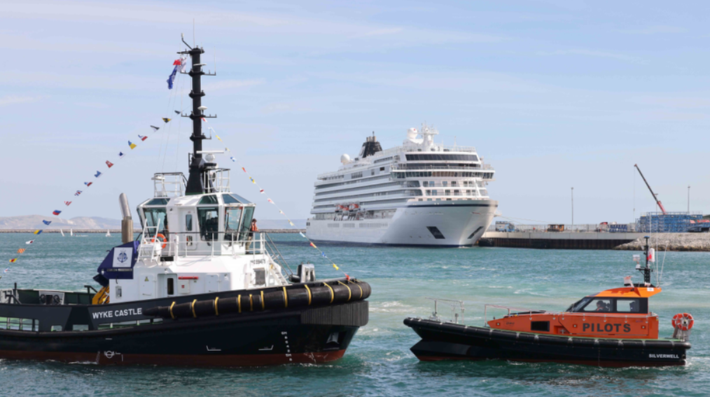

Methodology Report for the Design, Development and Delivery of the GREENPORT Educational Streams
(HEI, VET and TTT)

October 2025
Table of Contents

Chapter 1 – Introduction 6
1.1 Overview of the GREENPORT Project 6
1.2 Role of Work Package 4 within GREENPORT 8
1.3 Purpose of the Methodology Report 9
1.4 Context: Sustainability Challenges in In-Port Services 10
1.5 Alignment with EU and IMO Decarbonisation Strategies 11
1.6 Report Structure and Methodological Logic (Extended) 12
1.7 Concluding Perspective 16
Chapter 2 – Theoretical and Policy Framework 18
2.1 Introduction 18
2.2 The COM-B Model: Framework for Behavioural Change 18
2.3 Behavioural Science in Education: Why Behavioural Change Is Central to GREENPORT 21
2.4 Pedagogical Principles of the GREENPORT Educational Model 24
2.5 Policy Alignment: Integrating Behavioural Education with EU and Global Frameworks 25
2.6 Synthesis: The Interplay Between Behaviour, Pedagogy, and Policy 28
2.7 Conclusion 29
Chapter 3 – Methodology for Development 31
3.1 Introduction 31
3.2 Data sources 32
3.3 Concept 33
3.4 Methodological steps for curriculum development 36
3.4.1 Identifying the need 36
3.4.2 Collaboration process 37
3.4.3 Principles for curriculum development 38
3.4.4 Validation and accreditation 38
3.5 Integrating data and evidence 39
3.6 Learning tools and technology 39
3.7 Challenges and difficulties 41
3.8 Conclusion 42
Chapter 4 Methodology per Learning Stream 44
4.1 Methodology per Learning Stream – Higher Education (HEI) 44
4.1.1 Introduction 44
4.1.2 Methodological Foundations 44
4.1.3 Curriculum Design Process 45
4.1.4 Design of the 14-Week Modules 45
4.1.5 Course Catalogue Architecture 47
4.1.6 Pedagogical Implementation 47
4.1.7 Assessment and Feedback 48
4.1.8 Quality Assurance and Validation 48
4.1.9 Expected Outcomes and Impact 48
4.1.10 Summary 49
4.2 Methodology per Learning Stream – Vocational Education and Training (VET) 49
4.2.1 Introduction 49
4.2.2 Methodological Foundations 50
4.2.3 Course Design Logic 50
4.2.4 Learning Content and Pedagogical Design 51
4.2.5 COM-B Application in the VET Context 52
4.2.6 Assessment and Evaluation Strategy 53
4.2.7 Quality Assurance and Continuous Improvement 53
4.2.8 Outcomes and Behavioural Impact 54
4.2.9 Summary 54
4.3 Methodology per Learning Stream – Train-the-Trainer (TTT) 54
4.3.1 Introduction 54
4.3.2 Methodological Foundations 55
4.3.3 Behavioural and Pedagogical Framework 56
4.3.4 Integration of the COM-B Model in Trainer Development 57
4.3.5 Digital Learning Infrastructure 58
4.3.6 Pedagogical Implementation 58
4.3.7 Pedagogical Strategies and Learning Methods 61
4.3.8 Behavioural Impact of Pedagogical Implementation 61
4.3.9 Assessment and Certification 62
4.3.10 Quality Assurance and Continuous Improvement 62
4.3.11 Expected Outcomes and Long-Term Impact 63
4.3.12 Summary 63
Chapter 5 – Integration, Evaluation, Dissemination and Sustainability 65
5.1 Introduction 65
5.2 Integration Across Learning Streams 65
5.3 Evaluation and Assessment 67
5.4 Impact of the Project 69
5.5 Dissemination of Results 71
5.6 Sustainability and Continuity 71
5.7 Recommendations for Future Development 72
5.8 Conclusion 73
5.9 Acknowledgements 73
REFERENCES 76
1. Behavioural Science and Learning Frameworks 76
2. Pedagogical Models and Digital Education 76
3. European and International Policy Frameworks 77
4. Maritime Operations, Port Sustainability, and Digitalisation 77
5. Behavioural Training and Simulation Studies 78
6. Quality Assurance, Evaluation, and Sustainability in Education 78
7 Behavioural Economics and Change Management (Supplementary) 79
8. Project-Specific and Internal References 79

Chapter 1 – Introduction

1.1 Overview of the GREENPORT Project

The GREENPORT Project (Grant Agreement No. 101139879, ERASMUS-EDU-2023-PI-ALL-INNO) is a strategic alliance among European higher-education institutions, maritime academies, industry associations, and technology partners dedicated to advancing sustainable, low-emission, and digitally connected port operations. It addresses one of the defining challenges of the twenty-first century — the transition of ports and maritime services toward climate neutrality while maintaining safety, efficiency, and competitiveness. At its core, GREENPORT seeks to build human capability for port decarbonisation. The project recognises that technological innovation—alternative fuels, hybrid propulsion, shore-power systems—must be matched by behavioural change and professional competence if Europe is to achieve its climate objectives. Every pilot, tug master, and port manager become an active participant in the effort to reduce greenhouse-gas emissions and transform ports into clean-energy hubs.
The consortium unites institutions from eight EU Member States, including Nikola Vaptsarov Naval Academy (Bulgaria), University of Rijeka (Croatia), Constanta Maritime University (Romania), Antwerp Maritime Academy (Belgium) and Piri Reis University (PRU), together with industry partners such as MAR.TE Logistics (Italy), the European Tug owners Association (ETA), the European Maritime Pilots’ Association (EMPA) and Port of Aveiro Administration (Portugal). Across Limits Ltd (Malta) takes the responsibility for leading the project’s digital innovation, dissemination and exploitation activities, ensuring the effective development of the GREENPORT e-learning platform, the digital visibility of all training outputs and the long-term sustainability and transferability of the project’s results across Europe. This composition enables a continuous feedback loop between research, education, and operational practice.
The overall project vision aligns with the European Green Deal (2019), the Fit for 55 Package (2021), the FuelEU Maritime Regulation (EU 2023/1805), and the IMO 2023 GHG Strategy—all of which establish Europe’s and the world’s path toward net-zero emissions by mid-century. Within this policy framework, GREENPORT functions as a laboratory for educational innovation, demonstrating how behavioural science and experiential learning accelerate environmental change in port operations. According to Annex 1 of the Grant Agreement, Work Package 4 (WP4) encompasses the full curriculum-development cycle, comprising conceptual design, collaborative development, piloting, validation, and dissemination. Its key deliverables are the three course packages—D4.1 (HEI), D4.2 (VET), D4.3 (TTT)—and the present D4.4 Methodology Report.

The expected outcomes of WP4 align with the horizontal objectives of the ERASMUS+ Programme and the European Skills Agenda:
- Creation of a competence-based model for sustainable port operations.
- Development of interdisciplinary modules connecting engineering, navigation, management, and environmental studies.
- Reinforcement of the behavioural dimension in maritime education through adoption of the COM-B framework.
- Deployment of digital infrastructure and e-learning tools to support lifelong learning and open access.
- Generation of policy recommendations for integrating sustainability competencies into national maritime-education standards.

Through these results, WP4 contributes directly to the project’s three-level impact pathway defined in Annex 1:
- Learners: enhanced employability, behavioural competence, and environmental awareness.
- Institutions: modernised curricula, digital transformation, and strengthened international cooperation.
- Industry: measurable reductions in energy waste and emissions achieved through improved human performance.

1.2 Role of Work Package 4 within GREENPORT

Among the six work packages, Work Package 4 (WP4) — Curriculum Design, Development and Piloting — occupies a pivotal position. It transforms the analytical insights from WP2 (Needs Analysis and Competency Mapping) and the empirical findings from WP3 (Case Studies on Emission Reduction in Port Services) into practical educational programmes.
WP4 therefore constitutes the implementation and knowledge-transfer axis of the project. Its purpose is to ensure that the scientific and operational knowledge generated elsewhere in GREENPORT is converted into learning experiences that build competence and reshape professional behaviour.
WP4 is structured around three inter-connected educational pathways:
1. Higher Education Training (HEI) — A semester-long academic course titled Sustainable Maritime Operations and Green Ports, designed for university students, cadets, and young officers. It blends theoretical understanding with simulation and case-based learning, linking environmental performance with navigation, port management, and logistics.
2. Vocational Education and Training (VET) — A short, intensive course for active maritime professionals — maritime pilots, tug masters, and technical operators. It focuses on behavioural change and immediate application of green operational practices through hands-on scenarios and simulator exercises.
3. Train-the-Trainer (TTT) — An online, self-paced programme for educators, instructors, and training-centre staff. It provides pedagogical foundations, digital-learning competencies, and behavioural-science awareness necessary to deliver the HEI and VET courses effectively.
Together these three streams form a comprehensive “learning ecosystem” covering the full life cycle of maritime human-capital development — from initial education to lifelong professional learning and pedagogical upskilling.
In operational terms, WP4 contributes directly to the project’s specific objectives listed in the Grant Agreement Annex 1:
- To design competence-based curricula that embed environmental and behavioural learning outcomes.
- To integrate digital and simulation technologies in maritime education.
- To implement pilot trainings with representative learners from each target group.
- To establish an evaluation and quality-assurance system enabling future accreditation and replication.

1.3 Purpose of the Methodology Report
The WP4 Methodology Report (Deliverable 4.4) represents a foundational resource for examining the theoretical and practical dimensions of integrating educational products within institutional contexts. By articulating the methodological framework underpinning this process, the report addresses a critical component of the Project’s objectives and contributes to the scholarly discourse on educational implementation strategies. The report has both a descriptive and a prescriptive function:
1. Descriptive Function — to record the process of curriculum design and development, explaining how findings from earlier work packages were transformed into pedagogical structures, learning outcomes, and teaching materials.
2. Prescriptive Function — to serve as a methodological guide for replication, enabling other institutions or sectors to adopt the GREENPORT approach.
The report therefore addresses three key questions:
- How were the HEI, VET, and TTT curricula conceptualised and developed?
- Why were particular pedagogical and behavioural models (such as COM-B) chosen?
- What are the expected educational and operational results when the courses are delivered at scale?
By answering these, the methodology report provides an evidence-based foundation for further piloting, evaluation, and policy dissemination. It also defines the interface between human-behavioural research and applied maritime education, making WP4 a bridge between theory and real-world training.

1.4 Context: Sustainability Challenges in In-Port Services

Port Operations and their Environmental Footprint
Ports are complex ecosystems where numerous small-scale operations collectively produce a significant environmental impact. Tug assistance, pilotage, mooring, cargo handling, and auxiliary vessel movements consume large quantities of fuel and generate carbon dioxide, nitrogen oxides, and particulate emissions. Studies within WP2 revealed that in-port services can represent up to 25 % of total port-related emissions, especially in older fleets lacking hybrid or electric propulsion.
The challenge is amplified by the fragmented regulatory environment: while ocean-going ships are subject to IMO conventions, local port services often fall under national or municipal jurisdiction, leading to variable environmental standards. This inconsistency underscores the need for a unified approach based on shared competencies and behavioural norms.

Policy Drivers and Strategic Frameworks
The European Union has developed an integrated set of measures addressing these issues:
- The European Green Deal identifies maritime transport as both a challenge and an opportunity, calling for “smart and sustainable mobility.”
- Fit for 55 revises the EU ETS to include shipping and promotes the use of alternative fuels through taxation and incentives.
- FuelEU Maritime establishes greenhouse-gas-intensity limits for energy used on board ships from 2025 onwards.
- The Alternative Fuels Infrastructure Regulation (AFI Regulation) mandates shore-side electricity supply in major EU ports by 2030.
- The IMO GHG Strategy (2023) sets global mid-term measures including the Carbon Intensity Indicator (CII) and Energy Efficiency Existing Ship Index (EEXI).
In parallel, the ESG (Economic, Social, Governance) reporting obligations and the Corporate Sustainability Reporting Directive (CSRD) create new expectations for transparency in port operations, linking environmental performance to financial accountability.

Human Factor and Behavioural Dimension
Despite technological advances, WP3 case studies confirm that human decisions remain decisive in determining energy efficiency and emission levels. Small behavioural changes — reduced idling, coordinated tug operations, anticipation of currents — can yield measurable savings. However, these depend on awareness, motivation, and organisational culture. Therefore, GREENPORT positions behavioural change as the missing link in traditional training. By applying the COM-B model (Capability, Opportunity, Motivation → Behaviour), WP4 integrates behavioural science into every stage of learning design, ensuring that knowledge is translated into sustainable daily action.

Digitalisation as an Enabler
Digital transformation supports this behavioural shift. Data analytics, IoT sensors, and simulation technologies enable real-time feedback and performance monitoring. Within WP4, these digital tools are used not merely as teaching aids but as behavioural mirrors, helping trainees visualise the environmental consequences of their operational decisions.

1.5 Alignment with EU and IMO Decarbonisation Strategies

GREENPORT’s educational objectives are consistent with the EU Maritime Transport Strategy 2020–2030, which calls for “a digital and green maritime space based on skills and innovation.” By embedding sustainability competencies into learning outcomes, the project directly supports several key EU policy frameworks. (Table 1)
By teaching professionals to interpret and operationalise these frameworks, GREENPORT contributes to policy literacy in the maritime workforce — a competence increasingly valued by both regulators and employers.
Table 1
Policy Framework | Relevance to GREENPORT WP4
EU Green Deal (2019) | Provides the overarching goal of climate neutrality; the curricula translate this macro-objective into micro-level operational practices.
Fit for 55 Package | Shapes the regulatory content of learning materials; students and trainees learn compliance and implementation pathways.
FuelEU Maritime Regulation | Forms part of the legal module explaining alternative-fuel strategies and emission-monitoring requirements.
EU ETS Extension to Maritime Transport | Integrated into exercises on cost analysis and decision-making under carbon pricing.
IMO 2023 GHG Strategy | Anchors international dimension: HEI and VET modules examine global policy mechanisms and their local implications.

1.6 Report Structure and Methodological Logic (Extended)

The Methodology Report is conceived as both a strategic narrative and a technical manual, designed to ensure full transparency, replicability, and coherence of the processes applied under Work Package 4 (WP4). It documents the pedagogical reasoning, research-based evidence, and collaborative practices that underpinned the design of the GREENPORT educational framework.
The report is divided into five main chapters and a comprehensive annex section. Each chapter serves a distinct but complementary function, forming a logical sequence that mirrors the stages of curriculum conception, co-creation, implementation, and validation. Together, these chapters trace the full methodological journey from the initial policy rationale to the operationalisation of teaching modules, assessment tools, and behavioural indicators.

Chapter 1 – Introduction
The first chapter, which serves as the current section of this document, provides a broad overview of the GREENPORT project, situating WP4 within the project architecture and policy ecosystem. It explains the purpose and scope of the methodology report, articulates the strategic relevance of the three learning streams (HEI, VET, TTT), and contextualises the report within European sustainability and maritime policy frameworks such as the EU Green Deal, Fit for 55, FuelEU Maritime, and the IMO GHG Strategy (2023).
This chapter also outlines the intended outcomes of WP4 as specified in Annex 1 of the Grant Agreement, defining the report’s alignment with project deliverables D4.1–D4.3. It closes with a structural roadmap, introducing the content of the subsequent chapters and the methodological principles guiding the overall report.

Chapter 2 – Theoretical and Policy Framework
The second chapter establishes the conceptual foundations upon which the three curricula are built. It explains the theoretical underpinnings of the COM-B model (Capability, Opportunity, Motivation → Behaviour) and how this behavioural framework informs both teaching design and learning assessment.
The chapter links the behavioural science component with educational theory, referencing andragogy (adult learning theory), competence-based education, and experiential and simulation learning methodologies. It also provides an in-depth policy analysis; mapping how international and EU decarbonisation policies are embedded into the educational content.
By connecting behavioural theory with policy objectives, Chapter 2 positions GREENPORT as a model for policy-driven educational innovation in the maritime and port services sector. It sets the academic and policy context that justifies the methodological choices later presented.

Chapter 3 – Methodology for Development
This chapter describes the process and methodology used to design and develop the three educational streams. It elaborates the steps of the curriculum-development cycle:
1. Needs Identification – deriving educational priorities from the WP2 needs analysis and WP3 case studies.
2. Co-creation Process – explaining how academic and industry partners collaborated in iterative design loops.
3. Curriculum Design and Structuring – showing how learning objectives, content, and assessment tools were aligned with the COM-B model.
4. Validation and Quality Assurance – documenting peer review, piloting, and stakeholder feedback.
It provides detailed methodological diagrams and tables that illustrate data integration, alignment with policy frameworks, and the use of simulation technologies. Chapter 3 demonstrates how data-driven evidence from research was transformed into structured learning content, ensuring that the training materials are both scientifically grounded and pedagogically robust.

Chapter 4 – Methodology per Learning Stream
As the central analytical component of the report, Chapter 4 provides three sub-sections, each devoted to one of the GREENPORT learning streams — Higher Education (HEI), Vocational Education and Training (VET), and Train-the-Trainer (TTT).
For each stream, the chapter presents:
  - the curricular rationale and intended target group.
  - the pedagogical structure and delivery format (e.g., semester-long, two-day intensive, or online self-paced course);
  - the learning outcomes and behavioural indicators mapped to COM-B components.
  - the teaching and assessment methods, including simulation, blended learning, and digital tools.
Each sub-section also provides examples of module content, learning trajectories, and pilot feedback.
Together, these three parts illustrate how the same methodological philosophy — sustainability through behavioural change — has been adapted to different educational contexts and learner profiles. Chapter 4 therefore acts as the core demonstrator of the report’s methodological logic.

Chapter 5 – Integration, Evaluation, Dissemination and Sustainability
The fifth chapter explores the horizontal connections between the HEI, VET, and TTT courses. It examines their complementarity in terms of skills progression and behavioural reinforcement.
The section analyses shared methodological features such as:
  - the use of simulation as a common learning tool.
  - the integration of digital platforms (LMS) for cross-level continuity.
  - and the establishment of transferable learning outcomes that enable credit recognition or modular adaptation.
It also explains how the three learning streams are designed as complementary formats for different target groups, using shared methodological principles (competence orientation and evidence-based content), while remaining operationally independent.

This chapter positions WP4 not as a set of separate courses, but as a coherent educational framework that enables methodological consistency and synergy across the three streams. The separate courses are envisaged for different target groups and there is a holistic view for synergy. The chapter outlines the methodology used to evaluate and validate the learning streams during their pilot implementation phase. It presents the design of evaluation instruments such as feedback questionnaires, observation checklists, self-reflection forms, and performance indicators.
The section explains how quantitative and qualitative data from pilot trials were collected and analysed to assess:
  - the effectiveness of learning design,
  - the degree of behavioural change achieved, and
  - the satisfaction of both learners and trainers.
It also discusses the process of external validation by industry partners (e.g., ETA and EMPA) and academic peers, thereby establishing the credibility of the courses and supporting their integration into institutional frameworks.
This chapter connects directly to the impact assessment objectives outlined in the Grant Agreement, ensuring that GREENPORT’s educational innovation is evidence-based and measurable.
The chapter turns to the long-term perspective of the project. It explains how the developed curricula and methodological insights will be disseminated, digitalised, and sustained after the end of the project lifecycle.
Topics covered include:
  - integration of the three learning streams into the GREENPORT Learning Management System (LMS);
  - creation of open educational resources (OER) for partner and external institutions.
  - organisation of multiplier events and workshops to promote the results.
  - and establishment of sustainability measures ensuring continuous updating and institutional ownership.
The chapter also discusses the digital-transformation strategy underpinning the TTT stream — highlighting how online delivery, interactive tools, and analytics enhance both accessibility and pedagogical efficiency.
In doing so, the chapter provides a blueprint for scaling up GREENPORT’s outcomes across Europe, ensuring that the project’s impact continues beyond its contractual timeframe.
The final discussions synthesise the main insights derived from the entire methodology process. It presents a concise summary of achievements, identifies challenges encountered during curriculum development, and formulates policy and pedagogical recommendations.
These recommendations address:
  - the European and national policy levels (integration into maritime-education frameworks and ESG compliance standards);
  - institutional levels (embedding behavioural-change education into curricula); and
  - practitioner levels (encouraging continuous learning and peer mentoring).
This concluding chapter highlights GREENPORT’s contribution to the EU’s broader agenda for sustainable blue growth, proposing avenues for replication and cooperation with other Erasmus+ alliances and maritime initiatives.

Annexes
The annex section provides the technical backbone of the methodology report. It includes:
  - detailed syllabi for the HEI, VET, and TTT modules.
  - COM-B mapping matrices linking learning outcomes to behavioural indicators.
  - assessment rubrics, simulation templates, and case-study summaries.
  - and pilot-testing documentation, including feedback analyses and participant demographics.
The annexes ensure transparency and replicability, allowing other institutions to implement the GREENPORT model with fidelity while adapting it to their local context.

Logical Flow of the Report
The overall structure thus follows a progressive logic:
  - Chapters 1–2 provide the rationale and theoretical foundations.
  - Chapters 3–4 describe the design and implementation processes.
  - Chapters 5 evaluate integration and validation, continuity and strategic dissemination.
This systematic architecture transforms the methodology report from a static deliverable into a living framework for educational innovation, embodying the GREENPORT vision of sustainable transformation through learning, leadership, and behavioural change.

1.7 Concluding Perspective

Chapter 1 establishes the intellectual and strategic foundation for the GREENPORT Methodology Report. It presents the rationale for integrating sustainability, behavioural science, and digitalisation into maritime education, articulating the belief that true decarbonisation is as much a behavioural process as a technological one.
By linking European policy ambitions with local operational realities, GREENPORT demonstrates that education is the key driver of systemic change in ports. The subsequent chapters will explain how theoretical frameworks were operationalised into tangible learning designs — creating a scalable, evidence-based educational model for Europe’s green maritime transition.

Chapter 2 – Theoretical and Policy Framework

2.1 Introduction

The transition toward low- and zero-emission port operations requires not only new technologies but also a re-orientation of human behaviour, institutional culture, and professional decision-making. Within the GREENPORT Project (Grant Agreement No. 101139879), Work Package 4 (WP4) recognises that the effectiveness of decarbonisation depends on what people do when they plan, navigate, coordinate, and manage operations in port environments.
Theoretical and policy frameworks therefore occupy a central place in this methodology report. Chapter 2 explains how the COM-B model (Capability → Opportunity → Motivation = Behaviour) provides the scientific structure for behavioural change in education and training. It also explores how behavioural science informs learning design, how pedagogical principles—competence-based, adult-learning, blended, and simulation-based approaches—translate those insights into practice, and how the resulting curricula align with EU and IMO policies such as the European Green Deal, Fit for 55, FuelEU Maritime, EU ETS, and IMO GHG Strategy (2023).
By linking behavioural theory with educational practice and policy compliance, this chapter establishes the conceptual backbone of WP4, ensuring that the three GREENPORT learning streams—HEI, VET, and TTT—are pedagogically sound, scientifically justified, and policy-relevant.
The methodological logic supports behavioural change in port operations by addressing capability, opportunity, and motivation factors identified through empirical analysis.

2.2 The COM-B Model: Framework for Behavioural Change

Origins and Core Concept
Developed by Michie et al. (2011), the COM-B model identifies three interacting prerequisites for any behavioural change:
1. Capability (C) – the individual’s physical and psychological ability, including skills and knowledge.
2. Opportunity (O) – the environmental and social conditions that enable or prompt the behaviour.
3. Motivation (M) – the reflective and automatic processes that energise and direct action.
When all three converge, new behaviour becomes both feasible and sustainable.
To discuss - in GREENPORT, COM-B serves as the diagnostic and design tool for all curricula: every learning objective, scenario, and assessment method is mapped to at least one COM-B dimension. In practical terms, this mapping does not imply that all dimensions are addressed equally in every course unit. Instead, the COM-B framework is applied selectively, depending on the nature of the target group and the operational context. For example, HEI courses place stronger emphasis on developing analytical and cognitive capability, while VET modules focus on procedural capability and situational opportunity within real port operations. Train-the-Trainer activities, in turn, prioritise reflective motivation and instructional opportunity, enabling trainers to transfer behavioural principles into their own teaching environments. The use of COM-B in GREENPORT is therefore not prescriptive but functional. It provides a structured lens through which training designers can identify gaps between existing competences and desired operational behaviours, without reducing complex maritime decision-making to simplistic behavioural models. This approach ensures that behavioural considerations remain embedded throughout curriculum design, while professional judgement, regulatory requirements, and technical constraints retain their central role.

Finally, COM-B mapping supports transparency and consistency across the three learning streams. By explicitly linking learning objectives, instructional methods, and assessment tools to behavioural determinants, the methodology allows partners to justify pedagogical choices, compare approaches across institutions, and refine course content during piloting based on feedback and evaluation results.

Application in the Maritime Context
Port operations present complex behavioural systems: decision-making occurs under stress, communication flows across mixed teams, and performance is evaluated through both safety and efficiency. Behavioural bottlenecks—habitual idling, poor coordination, or risk-averse manoeuvring—often offset the gains of new technologies.
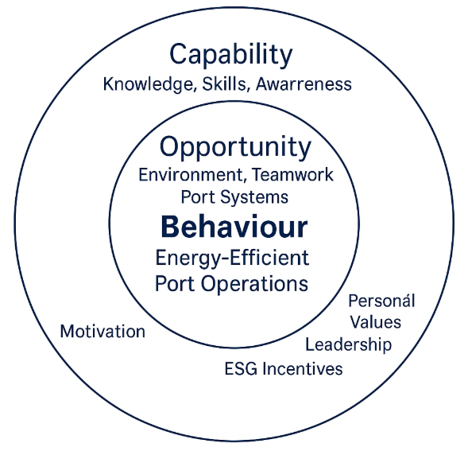

Figure 2.1. The COM-B Behavioural Model applied to Maritime Training.

By applying COM-B, GREENPORT reframes these bottlenecks as educational opportunities. Training therefore targets:
  - Capability: knowledge of energy-saving techniques, digital navigation tools, emission indicators.
  - Opportunity: creation of simulator-based environments mirroring real port operations.
  - Motivation: development of ecological responsibility, leadership, and peer accountability.

As illustrated in Fig. 2.1, the COM-B framework is operationalised in GREENPORT as an iterative design loop linking training inputs to expected operational effects. Learning activities are first aligned with the relevant behavioural determinants—capability, opportunity, and motivation—which together influence professional behaviour in port-related tasks. The figure also highlights that behaviour is not treated as an isolated outcome, but as an intermediate step between training and performance-related indicators. Feedback from assessments, participant reflections, and piloting results feeds back into the curriculum design process, allowing continuous adjustment of learning objectives and instructional methods.

In this way, Fig. 2.1 demonstrates how COM-B supports coherence between educational design, behavioural considerations, and evaluation mechanisms, while acknowledging the influence of organisational, regulatory, and technical factors beyond the scope of training alone.

Educational Translation
Each GREENPORT learning stream addresses COM-B in different proportions:

Table 2
Stream | Primary Focus | Behavioural Objective | Example Activity
HEI | Capability | Develop analytical understanding of port decarbonisation systems. | Research project on alternative fuel supply chains.
VET | Opportunity | Apply energy-efficient behaviour in realistic scenarios. | Simulator exercise – eco-tug coordination.
TTT | Motivation | Promote behavioural change through pedagogical leadership. | Workshop on coaching and feedback techniques.
This alignment ensures that behavioural competence progresses from knowing → doing → teaching.

Within the HEI stream, the COM-B model is not applied as a behavioural intervention tool, but as an analytical framework supporting structured reflection on how policy, organisational context, and professional decision-making interact in port operations. Figure 2.1 and Table 2 therefore serve as conceptual references that help students analyse the conditions under which environmentally responsible behaviour may emerge, rather than as prescriptive models for individual behavioural change. In such context, “Capability” refers primarily to cognitive and analytical competences developed through higher education, including policy interpretation, systems thinking, and critical evaluation. “Opportunity” is understood as the regulatory, organisational, and infrastructural environment within which port-related decisions are taken, while “Motivation” relates to professional values, responsibility, and awareness shaped through academic learning.

This reinterpretation ensures consistency between the COM-B framework and the HEI methodological approach, which emphasises understanding, analysis, and informed decision-making rather than direct operational behaviour modification.

Measurement and Feedback
To verify behavioural change, the courses incorporate measurable indicators:
  - Capability: accuracy in data-driven decision-making tasks.
  - Opportunity: participation and coordination quality during simulation.
  - Motivation: self-reflection entries revealing commitment to sustainability.
Feedback cycles—observation, debriefing, peer review—translate these measurements into personal learning plans.
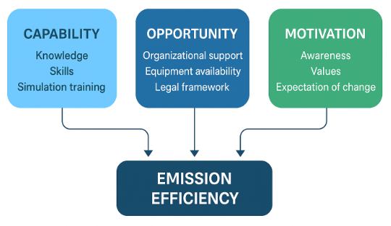
Figure 2.2. Behavioural Determinants of Emission Efficiency in Port Operations. Source: GREENPORT Deliverable 4.2 – VET Course Material (2025, p. 12).

Behavioural Continuum and Organisational Culture
Behaviour changes at individual level scales up to cultural transformation when reinforced by institutional norms. In GREENPORT partner institutions, instructors’ model sustainable practices; simulation centres track fuel metrics; and port partners integrate behavioural KPIs into operational reviews. Thus, COM-B functions not only as a pedagogical tool but as a management philosophy connecting education with real operational outcomes.

2.3 Behavioural Science in Education: Why Behavioural Change Is Central to GREENPORT
From Knowledge to Behaviour
Conventional maritime instruction is primarily cognitive—it transmits procedures, regulations, and technical knowledge. Yet research from WP2 and WP3 shows that knowledge alone rarely changes behaviour. For instance, tug crews may fully understand emission-control procedures but revert to inefficient practices under operational stress or tight schedules.
Behavioural science provides the missing link between understanding and action. It analyses the drivers and inhibitors of human performance—habits, norms, feedback loops, emotional triggers—and offers frameworks to influence them constructively. In GREENPORT, this understanding guides how learning materials are designed, sequenced, and evaluated.

Cognitive and Social Determinants of Behaviour
The maritime workplace is social and hierarchical. Decisions are shaped not only by rules but also by informal norms, peer expectations, and risk perceptions. The most common behavioural determinants identified in WP3 case studies include:
  - Routine bias – preference for established manoeuvring habits even when new data suggest better options.
  - Perceived risk – overestimation of danger when experimenting with low-thrust or slow-steaming techniques.
  - Authority gradient – reluctance of junior crew to question inefficient orders.
  - Outcome visibility – inability to see the immediate environmental results of actions.
GREENPORT courses counteract these factors through reflective dialogue, transparent data presentation, and simulation-based feedback.
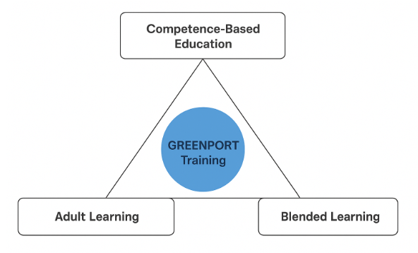
Figure 2.3. Behavioural Determinants in Port Service Operations. Source: GREENPORT Deliverable 4.2 – VET Course Material (2025, p. 13).

Feedback, Reflection, and Self-Regulation
Learning becomes behaviourally effective only when participants perceive the consequences of their decisions. Each stream integrates feedback mechanisms:
  - HEI: digital dashboards displaying fuel-efficiency metrics for hypothetical port systems.
  - VET: simulator read-outs quantifying emission reductions after each exercise.
  - TTT: peer-observation rubrics that visualise teaching impact on learner engagement.
Reflection journals and debriefing sessions close the loop by converting feedback into internalised behavioural norms.
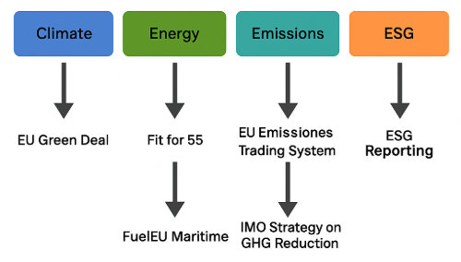
Figure 2.4. Feedback Loop Structure in GREENPORT Learning Cycles. Source: GREENPORT Deliverable 4.3 – TTT Course Material (2025, p. 10).

Behavioural Change as Collective Culture
Behavioural science in education ultimately serves cultural transformation. The goal is to evolve ports and maritime organisations into learning ecosystems where sustainable decisions are the norm, not the exception.

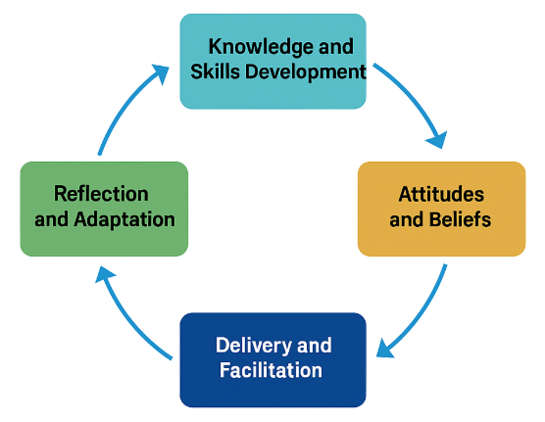
Figure 2.5. Behavioural Learning Cycle for Trainers and Educators. Source: GREENPORT Deliverable 4.3 – TTT Course Material (2025, p. 11).

The TTT stream cultivates trainers as behavioural multipliers capable of influencing institutional culture through everyday pedagogy and leadership Collective reinforcement—crew briefings, post-operation reviews, sustainability dashboards—translates individual motivation into shared practice.

2.4 Pedagogical Principles of the GREENPORT Educational Model
The educational design of WP4 translates behavioural insights into concrete learning experiences. Four complementary pedagogical pillars ensure that the desired behavioural outcomes are achieved.

Competence-Based Education (CBE)
CBE defines outcomes in terms of what learners can demonstrably do. Every GREENPORT module expresses learning objectives using measurable verbs (analyse, apply, optimise, coordinate).
For example:
  - HEI Module 4 – “Sustainable Port Operations and Digital Twins”: learners model emission scenarios using simulation software, satisfying the Capability component of COM-B.
  - VET Exercise 2 – “Hybrid Tug Operations”: participants demonstrate operational competence in energy-saving manoeuvres (Opportunity).
  - TTT Unit 3 – “Designing Behaviour-Centred Lessons”: educators create lesson plans embedding motivational triggers (Motivation).
CBE also allows alignment with the European Qualifications Framework (EQF), enabling credit transfer and formal recognition.

Adult Learning and Andragogy
Most VET and TTT participants are seasoned professionals; thus, teaching follows the principles of andragogy (Knowles, 1980):
1. Relevance: tasks mirror authentic port scenarios.
2. Autonomy: learners choose case studies relevant to their workplace.
3. Experience as resource: participants bring operational insights into classroom debates.
4. Goal orientation: every task links to measurable operational improvements.
Instructors act as facilitators rather than lecturers, supporting self-directed problem solving.

Blended Learning Design
The GREENPORT Learning Management System (LMS) provides an integrated structure for online and face-to-face activities. Its blended design ensures continuity between theory and practice:
  - Pre-Course Online Phase: participants access reading materials, EU-policy briefings, and self-assessment quizzes.
  - In-Person Workshops: simulation and teamwork sessions.
  - Post-Course Follow-Up: digital reflection reports and further discussion forums.
This sequence supports spaced learning and long-term retention.

Simulation-Based Training (SBT)
Simulation represents the behavioural laboratory of GREENPORT. It allows safe experimentation and immediate quantification of results. The VET stream’s two-day intensive sessions include scenarios such as:
  - “Energy-Optimised Tug Assistance”
  - “Cold-Ironing Berthing Operations”
  - “Communication Efficiency under Stress”
During each scenario, participants manipulate variables (speed, thrust, coordination) while real-time dashboards display emission metrics.
The debrief stage connects simulator data to COM-B dimensions:
  - Capability – technical precision.
  - Opportunity – coordination with peers.
  - Motivation – reflection on environmental responsibility.

2.5 Policy Alignment: Integrating Behavioural Education with EU and Global Frameworks

GREENPORT’s educational model does not exist in isolation. It was designed to respond directly to European and international maritime decarbonisation policies, ensuring that learners understand and can operationalise the regulatory landscape.

The European Green Deal (2019)
The European Green Deal establishes the EU’s overarching goal of climate neutrality by 2050. It calls for a transformation of transport and port operations into smart, sustainable, and resilient systems.
Within this macro policy, GREENPORT performs a micro-level translation: it turns abstract policy goals into professional competences. Learners are trained not just to comply with rules but to understand their rationale and translate them into daily operational practices.
The HEI modules introduce the Green Deal as a policy ecosystem, linking it to energy transition and port management. VET and TTT courses then focus on operationalisation—how pilots, tug masters, and trainers can contribute directly to Green Deal objectives through decision-making and leadership.
Fit for 55 Package (2021)
The Fit for 55 Package contains multiple legislative acts driving emission reductions by 55% before 2030. Of particular relevance to maritime education are:
  - Directive (EU) 2023/959 extending the EU Emissions Trading System (ETS) to shipping.
  - Regulation (EU) 2023/1805 (FuelEU Maritime) establishing GHG-intensity limits for marine fuels.
  - Alternative Fuels Infrastructure Regulation (AFIR) requiring onshore power supply in major EU ports.
Each course stream translates these instruments into learning outcomes:
  - HEI: policy analysis assignments—students map Fit for 55 obligations to port operations.
  - VET: simulation scenarios—pilots adjust manoeuvres to minimise emission costs under ETS.
  - TTT: digital content—trainers design micro-lessons explaining regulatory implications to practitioners.

In practical terms, this could be achieved through structured policy analysis assignments in which students work with selected EU regulatory instruments related to decarbonisation, such as the Fit for 55 package, and examine their implications for specific port operations. Students are guided to identify relevant policy objectives, compliance mechanisms, and timelines, and to translate these into operational requirements affecting port services, vessel calls, energy use, and emissions reporting. Using case-based scenarios, students analyse how policy obligations influence decision-making at port level, including infrastructure planning, operational procedures, and coordination between port authorities, operators, and shipping companies. The assignment framework encourages critical evaluation rather than policy reproduction, requiring students to assess feasibility, trade-offs, and potential implementation challenges within real port contexts.
Through such process, policy knowledge could be transformed into analytical capability, enabling students to link regulatory drivers to practical operational consequences, which directly supports the development of higher-level competences in maritime governance and sustainable port management.

FuelEU Maritime Regulation (EU 2023/1805)
This regulation introduces a lifecycle GHG-intensity standard for the energy used onboard ships. It applies to both international and domestic voyages of vessels calling at EU ports.
GREENPORT integrates this regulation through multidisciplinary modules:
  - Technical dimension: alternative fuels, hybrid propulsion, and energy efficiency measures.
  - Operational dimension: fuel choice in simulator tasks and emission data interpretation.
  - Managerial dimension: economic impact of compliance for port authorities and tug operators.
EU Emissions Trading System (ETS) Expansion
From 2024 onward, maritime transport enters the EU ETS, linking emission performance with economic consequences.
GREENPORT uses this as a behavioural lever: when learners see that emissions directly affect financial outcomes, motivation is reinforced through tangible incentives.
For example, VET participants simulate alternative berthing speeds to compare emission-cost impacts. HEI students perform cost–benefit analyses of emission abatement versus carbon credit expenditure. Trainers in the TTT stream develop classroom demonstrations explaining the economics of emission compliance.

IMO Strategy on the Reduction of GHG Emissions from Ships (2023)
The International Maritime Organization (IMO) adopted its 2023 Strategy to reach net-zero GHG emissions from international shipping by 2050, with intermediate checkpoints (−20% by 2030, −70% by 2040). It includes technical and operational measures such as:
  - EEXI (Energy Efficiency Existing Ship Index)
  - CII (Carbon Intensity Indicator)
  - SEEMP (Ship Energy Efficiency Management Plan)
GREENPORT integrates these into the HEI module “Global Maritime Governance and Sustainability” (Deliverable 4.1, pp. 26–27). Students conduct comparative analyses between IMO and EU frameworks.
In VET exercises, trainees interpret CII reports in the simulator context. The TTT course, meanwhile, shows trainers how to embed IMO metrics into case-based instruction.

ESG Reporting and Port Sustainability Frameworks
The implementation of the Corporate Sustainability Reporting Directive (CSRD) and related ESG frameworks (Environmental, Social, and Governance) redefines how ports report performance.
GREENPORT prepares learners to interpret ESG indicators and align operational data with institutional reporting systems (e.g., EcoPorts, WPSP).
TTT modules on “Digital Tools for ESG Literacy” (Deliverable 4.3, pp. 12–13) equip trainers to build lessons that show:
  - how emissions data translate into sustainability reports.
  - how behaviour affects ESG key metrics.
  - how transparency supports the port’s social licence to operate.

2.6 Synthesis: The Interplay Between Behaviour, Pedagogy, and Policy

The Triangular Logic of GREENPORT (Fig.2.18)
At the heart of GREENPORT lies the interaction between Behavioural Science (COM-B), Pedagogical Design, and Policy Frameworks. These three domains operate in mutual reinforcement:

Table 3
Level | Function | Example
Behavioural (COM-B) | Defines the psychological and social levers of change. | Motivation through emission-feedback dashboards.
Pedagogical | Provides the methods to teach and reinforce behaviour. | Simulation-based teamwork and reflection journals.
Policy | Supplies external rationale and compliance motivation. | Fit for 55 and FuelEU Maritime scenarios.

This triangular logic ensures systemic transformation rather than isolated learning.

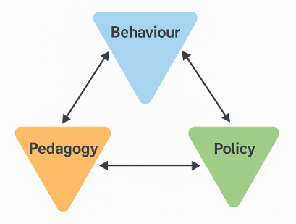
Figure 2.6. Conceptual Integration Triangle of Behaviour, Pedagogy, and Policy. Source: Synthesised from GREENPORT WP4 Methodology (2025, p. 3).

Cross-Stream Synergy
The three educational streams (HEI, VET, TTT) function as interconnected levels of one learning continuum:
  - HEI: develops analytical capability and policy understanding.
  - VET: operationalises that knowledge through behavioural practice.
  - TTT: ensures sustainability of change by equipping new educators.
Their synergy forms a self-reinforcing system: HEI graduates bring awareness into ports, VET participants improve daily practice, and TTT instructors multiply the message.

Within this framework, the three educational streams address distinct target groups with different professional roles, responsibilities, and learning needs, rather than a single cohort progressing through successive stages. The HEI stream primarily targets university students and early-career maritime professionals who are expected to engage with policy analysis, strategic planning, and system-level decision-making related to sustainable port operations. The VET stream is designed for practising port and maritime professionals, including operational staff, supervisors, and technical personnel whose daily activities directly influence emissions, energy use, and procedural compliance. For this group, learning focuses on applying knowledge in real operational contexts, reinforcing safe and efficient behaviours through practice-based training and scenario work. The Train-the-Trainer stream addresses educators, instructors, and senior practitioners who are responsible for delivering training within academic institutions, maritime training centres, port organisations, or companies. This group plays a critical role in sustaining and scaling project outcomes by embedding GREENPORT principles into existing training programmes and institutional practices.

By addressing these differentiated target groups, the three streams create a complementary system in which strategic understanding, operational competence, and instructional capacity reinforce one another, while remaining aligned with the specific professional contexts of each audience.

Digitalisation as Behavioural Enabler
The digital infrastructure supporting the project (LMS platform, simulation databases, analytics dashboards) strengthens all COM-B components:
  - builds Capability through online learning materials.
  - creates Opportunity by connecting geographically dispersed learners.
  - sustains Motivation via visualised progress and badges of achievement.
Digitalisation thus becomes both a pedagogical and behavioural instrument.

2.7 Conclusion

The theoretical and policy framework of GREENPORT illustrates how behaviourally informed pedagogy bridges the gap between regulation and reality.
By merging the COM-B model, advanced learning design, and EU/IMO sustainability policies, WP4 establishes a replicable model for maritime education that not only informs but transforms.
Through these aligned structures:
  - Capability is developed by competence-based and digital learning;
  - Opportunity is provided through simulation and collaboration;
  - Motivation is sustained by policy relevance and social recognition.
The outcome is a holistic educational system that supports Europe’s Green Deal and Fit for 55 ambitions, aligns with IMO global targets, and embeds sustainability as a behavioural norm across maritime professions.
The next chapter, Methodology for Development, will describe how this theoretical foundation was operationalised into tangible curricula, materials, and assessment systems for the three learning streams under WP4.

Chapter 3 – Methodology for Development

3.1 Introduction

In recent years, sustainability has become a central concern in the global maritime industry. Governments, shipping companies, and international organizations have heavily promoted “green shipping” — practices aimed at reducing greenhouse gas emissions, improving fuel efficiency, and minimizing ocean pollution. The port services industry needs comprehensive information and data on sustainability practices, green skills, and emission reduction measures.
The role of WP4 is to be as a continuation of WP2. Within the WP2 of GREENPORT project the European Tug owners Association (ETA) and the European Maritime Pilots Association (EMPA) conducted surveys to gather data from towage industry professionals and pilots. The aim is to establish how the needs identified in the surveys’ analysis (lack of training, low awareness, lack of green skills) could serve as a starting point for the development of courses “High education and Training” (HEI), “Vocational Education and Training” (VET) and “Train-the-Trainer” (TTT) curricula.
Based on this, the methodology aims to translate empirical results (industry–academia–policy) into structured learning solutions. The critical methodological challenge lies in translating empirical insights into such learning solutions that can be systematically applied to professional practice and educational programs. Successful outcome of this process requires close collaboration among industry and academic institutions. While such collaborations often generate rich empirical results through joint research, pilot projects, and case studies, these findings frequently remain fragmented and underutilized. To avoid such a result, the GREENPORT project includes several main maritime industry organizations with well respectable educational institutions.
In this translation of empirical results into learning programs and curricula the project participants collaborate to transform the conceptual framework into structured learning solutions. These may include e-learning modules, simulation exercises, decision-making scenarios, or policy-learning laboratories. Pedagogical models such as experiential learning, problem-based learning, or competency-based frameworks are used to ensure that the learning process reflects both theoretical understanding and practical application.

3.2 Data sources

The methodology is based on the following studies:
Industry survey conducted by European Tug owners Association (ETA)
- Seventy responses were collected from managers and specialists.
- 64.3% of respondents say that crews acknowledge the need for sustainable practices, but only 55.7% of them are aware of the environmental impact of their daily tasks.
- Key factors affecting emissions include speed, planning, and the need for more awareness.
- Training on emission reduction and sustainability is desirable, but a significant lack of such training is available.
- The industry demonstrates efforts to reduce emissions through better planning and low-impact fuels.

Pilots’ survey conducted by European Maritime Pilots Association (EMPA)
- Twenty-six responses were collected.
- 57.7% of pilots are aware of the need for sustainable practices, and 65.4% consider the environmental impact of their tasks.
- Implementing efficient manoeuvring techniques, optimising tugboat power for enhanced safety and efficiency, and refining shipping movement planning and coordination can reduce emissions within ports.
- There is a strong demand for training on environmental legislation, emission monitoring, and sustainable practices.

Academic survey conducted by Piri Reis University (PRU) among maritime educators
- Seventy-six academic responses indicate a strong agreement on the importance of sustainability in maritime education.
- Despite this, participation in training or workshops on sustainability could be higher.
- There is a need for better integration of sustainability principles into curricula and more training on behavioural change approaches.
Desk-based literature review highlights:
- Ports are significant contributors to air pollution due to emissions from vessels.
- Effective regulations and emission inventories are essential for mitigating impacts.
- Research gaps remain in understanding specific emissions from tugboats and pilot boats.

Specific port case studies:
Emissions data and sustainability practices were analysed for several European ports, including Naples, Salerno, Vigo, Klaipeda, Aveiro, Dubrovnik, Zadar, Šibenik, Rijeka, and Split, as well as Bulgarian Black Sea ports emissions over the period 2018- 2023. Key findings emphasise the need for targeted emission reduction strategies, such as using alternative fuels, port equipment electrification, and shore power implementation.

3.3 Concept

As detailed in Chapter 2, the COM-B model provides a systematic approach for analysing and promoting behavioural change. It identifies three interdependent factors required for any behaviour to occur — Capability, Opportunity, and Motivation — which together drive behavioural outcomes.

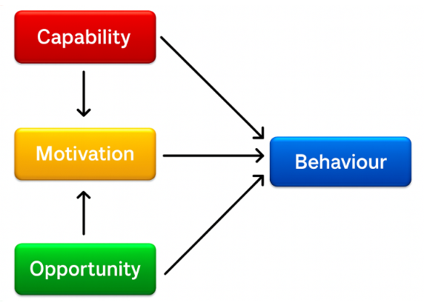

Figure 3.1. The COM-B System – A Framework for Understanding Behaviour

These three dimensions interact dynamically: changes in one can influence the others, creating positive or negative feedback loops. Behavioural interventions therefore target one or more of these levers to achieve lasting change. COM-B is often operationalised through the Behaviour Change Wheel, which links each component to suitable intervention strategies.

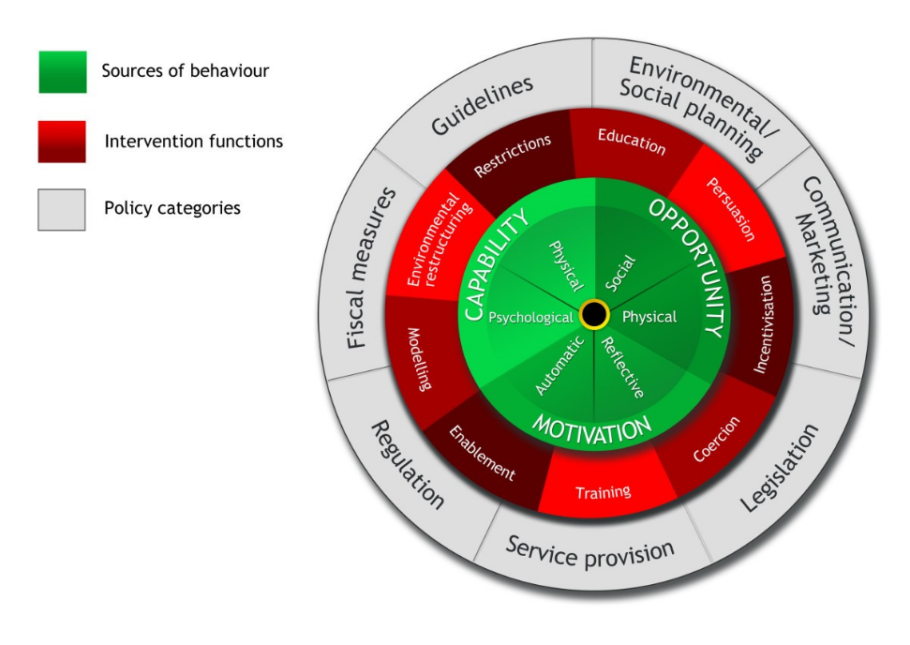
Figure 3.2. COM-B Behaviour Change Wheel

As can be seen in figure 3.3., capability and opportunity influence motivation, and not only do all three-influence behaviour change but are also influenced by the change which occurs. For example, the opportunity component may be targeted to encourage someone who is inactive to be active, i.e. providing social and physical opportunity through free, group exercise sessions. If this individual initially thought that they did not have the appropriate skills to take part in an activity (capability) but were still provided with the opportunities to attend a class, then by going to this class they reinforce the idea that they do have the capabilities required.
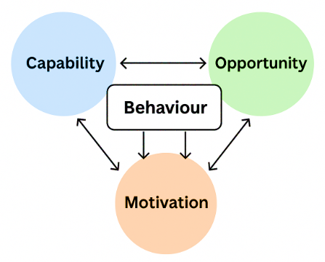
Figure 3.3. Interaction of COM-B Factors

The COM-B model views these components as a reciprocal system: capability and opportunity influence motivation, and behavioural change, once achieved, reinforces each determinant. For example, structured simulator training (opportunity) enhances confidence (capability), which in turn increases willingness to adopt new procedures (motivation).

Within GREENPORT, COM-B acts as both a diagnostic and design framework for curriculum development. Every learning outcome, simulation, and assessment tool is mapped to at least one COM-B element, ensuring that technical competence, operational access, and motivational reinforcement evolve in parallel.

Work Package 4 transforms these behavioural principles into a practical learning process by:
- Developing multimedia content, case studies, and interactive e-learning modules.
- Designing simulation-based training to reinforce real-world applicability.
- Creating assessment tools to measure both technical and behavioural progress.
- Aligning all materials with the curricular objectives and expected behavioural outcomes defined in the project methodology.

While Work Package 4 establishes the methodological framework and design principles for these learning activities, the level of development and implementation differs across the three educational streams. Multimedia and e-learning content within the Train-the-Trainer stream is currently conceived as a foundational resource, with further enrichment expected through future iterations, institutional adaptation, and post-project use by partner organisations. Simulation-based training could be primarily developed and delivered within the HEI and VET streams, where access to accredited simulators, technical infrastructure, and experienced instructors is available. In these cases, WP4 defines the learning objectives, behavioural focus, and assessment logic of simulation scenarios, while the detailed scenario design and execution are carried out by partner institutions and training centres with established simulation capabilities.
For the Train-the-Trainer stream, simulation could be addressed indirectly, through methodological guidance on how behavioural principles and learning objectives can be embedded into simulation exercises designed by local providers, rather than through the creation of standalone simulation scenarios within the project.

Such differentiated approach would ensure that WP4 remains focused on curriculum coherence, behavioural alignment, and quality assurance, while allowing implementation responsibilities to reflect the practical capacities and roles of the participating institutions.

3.4 Methodological steps for curriculum development
There are four stages reflecting the process from WP2 to WP4:

3.4.1 Identifying the need

As derived from the surveys summarized above, curriculum development must be grounded in evidence that reflects emerging industry requirements and evolving professional competencies. In the context of the GREENPORT Project, the need for new educational programs stems from a clear gap between existing maritime training frameworks and the operational realities of sustainable port services. Surveys conducted among the project’s industrial, professional, and academic partners confirm this gap and illustrate the urgency of curricular innovation.
The European Tug Owners Association (ETA) survey revealed that although most tug masters and engineers acknowledge the importance of sustainability, awareness does not consistently translate into practical behaviour. While over 80 % recognise that tugboat operations directly affect fuel consumption and emissions, nearly 60 % report limited or no structured training in emission reduction. Most respondents agreed that dedicated education and simulator-based practice are necessary to build the competence required for greener tug operations.
Similarly, the European Maritime Pilots’ Association (EMPA) survey showed that pilots are aware of their environmental impact, yet formal training on energy efficiency and emission reduction remains largely absent. More than three-quarters of respondents indicated a complete lack of specialised courses on environmental performance. Many also highlighted the need for cross-industry training linking pilots, tug masters, and port operators to improve collective decision-making in port manoeuvring.
In academia, the Piri Reis University (PRU) survey demonstrated that maritime educators broadly recognise the relevance of sustainability principles—over 80 % already include such topics in teaching—but existing curricula do not yet systematically integrate environmental, social, and governance (ESG) dimensions. Respondents emphasised the need for structured frameworks and shared learning materials to support deeper and more consistent incorporation of sustainability into maritime education.
Across all three groups, the findings converge:
- Sustainability awareness is present but unevenly applied in practice.
- Training and curriculum content lag behind technological and regulatory progress.
- Industry, academia, and professional bodies strongly support the development of new training materials.
These conclusions provide the evidence base for Work Package 4, validating the design of the three GREENPORT learning streams (HEI, VET, and TTT). The results underscore that behavioural change—rooted in improved capability, opportunity, and motivation—is essential for achieving measurable emission reductions in port operations.

3.4.2 Collaboration process

The participation in GREENPORT project is a perfect example of very good teamwork and cooperation. The development and testing of the curricula for the three courses is carried out jointly by all project participants.
    - European Tug owners Association, European Maritime Pilots Association and Piri Reis University conducted surveys which served as the basis for the conclusions on which the curricula are built
    - High education and Training curricula is developed by Piri Reis University and University of Rijeka
    - Vocational Education and Training curricula is developed by Constanta Maritime University & MARTE Logistics
    - Train-the-Trainer Course curricula is developed by Antwerp Maritime Academy & European Tug Association
    - NVNA will participate in the "pilot" teaching of these programs, according to the project's tasks, including simulation trainings.
This collaboration between the participant continues during the whole process. Development of curricula was performed by different methods: through online meetings, thematic working groups, continuous connection between academic institutions, etc.
Very important is also collaboration between different stakeholders in maritime industry. In the Piri Reis University survey was found out that 92% of academic respondents strongly agree or agree on the importance of collaboration between education institutions and industry stakeholders as a factor in addressing port services sustainability. During the entire process of curricula development, the ideas were shared with the industry participants, and they gave their feedback.
As mentioned in WP2 recommendations, training and development is seen as one of the means to improve sustainability. Industry recognises the role of academia in this respect. Nonetheless, there is not sufficient interaction between industry stakeholders and academia to tailor such training and development courses. Furthermore, there are some knowledge gaps in academia in areas like the economic and especially the social dimensions of sustainability practices in port operations. These knowledge gaps can be reduced through coordinated and systematic interaction between industry and academia.

3.4.3 Principles for curriculum development

Curriculum development is the systematic process of planning, designing, implementing, and evaluating educational programs. A curriculum must be relevant to learners’ needs, interests, and future aspirations. It should connect classroom learning with real-life contexts, helping students apply knowledge in practical situations. In GREENPORT project such connection with real-life situation and needs is well conducted with participation of industry organizations.
The principles of courses curricula are competency-based orientation, modularity, simulation training, blended learning, and assessment of results through behavioural indicators. In defining these principles, the analysis and conclusions from surveys conducted among tugboat ‘s masters, pilots, and academic staff of training institutions were widely used. Particularly, in the different curricula development the following principles were laid down:
- Higher Education Training (HEI): academic framework and research skills.
- Vocational Education and Training (VET): practical application through simulations and cases study.
- Train-the-Trainer (TTT): teaching skills and multiplication of the effect.

3.4.4 Validation and accreditation

Curricula validation and accreditation are essential components of quality assurance in education. They ensure that educational programs meet established standards of excellence and are aligned with institutional, national, and international expectations. Curricula validation refers to the systematic process of reviewing and approving a proposed or revised curriculum before it is implemented. It ensures that the curriculum meets academic, professional, and industry requirements. Accreditation is the formal recognition granted to an educational program or institution that has met predetermined quality standards and it is a continuous process that involves both initial approval and periodic re-evaluation.
In GREENPORT project the results are verified through pilot testing, feedback and quality control. For example - validated by ETA and EMPA, pedagogical verification by PRU, simulation tests at the NVNA. Also, COM-B model serves as the diagnostic and design tool for all curricula: every learning objective, scenario, and assessment method is mapped

3.5 Integrating data and evidence

In modern project development collected data and evidence play a vital role in ensuring that decisions are informed, effective, and measurable. The integration of data and evidence throughout a project’s life cycle strengthens its credibility, efficiency, and impact. It moves project planning and implementation from guesswork to an evidence-based approach grounded in facts, analysis, and continuous improvement.
Integration of data and evidence in GREENPORT project is performed by methods of analytical methodology: all survey results and analyses, case studies and desk-based literature and policy review were well considered in curricula development. The aim was specific data and findings from the WP2 package to be transformed into learning modules in WP4. Examples:
- In ETA survey, 64% of towage operators admit the need for sustainable practices, which led to including the module on energy efficient management in “Vocational Education and Training” (VET) course curricula.
- In PRU survey, 91% of academics determine the behavioral change as an effective tool, so in the “Train-the-Trainer (TTT)” course curricula module using COM-B methodology was included.
As the integration of data and evidence is not a one-time task but a continuous process embedded in every phase of project management, this process shall continue during entire project – including piloting, testing, verification and accreditation. There should be constant feedback from all project participants and any noticed problems, inaccuracies or advice for improving the curricula should be shared, discussed and possibly reflected in the preparation of the training courses.

3.6 Learning tools and technology
For the successful implementation of the goals set in the project and the full application of the developed curricula, various interactive tools can be used:
- Simulation and Virtual Reality Tools
One of the most effective ways to teach green shipping concepts is through maritime simulators and virtual reality (VR) systems. These tools recreate real-life vessel operations and allow trainees to practice sustainable decision-making in a risk-free environment. Modern simulators incorporate energy efficiency modules where trainees learn about fuel optimization, route planning, and emission reduction strategies. Especially successful education and training could be carried out when virtually connected Bridge and Engine Room simulators are used. Very well received by learners is the Virtual Reality (VR) training, because these platforms immerse students in realistic shipboard environments to study ballast water management, fuel switching, or waste handling procedures without the environmental risks of real operations.
- e-learning platforms
Online learning platforms make green shipping education accessible to a wider audience. Through digital and interactive learning environments, maritime institutions can deliver flexible, accessible, and up-to-date training on sustainable shipping practices. E-learning platforms provide an innovative approach to teaching complex environmental topics. Unlike traditional classroom methods, e-learning encourages self-paced learning, interactive simulations, and real-time collaboration, all of which enhance understanding and retention of green shipping concepts.
- Learning Management System (LMS) platforms
Digital tools like learning management systems (LMS) (e.g., Moodle, Blackboard) incorporate quizzes, scenario-based games, and multimedia lessons to reinforce sustainable maritime practices. They use interactive modules and offer gamified learning, which make them very interesting for learners. These systems help improve teaching efficiency by providing tools for managing users, content, assessments, and student progress reports. There are platforms with integrated Artificial Intelligence (AI) which bring the best of an LMS, Learning Experience Platform (LXP), authoring, and virtual classroom into one platform.
- Interactive panels
To support the goals, set in the curricula, educational institutions are increasingly integrating interactive panels into their teaching and training environments. Such digital tools are revolutionizing how students and professionals learn about sustainable maritime operations. Interactive panels are large touchscreen displays that allow users to interact directly with digital content. Unlike traditional whiteboards or projectors, these panels support multi-touch gestures, digital annotation, multimedia presentations, and internet connectivity. In the context of maritime education, interactive panels serve as dynamic teaching aids that bring complex concepts, such as ship energy systems, pollution control mechanisms, and emission management, to life through hands-on learning experiences.
- Environmental Monitoring and Data Analysis Tools
Data-driven decision-making is at the heart of green shipping. Students and trainees are increasingly trained to use environmental monitoring and analysis tools to assess ship and port performance. Very useful could be the promoting the positive experience of “Port Authority Dashboard”, created by MAR.TE., with its five respective areas. It shows how the port of the future will look like.

3.7 Challenges and difficulties
Green shipping, which involves using cleaner fuels, energy-efficient technologies, and environmentally responsible practices, has become a central focus for the sector – the industry as well as the maritime education and training. In the process of green transition, the stakeholders face different challenges and difficulties:
- Lack of awareness and understanding among students, seafarers, and even maritime professionals. Many of them still view environmental sustainability as a secondary concern compared to operational efficiency or economic performance as can be seen by answers in the project surveys. Education institutions play essential role in this, as still some maritime curricula give only minimal attention to green topics such as emissions reduction, ballast water management, or renewable energy use.
- Limited Data: One of the major challenges to achieving goals of green shipping transition is the limited availability of reliable and accessible data. Without adequate data, educators, students, and researchers face significant challenges in understanding, analyzing, and improving the environmental performance of shipping operations. Reliable, accurate, and accessible data are essential for measuring, managing, and improving environmental performance. There is no global standardized system for collecting and reporting environmental data across vessels and ports. Different organizations, countries, and ship types use varying measurement tools and reporting formats, making global comparisons difficult.
- Different capacity between partners: Unequal levels of technology, finance, knowledge, and institutional readiness create significant challenges in the global effort to achieve sustainable maritime operations. These capacity differences vary in economic strength, technological advancement, human resources, etc. The inadequacy in capacity between partners has far-reaching consequences for the green shipping transition and could lead to uneven progress, compliance challenges, reduced collaboration and innovation gaps.
- Lack of common standards: Despite global efforts, one of the greatest barriers to achieving green shipping is the lack of common standards. Without unified rules, definitions, and measurement systems, progress toward sustainability becomes fragmented, inconsistent, and difficult to evaluate. Common standards ensure that all maritime stakeholders follow consistent environmental principles. They also create a level playing field for competition and make compliance easier to monitor. On another hand, the absence of such harmonized standards leads to confusion, unequal implementation, and slowed progress. The challenge of establishing common standards in green shipping arises from multiple factors: fragmented international regulations, different levels of economic and technological development, lack of standardized data and reporting.

3.8 Conclusion

In an era where climate change is reshaping global policies and industrial strategies, the maritime industry finds itself at a critical junction. International Maritime Organization (IMO) have already set ambitious goals, including net-zero emissions by or around 2050.
Global initiatives such as the International Maritime Organization’s (IMO) greenhouse gas reduction targets, the rise of alternative fuels, and digital innovations require educational and training systems which correspond to the industry development. Many maritime curricula still emphasize traditional navigation, engineering, and logistics competencies, with limited integration of environmental sustainability. This mismatch between industry transformation and educational preparation highlights a critical need for green shipping curriculum development — a process that ensures that maritime education aligns with global sustainability goals and equips learners with the skills to drive the industry’s green transition.
While there is a strong sectoral and academic commitment to reducing emissions and improving environmental standards, significant gaps in training, resources, and practical application must be addressed to effectively achieve these goals, while not compromising the overall mission of tugs and pilots, which is safety.
Green shipping demands more than technical proficiency; it requires professionals who can think systemically, act sustainably, and adapt to innovation. Therefore, following key areas of competence can be highlighted: energy efficiency, sustainable fuels, environmental legislation, emissions monitoring, communication and leadership.

Chapter 4 Methodology per Learning Stream

4.1 Methodology per Learning Stream – Higher Education (HEI)

4.1.1 Introduction

The Higher Education learning stream represents the academic core of Work Package 4 (WP4) in the GREENPORT Project. Its principal objective is to integrate sustainability, digitalisation, and behavioural science into university curricula that educate the next generation of maritime and port professionals.
While previous European initiatives have addressed the technical and regulatory dimensions of green transition, GREENPORT goes further by embedding behavioural competencies within academic learning outcomes. The HEI stream therefore provides both the conceptual foundation and the methodological model for the subsequent vocational (VET) and trainer-training (TTT) programmes.
This learning stream is targeted at bachelor’s and master’s students in navigation, port management, logistics, and marine engineering. Its design emphasises that future officers, pilots, and port planners must understand not only the technologies enabling decarbonisation but also the human and organisational behaviour that determines their success.

4.1.2 Methodological Foundations

The methodological structure for HEI course development rests on the three interlinked pillars:
- Behavioural Framework (COM-B) – Learning objectives are mapped to Capability, Opportunity, and Motivation dimensions to ensure that students acquire knowledge (C), encounter enabling environments (O), and develop sustainable mindsets (M).
- Competence-based Education – All modules follow the European Qualifications Framework (EQF Levels 6–7) and link to sectoral competence standards in maritime navigation, engineering, and environmental management.
- Pedagogical Innovation – Courses apply a blended model combining lectures, seminars, simulation exercises, digital-twin case studies, and self-reflective assessment.
Together these pillars ensure that the HEI stream acts as an academic-behavioural laboratory, cultivating reflective professionals capable of designing and managing green maritime systems.

4.1.3 Curriculum Design Process

The HEI curriculum was developed through a five-stage iterative process consistent with Annex 1 of the Grant Agreement:
- Needs Analysis – Drawing upon WP2 and WP3 surveys and case studies, partners identified capability gaps in emission monitoring, alternative-fuel handling, digital-twin utilisation, and sustainable manoeuvring.
- Learning Outcome Formulation – Using Bloom’s revised taxonomy, outcomes were designed to progress from understanding to evaluation and creation. Each outcome was aligned with at least one COM-B component.
- Module Design – Modules were structured for a 14-week academic semester, integrating theory, application, and reflection (detailed in § 4.1.4).
- Pilot Implementation – Prototypes were delivered at Nikola Vaptsarov Naval Academy (NVNA) and the University of Rijeka; data on student performance, participation, and perception were collected via the LMS.
- Evaluation and Refinement – Quantitative indicators (scores, simulator metrics) and qualitative feedback (focus groups, peer review) informed the revision of module content and workload balance.
This cyclical approach ensures adaptability, evidence-based improvement, and continuous alignment with both industry expectations and academic standards.

4.1.4 Design of the 14-Week Modules

Each HEI module spans 14 weeks, following the conventional European semester format and applying the principles of experiential learning (Kolb, 1984). The progression is intentionally structured to guide learners from theoretical awareness to applied behavioural competence:

Table 4
Phase | Weeks | Learning Focus | Representative Activities
I. Conceptual Foundation | 1–4 | Introduction to sustainability, EU policy context, maritime emissions, and digitalisation. | Lectures, guided readings, short analytical essays.
II. Applied Analysis | 5–8 | Exploration of operational case studies from WP2 (e.g., hybrid tugboats, cold ironing). | Group discussions, scenario mapping, initial simulation tasks.
III. Experiential Practice | 9–12 | Full-mission simulation of port operations integrating energy-efficiency parameters. | Simulator sessions, team-based decision logs, data reflection sheets.
IV. Reflection and Assessment | 13–14 | Synthesis of learning outcomes and behavioural reflection. | Portfolio submission, peer review, oral presentations.
Each week combines theoretical contact hours, guided self-study, and practical simulation or digital-twin engagement.
The structure maintains flexibility so partner universities can adapt credit weighting (5–8 ECTS) and delivery mode while preserving the methodological sequence.

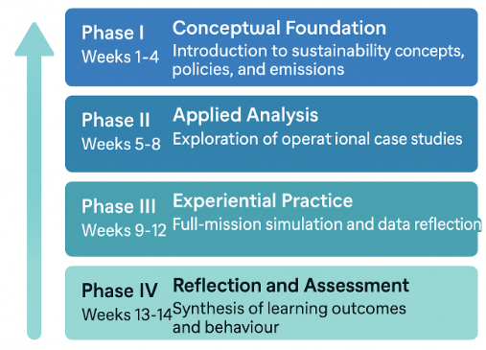
Figure 4.1. Four-Phase Design of the 14-Week HEI Module

4.1.5 Course Catalogue Architecture

The HEI Course Catalogue provides a unified academic framework consisting of four interrelated module clusters:
- Foundations of Sustainable Maritime Operations – Environmental economics, GHG accounting, and international regulation.
- Digitalisation and Data-Driven Port Management – Port digital twins, IoT monitoring, predictive analytics.
- Behavioural Dimensions of Navigation and Leadership – COM-B applications, situational awareness, human-factor analysis.
- Innovation and Policy Integration – ESG metrics, EU taxonomy, and strategic transition planning.
Each module cluster supports cognitive, technical, and motivational development and can operate independently or as part of an integrated degree pathway. The catalogue is designed for interoperability, enabling mutual recognition among partner universities.

4.1.6 Pedagogical Implementation

Pedagogy within the HEI stream blends cognitive and experiential approaches. The following instructional elements ensure balanced development of knowledge, skills, and behaviour:
- Flipped-classroom preparation, where students access micro-lectures and digital readings before seminars;
- Interactive workshops using real case data from WP3;
- Simulator-based tasks replicating port manoeuvres and emission-efficiency scenarios;
- Reflective journaling, guiding students to link learning with behavioural self-assessment;
- Collaborative project work, fostering multidisciplinary problem-solving.
This integration transforms traditional lecture-based delivery into an active learning environment that promotes decision-making autonomy and sustainability awareness.

4.1.7 Assessment and Feedback
Assessment is designed to verify not only knowledge retention but also behavioural transformation. It includes:
- Formative assessment – short quizzes and in-class problem-solving tasks;
- Performance-based assessment – evaluation of simulation exercises using emission and safety indicators;
- Reflective assessment – learning portfolios and essays connecting COM-B dimensions with professional ethics.
Feedback loops are embedded through LMS dashboards and instructor debriefings, supporting continuous learner improvement.

4.1.8 Quality Assurance and Validation
All HEI modules adhere to the ENQA (2015) Standards and Guidelines for Quality Assurance in the European Higher Education Area (ESG). Validation occurred in three stages:
- Internal peer review among consortium universities to ensure academic rigour;
- External consultation with representatives of the European Tugowners Association (ETA) and the European Maritime Pilots’ Association (EMPA);
- Compliance check with IMO STCW competency tables relevant to navigation and port operations.
Continuous monitoring through student surveys and examiner reports guarantees transparency and improvement.

4.1.9 Expected Outcomes and Impact

The HEI learning stream is expected to yield:
- Cognitively equipped graduates who understand the environmental, operational, and digital dimensions of maritime sustainability;
- Behaviourally competent professionals capable of making evidence-based, low-emission decisions;
- Institutional enhancement, as partner universities embed sustainability and behavioural science into their curricula;
- Vertical knowledge transfer to VET and TTT streams, enabling coherence across all training levels.

4.1.10 Summary
The HEI methodology demonstrates how higher education can act as the catalyst for systemic change in maritime learning. Through a 14-week modular structure, blended pedagogy, and COM-B-aligned assessment, the stream bridges theoretical knowledge and behavioural competence. It offers a reproducible academic model for port-related sustainability training that directly informs vocational and professional upskilling across Europe.

4.2 Methodology per Learning Stream – Vocational Education and Training (VET)

4.2.1 Introduction

The Vocational Education and Training (VET) learning stream of the GREENPORT Project operationalises the behavioural and pedagogical principles formulated in the Higher Education (HEI) stream. Its purpose is to translate the theoretical understanding of sustainable port operations into hands-on competencies, professional habits, and measurable performance improvements for maritime practitioners.
This stream specifically targets pilots, tug masters, engineers, port operators, and terminal supervisors whose real-time decisions directly affect the environmental footprint of port operations. Their actions determine fuel consumption, emissions, and safety margins. Consequently, the VET methodology recognises that behavioural change at the operational level—not only technological innovation—is essential for achieving the emission-reduction targets of the European Green Deal, Fit for 55, and the FuelEU Maritime Regulation.
In this context, the VET stream functions as the bridge between academic research and industry application. It is informed by the empirical evidence collected in WP 2 (Needs Analysis) and the eighteen case studies under WP 3, which revealed a consistent demand for short, intensive, and experiential training focused on sustainable manoeuvring, energy efficiency, and digital awareness in port services.

4.2.2 Methodological Foundations

The VET methodology builds on a behaviourally anchored and practice-oriented framework that ensures immediate applicability in professional settings. It is underpinned by four complementary foundations:
- Behavioural Anchoring through COM-B
The Capability–Opportunity–Motivation → Behaviour (COM-B) model serves as the conceptual foundation for defining learning objectives and expected behavioural outcomes. In the VET context, “capability” equates to technical and procedural skills; “opportunity” involves the operational environment and teamwork; and “motivation” refers to professional attitudes toward safety, efficiency, and sustainability.
- Competence-Based Training Standards
Learning outcomes are aligned with the European Credit System for Vocational Education and Training (ECVET) and reflect the European Qualifications Framework (EQF Levels 5–6). This ensures transferability and recognition across national maritime training systems.
- Simulation-Centred Experiential Learning
Participants learn by performing realistic operations in bridge, tug, and port-management simulators. This practical immersion allows observation of how small behavioural adjustments—such as coordinated tug thrust, reduced engine revs, or optimised approach angles—produce measurable fuel and emission savings.
- Industry Co-Creation and Validation
Course design and validation involve ongoing collaboration with industrial partners such as the European Tugowners Association (ETA) and the European Maritime Pilots’ Association (EMPA). Their continuous feedback guarantees that learning activities correspond to actual workplace challenges.

4.2.3 Course Design Logic
The VET course is designed as a two-day, high-intensity training programme delivered in modular format. Although short in duration, it mirrors the four-phase learning logic of the HEI 14-week model, compressing conceptual instruction and experiential application into an accelerated professional cycle. Table 5 below presents a structured overview of how the COM-B dimensions are translated into concrete educational elements across the three learning streams within the GREENPORT methodology. The table illustrates the alignment between behavioural determinants, learning objectives, instructional approaches, and assessment methods, highlighting how a shared conceptual framework is adapted to different educational and professional contexts. Rather than prescribing uniform solutions, Table 5 demonstrates how capability, opportunity, and motivation are addressed through differentiated pedagogical strategies in HEI, VET, and Train-the-Trainer formats. This comparative view supports methodological coherence while allowing flexibility in course design and delivery.

Table 5
Phase | Duration | Primary Focus | Representative Activities
I. Contextual Awareness | ½ day | Understanding regulatory drivers (EU ETS, FuelEU Maritime) and the environmental cost of port operations. | Facilitated discussion on recent incidents; baseline self-assessment of emission awareness.
II. Applied Analysis | ½ day | Identifying inefficiencies and behavioural factors affecting fuel use and safety. | Group work analysing GREENPORT case studies (hybrid tugs, cold-ironing practices).
III. Experiential Simulation | 1 day | Practising manoeuvres with energy-efficiency metrics integrated into simulator dashboards. | Paired simulation runs; quantitative feedback on fuel consumption and emissions.
IV. Reflection and Behavioural Consolidation | ½ day | Synthesising lessons learned and setting action plans for workplace application. | Guided reflection sessions; peer feedback; personal commitment statements.
The course balances cognitive input (20 %), practical simulation (60 %), and reflective consolidation (20 %). Its modularity allows adaptation to different port contexts or national training frameworks.

4.2.4 Learning Content and Pedagogical Design
The VET modules combine technical precision with behavioural awareness, focusing on concrete operational themes:
- Energy-Efficient Manoeuvring – managing thrust, rudder angles, and power distribution to minimise emissions without compromising safety;
- Emission Measurement and Documentation – using onboard monitoring tools and digital dashboards for CO₂, NOₓ, and SOₓ tracking;
- Collaborative Decision-Making – enhancing coordination between pilots and tug masters during high-risk operations;
- Human Factors in Port Operations – identifying fatigue, miscommunication, or automation over-reliance as behavioural barriers to efficiency.
Pedagogically, the programme applies the experiential learning cycle: experience → reflection → conceptualisation → application. Each exercise concludes with structured debriefings facilitated by instructors trained in behavioural observation.

4.2.5 COM-B Application in the VET Context
Within the VET stream, the COM-B model is operationalised as a diagnostic and motivational tool rather than a theoretical construct.
- Capability (C): achieved through targeted demonstrations, simulator coaching, and problem-solving workshops;
- Opportunity (O): created by realistic simulation environments and teamwork scenarios that replicate port constraints;
- Motivation (M): reinforced by feedback that quantifies performance improvements—reduced engine load, lower emissions, shorter manoeuvre times—and by peer recognition during debriefs.
Participants are encouraged to see themselves as active agents of change, not passive operators. The behavioural reinforcement mechanism is further supported by short digital follow-up modules accessible through the GREENPORT LMS platform.

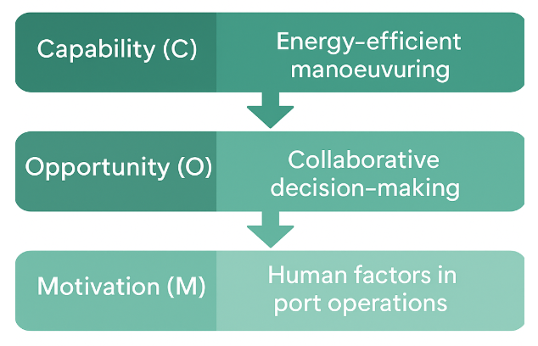
Figure 4.2. Mapping of VET Learning Objectives to COM-B Dimensions

4.2.6 Assessment and Evaluation Strategy

The VET assessment framework measures both operational proficiency and behavioural adaptation. Evaluation instruments are designed to capture change over a short time span and to provide actionable insights for workplace integration.
- Pre-Training Diagnostic Survey – assesses baseline awareness of sustainability practices.
- Simulator-Based Observation – records fuel consumption, course accuracy, and response time during manoeuvres.
- Reflective Learning Sheets – used after each simulation cycle to identify personal areas for behavioural improvement.
- Post-Training Review – includes a structured debriefing and completion of a “behavioural change checklist” linked to COM-B indicators.
Data from these tools are anonymised and aggregated to feed into the GREENPORT evaluation framework, allowing comparison across different partner institutions and training cohorts.

4.2.7 Quality Assurance and Continuous Improvement

Quality assurance for the VET stream is governed by a dual mechanism combining institutional oversight and industrial validation. NVNA, as WP 4 leader, coordinates a central quality register in cooperation with MAR.TE Logistics, documenting each course iteration, participant feedback, and simulator performance trends.
Continuous improvement is ensured by:
- Annual calibration meetings among instructors to harmonise simulation parameters and debriefing standards;
- Integration of new case studies reflecting evolving emission-reduction technologies;
- Benchmarking against EU frameworks such as EQAVET (European Quality Assurance Reference Framework for VET).
This dynamic feedback system guarantees that VET training remains responsive to technological change and behavioural evidence.

4.2.8 Outcomes and Behavioural Impact

Expected results of the VET learning stream extend beyond skill acquisition to observable behavioural transformation. Key outcomes include:
- Operational improvements: consistent reduction of fuel use per manoeuvre cycle and improved precision of tug coordination;
- Behavioural awareness: enhanced understanding of how individual actions affect collective emission levels;
- Cultural reinforcement: development of a sustainability mindset within port teams, sustained by peer influence and managerial support;
- Organisational integration: adoption of emission-monitoring checklists and eco-efficiency reporting as standard procedures.
The measurable impact of these outcomes contributes directly to the GREENPORT performance indicators under WP 5 (Evaluation) and WP 6 (Dissemination).

4.2.9 Summary

The VET methodology demonstrates how behavioural theory can be transformed into operational excellence. By combining simulation-based learning, COM-B-driven behavioural diagnostics, and evidence-based feedback, the programme establishes a replicable model of industry training that is practical, scalable, and measurable.
It ensures that the GREENPORT initiative does not remain confined to academic discourse but manifests in the daily conduct of maritime professionals whose choices shape the environmental and safety performance of European ports. In this way, the VET stream stands as the operational core of the project’s behavioural transformation mission, anchoring sustainability within the very routines of port operations.

4.3 Methodology per Learning Stream – Train-the-Trainer (TTT)

4.3.1 Introduction

The Train-the-Trainer (TTT) learning stream represents the pedagogical consolidation stage of the GREENPORT Project. Its overarching purpose is to empower maritime educators, instructors, and industry mentors with the knowledge, digital tools, and behavioural methodologies required to sustain the project’s educational and operational outcomes beyond its formal duration.
While the Higher Education (HEI) stream focuses on conceptual understanding and the Vocational Education and Training (VET) stream on operational application, the TTT stream targets those responsible for bridging education with practice. These include lecturers at maritime academies, simulator instructors, company training officers, and professionals from port service providers.
In essence, the TTT stream transforms trainers into multipliers of behavioural change, ensuring that sustainability, efficiency, and digitalisation become permanent fixtures of maritime training culture.

4.3.2 Methodological Foundations
The TTT methodology integrates insights from educational psychology, adult learning theory, and digital pedagogy into a unified framework for behavioural instruction in maritime contexts. It draws upon three conceptual pillars:
- Behavioural Science Application – The COM-B model (Capability, Opportunity, Motivation → Behaviour) provides a behavioural map for trainers to design learning environments that stimulate long-term behavioural adaptation rather than short-term skill acquisition.
- Pedagogical Competence Development – Grounded in andragogical principles, the TTT programme strengthens trainers’ ability to facilitate learning among experienced maritime professionals by using problem-centred, discussion-based, and experience-driven methods.
- Digital and Simulation-Based Facilitation – Trainers learn to integrate modern e-learning tools, learning management systems (LMS), and simulation platforms into blended course designs that promote active learner engagement and immediate feedback.
Together, these three pillars create a methodological continuum that mirrors the operational realities of ports and shipping but framed through a pedagogical lens of behavioural transformation.
The methodological foundations of the GREENPORT project are structured as a layered framework that integrates behavioural science, pedagogical theory, and policy alignment. At the conceptual level, the COM-B model provides a unifying behavioural reference, while its interpretation and application are adapted to the cognitive, operational, and pedagogical characteristics of the HEI, VET, and Train-the-Trainer streams respectively.
These foundations are operationalised through competence-based and adult-learning principles, ensuring that learning outcomes are measurable, context-sensitive, and aligned with European qualification frameworks.
Importantly, the methodological foundations do not prescribe uniform educational solutions.
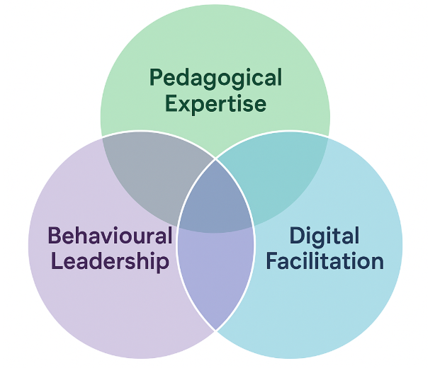
Figure 4.3. Domains of Competence in the TTT Methodology: Pedagogy, Behaviour, and Digital Facilitation

4.3.3 Behavioural and Pedagogical Framework
The behavioural dimension of the TTT methodology positions trainers as both role models and facilitators of change. Each training intervention is structured to achieve dual outcomes: professional competence (what trainers teach) and behavioural exemplarity (how they teach).
The framework is built on three progressive stages that align with Kolb’s (1984) experiential learning cycle (Fig.4.3):
Table 6
Stage | Focus | Illustrative Activities
I. Awareness and Reflection | Trainers analyse their own teaching behaviours and identify barriers to sustainability-oriented training. | Diagnostic self-assessment, peer reflection, review of COM-B mapping exercises.
II. Application and Facilitation | Trainers apply new methods using real or simulated teaching sessions, integrating behavioural cues and digital learning strategies. | Design of interactive lessons, LMS-based formative assessments, simulator instruction labs.
III. Evaluation and Leadership | Trainers evaluate outcomes, model sustainable teaching behaviour, and mentor others. | Peer observation, behavioural feedback, creation of continuous improvement plans.
Each stage includes feedback loops, encouraging trainers to adapt their instructional methods through reflection, dialogue, and digital observation analytics.
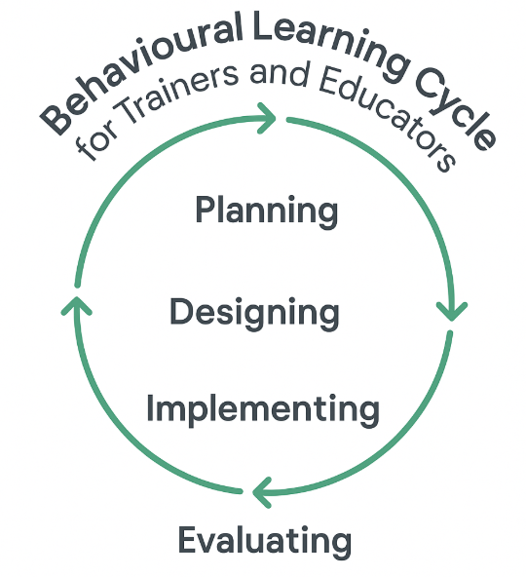
Figure 4.4. Behavioural Learning Cycle for Trainers and Educators

4.3.4 Integration of the COM-B Model in Trainer Development

The COM-B framework is operationalised in the TTT methodology as a pedagogical design matrix, linking trainer competencies with learner outcomes:
- Capability (C): Trainers acquire instructional design and digital facilitation skills—how to plan, deliver, and evaluate learning experiences through simulation and digital environments.
- Opportunity (O): Trainers learn to create psychologically safe and supportive classrooms, using LMS tools to personalise learning and enable collaborative activities.
- Motivation (M): Trainers are encouraged to cultivate intrinsic motivation by connecting sustainability with professional identity and pride in maritime stewardship.
This mapping transforms the trainer into a behavioural architect, capable of shaping both the content and the learning environment to achieve targeted behavioural outcomes among participants.

4.3.5 Digital Learning Infrastructure
A defining element of the TTT methodology is the integration of digital tools that extend learning beyond the physical classroom. The GREENPORT e-learning environment, built upon a modern LMS infrastructure, allows trainers to:
- design interactive multimedia modules, incorporating video briefings, infographics, and quizzes;
- host discussion forums and digital reflection journals to support asynchronous peer learning;
- access simulation exercises through virtual or hybrid interfaces;
- collect learner analytics (participation rates, completion statistics, quiz performance) to evaluate training effectiveness.
The platform also includes repositories for HEI, VET, and TTT learning materials, ensuring interoperability and continuous content updates. The use of blended digital formats reflects the EU’s Digital Education Action Plan and reinforces the principle that digitalisation and decarbonisation are pedagogically interdependent.

4.3.6 Pedagogical Implementation
The pedagogical implementation of the Train-the-Trainer (TTT) stream transforms the abstract principles of behavioural science and digital facilitation into practical instructional strategies that can be adopted, replicated, and scaled across Europe’s maritime education ecosystem. It provides trainers not only with the content and digital resources to teach sustainability but also with the pedagogical awareness to shape learner attitudes, behaviours, and professional values.
The TTT pedagogical model applies a three-layered implementation structure—micro, meso, and macro—each corresponding to a distinct sphere of trainer influence and institutional transformation. These layers are interconnected through continuous reflection, peer collaboration, and data-driven feedback gathered via the GREENPORT LMS.

Micro-Level: Individual Trainer Development
At the micro level, the TTT programme focuses on personal mastery and reflective competence. Trainers engage in an experiential learning cycle—observe → reflect → reconstruct → apply—designed to deepen both pedagogical and behavioural insight. Each participant begins as a learner within simulation-based lessons and then analyses how facilitation, feedback, and motivation shape behavioural outcomes.

Key activities include:
- Interactive online modules introducing the COM-B framework, digital pedagogy, and feedback design;
- Guided self-analysis of teaching styles through video-recorded sessions and peer comments;
- Micro-teaching exercises where trainers practise short instructional sequences that incorporate behavioural reinforcement techniques (e.g., goal framing, positive feedback, reflective questioning);
- Mentorship and feedback dialogues, aligning self-reflection with external observations.
This layer builds pedagogical capability—the foundation of professional identity for a sustainability-oriented educator. Trainers learn to see each lesson not simply as a transfer of knowledge, but as a behavioural intervention aimed at influencing motivation and decision-making.

Meso-Level: Institutional Adoption and Integration
At the meso level, pedagogical implementation transitions from individual development to institutional embedding. Partner academies and training centres pilot the TTT modules within their internal instructor qualification schemes, simulation courses, and continuing professional-development programmes.
Key elements include:
- Curriculum alignment workshops where institutional representatives adapt the GREENPORT TTT model to their local standards (credit systems, qualification frameworks, simulator types);
- Co-teaching sessions pairing certified trainers with junior instructors to reinforce mentoring and knowledge transfer;
- Shared resource repositories hosted on the LMS, including standardised lesson plans, assessment rubrics, and behavioural evaluation templates;
- Institutional reflection seminars, analysing aggregated learning data to identify improvement areas and integrate sustainability goals into internal quality-assurance systems.
Through these activities, institutions evolve into learning organisations capable of maintaining behavioural training capacity independently. The process reflects organizational learning theory (Argyris & Schön, 1996): feedback from implementation informs policy, governance, and curriculum renewal, creating a sustainable feedback cycle between trainers, learners, and management.

Macro-Level: Network Integration and European Collaboration
The macro level represents the strategic dimension of pedagogical implementation—cross-institutional collaboration and transnational scaling. It ensures that the behavioural training model disseminates beyond the initial consortium and remains adaptable to evolving technological and regulatory contexts.
Core mechanisms include:
- European Trainer Network, coordinated through the GREENPORT LMS, enabling knowledge sharing, peer review, and collaborative content creation;
- Annual multiplier events and staff-week activities, where trainers exchange best practices and showcase innovations in digital behavioural pedagogy;
- Inter-project cooperation with other Erasmus+ initiatives focusing on maritime sustainability, digitalisation, and human factors;
- Continuous policy dialogue linking educational outcomes with EU and IMO regulatory frameworks, ensuring that pedagogical design remains aligned with the Green Deal and Fit for 55 targets.
At this level, trainers become ambassadors of change, contributing to a unified European maritime training identity that prioritises sustainability and human-centred digitalisation.

4.3.7 Pedagogical Strategies and Learning Methods
Across all levels, the TTT methodology employs a blend of constructivist and experiential learning approaches, tailored for adult learners with professional experience. The following strategies define its instructional identity:
- Scenario-Based Learning: Trainer’s design and facilitate complex maritime scenarios that encourage problem-solving, ethical reasoning, and decision-making under uncertainty.
- Collaborative Reflection: Post-scenario debriefs prompt participants to analyse the behavioural and cognitive processes behind actions, guided by structured reflection templates.
- Simulation Pedagogy: Trainers learn to use simulators not merely as technical tools, but as behavioural laboratories where capability, opportunity, and motivation interact visibly.
- Blended and Hybrid Learning: Digital modules, live sessions, and asynchronous discussions combine to create flexible learning pathways accessible to trainers across different time zones and institutions.
- Feedback Literacy: Emphasis is placed on giving and receiving feedback that targets behaviour, not personality—reinforcing reflective practice and continuous improvement.
These methods embody the transition from content-centred teaching to learner-centred facilitation, where trainers orchestrate learning experiences that evoke commitment and responsibility toward sustainable maritime practices.

4.3.8 Behavioural Impact of Pedagogical Implementation

The success of pedagogical implementation is measured not only by trainers’ mastery of teaching techniques but by their ability to stimulate observable behavioural shifts among their learners.
Evaluation data from pilot courses demonstrate improved use of behavioural cues (e.g., verbal reinforcement, scenario reframing, reflective questioning), increased motivation toward environmental objectives, and enhanced confidence in using digital learning platforms. The ultimate pedagogical impact is achieved when trainers internalise the principle that teaching sustainability is itself a behavioural act—an iterative, reflective, and relational process in which both trainer and learner continuously evolve.

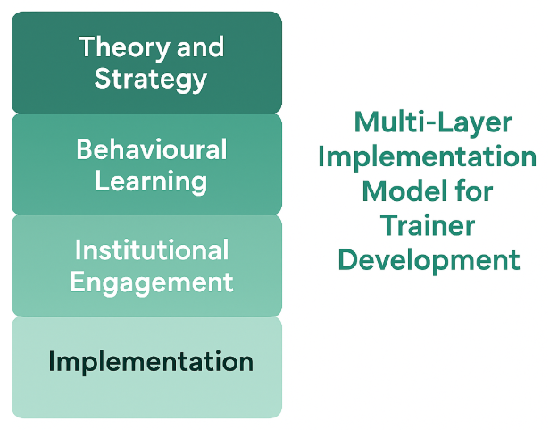
Figure 4.5 Multi-Layer Implementation Model for Trainer Development

4.3.9 Assessment and Certification

Evaluation of trainers focuses on teaching performance, behavioural modelling, and digital competence rather than mere content mastery.
Assessment components include:
- Teaching Simulation: Trainers conduct short sessions integrating sustainability topics and behavioural feedback methods.
- E-Learning Module Design: Development of an online lesson using COM-B-aligned activities and interactive assessments.
- Reflective Teaching Journal: Trainers document behavioural insights gained during instruction and identify strategies for improvement.
- Peer Review and Mentorship: Trainers assess each other’s instructional methods using shared behavioural rubrics.
Successful trainers are awarded the GREENPORT Trainer Certificate, co-endorsed by consortium partners. This certification validates their ability to design, deliver, and evaluate sustainability-oriented maritime education at multiple levels.

4.3.10 Quality Assurance and Continuous Improvement

The TTT methodology incorporates a dynamic quality-assurance system aligned with the European Quality Assurance Reference Framework for VET (EQAVET) and the ENQA Standards for Higher Education.
Quality management is ensured through:
- LMS-based feedback collection, enabling real-time monitoring of participant satisfaction and learning progress;
- Peer moderation sessions, where senior trainers review session plans and outcomes;
- Annual methodological audits, assessing alignment between behavioural goals, pedagogical approaches, and course delivery.
Continuous improvement mechanisms guarantee that new technologies (e.g., AI-assisted simulation, remote navigation labs) and regulatory developments (e.g., updated EU ETS guidelines) are integrated into the training design.

4.3.11 Expected Outcomes and Long-Term Impact
The expected impact of the TTT learning stream extends beyond the professional upskilling of trainers to the systemic transformation of maritime education. The programme cultivates:
- A transnational community of certified GREENPORT trainers, capable of disseminating sustainable practices across Europe’s port systems;
- Institutional capacity for innovation, through integration of digital pedagogy and behavioural science into academic standards;
- Enhanced teaching quality, reflected in learner engagement and measurable behavioural outcomes;
- Cultural reinforcement, as sustainability becomes embedded in training philosophy and institutional mission statements.
Ultimately, the TTT stream ensures that the methodologies developed in GREENPORT are self-propagating, continuing to influence maritime training systems well beyond the project’s formal timeline.

4.3.12 Summary
The Train-the-Trainer methodology transforms instructors into strategic enablers of behavioural change within the maritime sector. By merging the COM-B model, digital learning innovation, and experiential pedagogy, it creates a pedagogical architecture that is flexible, scalable, and future-ready.
As the final tier of the GREENPORT learning ecosystem, the TTT stream ensures that every module, lesson, and simulator scenario across the project is supported by skilled educators who can sustain behavioural, environmental, and operational excellence across Europe’s ports.

Chapter 5 – Integration, Evaluation, Dissemination and Sustainability

5.1 Introduction

The final chapter of this Methodology Report brings together all components of the GREENPORT project’s educational innovation.
Through the development of three complementary learning streams — Higher Education (HEI), Vocational Education and Training (VET), and Train-the-Trainer (TTT) — Work Package 4 (WP4) established a holistic model for cultivating sustainable behaviours across maritime professions. While the previous chapters examined each stream separately, this concluding section describes how they function as parts of a single learning ecosystem. It explains how the courses connect, how they are evaluated and improved, and how their outcomes are disseminated and sustained beyond the project’s lifetime.
The overarching aim is to demonstrate that behavioural change, once rooted in structured learning, can evolve into a culture of sustainability across ports, shipping companies, and training institutions.

5.2 Integration Across Learning Streams
Conceptual Integration
From the earliest stages of WP4, the team envisioned the three learning streams not as isolated deliverables but as interdependent layers of a unified behavioural model.
The HEI stream develops the theoretical and analytical foundation for understanding environmental challenges in maritime transport.
The VET stream translates this knowledge into practical action through real-world and simulator-based experiences. The TTT stream completes the cycle by preparing trainers capable of reinforcing and replicating behavioural learning across institutions. Together, they form what the project terms the Behavioural Learning Continuum — a dynamic pathway where knowledge becomes competence, and competence becomes leadership.
This continuum (Fig. 5.1) ensures that the principles of sustainability, initially explored in university classrooms, are applied in port operations and then propagated through training centres and maritime academies.
Functional Integration
Integration in GREENPORT is achieved through common design logic and shared pedagogical language.
Each stream uses the COM-B framework — Capability, Opportunity, Motivation → Behaviour — as its behavioural compass.
The same port case studies are adapted at different cognitive and professional levels:
  - In HEI courses, students analyse emission-reduction strategies conceptually.
  - In VET courses, pilots and tug masters apply them in simulations and practical workshops.
  - In TTT modules, instructors learn how to teach these behaviours, guiding others toward sustainable habits.

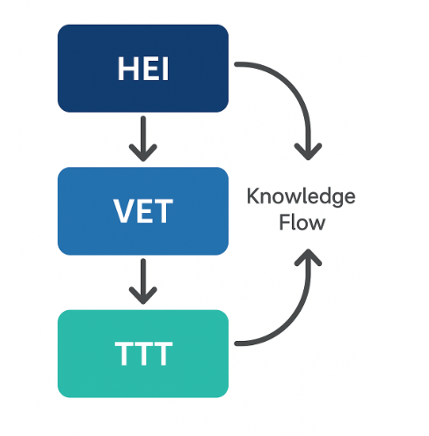

Figure 5.1: A three-tiered diagram showing the GREENPORT Learning Continuum HEI

This cross-stream coherence creates a sense of continuity for both learners and institutions. Whether analysing an LNG-powered tug operation in a classroom or executing it in a simulator, participants are guided by the same behavioural principles.
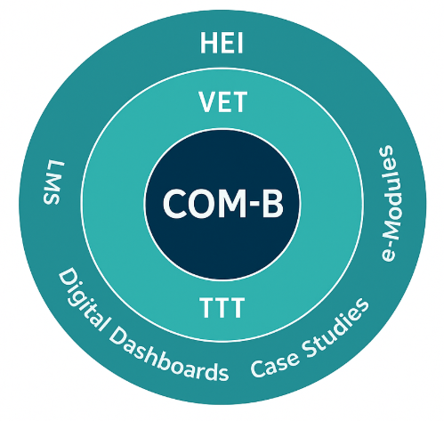

Figure 5.2 A model linking COM-B components with educational stages and digital tools.

Behavioural and Cultural Integration
Integration in GREENPORT also occurs at the level of culture and identity.
By working with different learner profiles — from cadets and university students to experienced pilots and port trainers — the project recognises that behavioural change must occur at multiple layers of the maritime profession.
Every actor in the system influences others: a student who learns to question unsustainable routines, a pilot who models fuel-efficient manoeuvring, or a trainer who frames every decision within environmental impact.
The project thereby establishes a shared professional ethos that merges operational excellence with environmental responsibility.
Over time, this interconnectedness is expected to lead to a cultural transformation in how port operations are perceived and performed.

5.3 Evaluation and Assessment

The Evaluation Framework in WP4 is not treated as a final measurement but as an ongoing reflective process accompanying every stage of learning.
It ensures that the training achieves both its educational objectives and its behavioural goals. The framework is built around four core dimensions — relevance, effectiveness, efficiency, and sustainability — mirroring the European Quality Assurance in Vocational Education and Training (EQAVET) model and the Erasmus+ results framework. Each dimension aligns with a specific question:

Relevance: Does the course respond to real port-industry needs?

Effectiveness: Are learners demonstrating behavioural change and improved decision-making?

Efficiency: Are time and resources optimally used to achieve measurable results?

Sustainability: Can the developed methods continue beyond the project and adapt to new challenges?

Evaluation results are derived from surveys, observation reports, simulator analytics, and participant reflections.
The combination of quantitative and qualitative evidence provides a balanced understanding of learning outcomes.

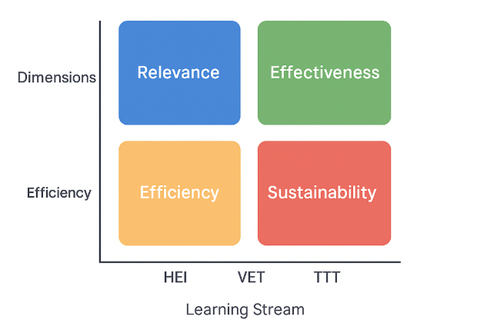
Figure 5.3 – Evaluation Framework of WP4

Assessment Philosophy
Assessment within GREENPORT moves beyond traditional testing. It focuses on behavioural performance, team communication, and reflective capacity.
For HEI learners, assessment includes research projects and sustainability analyses; for VET participants, it involves observed simulator exercises and structured debriefings; for TTT trainees, it consists of designing and facilitating short learning sessions that reflect behavioural principles.
In all cases, assessment is formative and participatory. Learners are encouraged to analyse their own decisions and to discuss them openly with peers and facilitators. This practice nurtures a learning culture in which mistakes are treated not as failures but as opportunities to refine professional judgement. The ultimate goal of assessment is to determine whether participants can translate awareness into behaviour — whether they act differently after understanding the environmental implications of their decisions.

Feedback and Validation
Feedback in GREENPORT operates at three levels. At the individual level, each learner receives structured debriefing based on simulator data or course assignments, helping them see their progress through objective evidence. At the course level, peer and trainer reviews support mutual learning and calibration of instructional approaches. At the institutional level, the consortium partners exchange feedback to validate outcomes and ensure consistency across countries.

Validation also involves external stakeholders, including port authorities and industry representatives, who review the practical relevance of training content. Through this iterative process, evaluation becomes a living mechanism for quality improvement.

5.4 Impact of the Project

Educational Transformation
The GREENPORT project demonstrates that when behavioural science is systematically integrated into maritime education, it can profoundly transform how future officers, engineers, and port operators think and act.
Students no longer perceive sustainability as an external policy requirement but as an integral part of professional competence.
Learning shifts from absorbing information to reflecting on practice — from knowing what to do, to understanding why and how behaviour matters.
Across partner institutions, the adoption of case-based and simulation-supported methods has led to curricula that are more interactive, evidence-driven, and behaviour-focused. This marks a shift from traditional maritime education, centred on technical proficiency, toward education for adaptive leadership in sustainable operations.

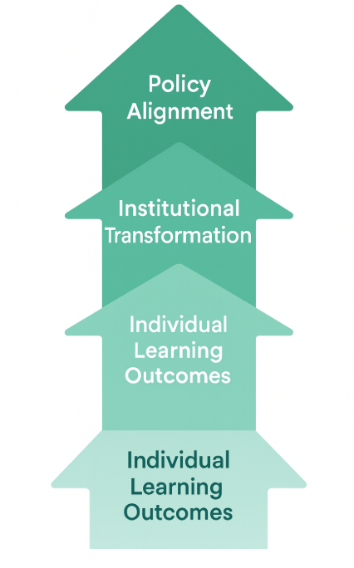

Figure 5.4 – Impact Pathway of GREENPORT

Institutional and Industrial Impact
The influence of GREENPORT extends far beyond classrooms. Participating institutions have revised internal quality assurance systems, introducing sustainability and behavioural competence as explicit learning outcomes. Port companies that participated in the pilot sessions have already started embedding behavioural checklists and feedback tools in their internal training. By linking education with operational reality, the project builds a bridge between policy ambition and daily maritime practice. This connection contributes directly to the EU Green Deal, Fit for 55, and the IMO GHG Strategy by equipping professionals with the behavioural and digital skills necessary to reduce emissions in port environments.

5.5 Dissemination of Results

Dissemination Philosophy
Dissemination within GREENPORT is understood as knowledge sharing with purpose. Rather than being limited to the presentation of results, it is seen as an act of community building — a means of extending the project’s behavioural philosophy across Europe’s maritime and logistics sectors.
The consortium designed a multi-layered dissemination strategy combining academic visibility, industry outreach, and digital presence.
It included the creation of newsletters, public workshops, multiplier events, and international conference sessions, as well as a robust online presence through the GREENPORT e-learning platform.
Through these activities, the project ensures that every target group — students, seafarers, trainers, policy-makers — can access, use, and adapt the developed resources.

Partner Roles in Dissemination
Each consortium partner played a defined role. NVNA coordinated the academic presentations and hosted the first Erasmus+ Staff Week; ETA engaged directly with port companies to promote VET results; the University of Rijeka integrated GREENPORT outcomes into higher education curricula.
This distributed model combines diversity of audiences with unity of message — showing that sustainability is not confined to one maritime domain but shared across Europe’s port ecosystem.

5.6 Sustainability and Continuity

Educational Sustainability
Sustainability begins with ownership. All developed materials — course syllabi, simulation scenarios, instructor guides — are designed as open educational resources available for further use and adaptation.
Partners have committed to maintaining these materials on institutional servers and within the GREENPORT digital platform, ensuring that the project continues to generate impact after funding ends. The three streams also create self-sustaining loops: HEI produces graduates who later join the VET and TTT target groups; VET courses train industry professionals who later contribute to teaching; and TTT graduates maintain the continuity of the pedagogical approach across institutions.

Industrial and Policy Sustainability
For the maritime industry, sustainability lies in embedding behavioural awareness into operational standards.
The involvement of pilots, tug masters, and port operators ensures that learning outcomes translate into measurable efficiency and emission improvements.
At policy level, the project aligns with the European Skills Agenda, the Digital Education Action Plan, and the EU Maritime Transport Strategy 2050. Its methodology provides a tested blueprint for integrating behavioural science into vocational and higher education across the EU.

5.7 Recommendations for Future Development

Building on the integration and evaluation results, several directions are proposed for the continued evolution of the GREENPORT approach:

Institutional embedding: Encourage maritime academies and port training centres to adopt GREENPORT modules as accredited courses.

Shared digital simulation library: Develop a European repository of port sustainability simulation scenarios accessible through the e-learning platform.

Micro-credentialing: Introduce short certification courses recognised across EU maritime education systems.
Cross-sectoral adaptation: Extend behavioural learning principles to other transport sectors such as inland waterways and logistics hubs.
Ongoing evaluation: Establish a monitoring mechanism to measure behavioural and emission impacts at regular intervals after project completion.

These steps would ensure that GREENPORT remains a living, evolving model — continuously generating knowledge, competence, and measurable environmental benefit.

5.8 Conclusion

GREENPORT concludes with a vision of maritime education that unites human behaviour, digital innovation, and sustainability policy.
The project demonstrates that emission reduction and environmental stewardship begin with the way people think, decide, and cooperate.
Through its integrated approach, WP4 has developed a replicable model where theory informs practice, practice transforms behaviour, and behaviour reshapes culture.

The project’s legacy is therefore not only a set of courses, reports, or digital tools — but a new professional mindset across Europe’s ports:
a mindset in which every pilot, student, and trainer recognises their capacity to influence the planet’s maritime future.

5.9 Acknowledgements

The authors of this Methodology Report gratefully acknowledge the commitment, collaboration, and expertise of all partner institutions participating in the GREENPORT Project (Grant Agreement No. 101139879, ERASMUS-EDU-2023-PI-ALL-INNO). The project has been developed through the collective efforts of academic, industrial, and professional partners who have contributed their knowledge, experience, and vision to create an integrated educational framework for sustainable port operations.

The consortium expresses its deepest appreciation to Piri Reis University (Türkiye), the Project Coordinator, for its strategic leadership, administrative guidance, and continuous coordination of all work packages. Through its commitment to excellence and cooperation, PRU ensured the project’s coherence, timely implementation, and alignment with the overall objectives of the Erasmus+ Alliances for Innovation initiative.

Special thanks are extended to the European Tug owners Association (ETA) for conducting the industry needs survey, which provided essential data on the skills, awareness, and training requirements of tug masters and engineers, forming a foundation for the design of the VET learning stream and the behavioural focus of the project. Our appreciation and thanks go again to the European Maritime Pilots’ Association (EMPA) for providing critical professional insights and for supporting the elaboration of VET course content, case studies, and simulation exercises that directly address the needs of port pilots and tug masters.

MAR.TE Logistics (Italy) are acknowledged for their essential role in linking educational innovation to port-industry realities, contributing expertise in sustainable operations, emissions monitoring, and digital port management. Their guidance ensured that the developed training materials remain operationally relevant and aligned with industry practices.

Our sincere appreciation goes to the Constanţa Maritime University (Romania) and University of Rijeka (Croatia) for their academic leadership in the development of the VET course materials and expected validation of the competence-based framework through pilot implementation in higher-education environments. This recognition extends also to the Antwerp Maritime Academy (Belgium),) for their contribution to the pedagogical and methodological validation of the Train-the-Trainer course, especially in relation to digital learning platforms and experiential teaching methods.

The Administration of Port of Aveiro (Portugal) is acknowledged for its invaluable contribution as an industrial and operational partner, providing authentic case studies, data on port energy use and emissions, and expert feedback.

The consortium extends its sincere appreciation to Across Limits Ltd (Malta) for their leadership in digital innovation, dissemination, and exploitation activities. Their expertise in e-learning technologies and communication strategies has been instrumental in transforming the project’s pedagogical outputs into accessible, interactive, and sustainable online learning environments, ensuring the long-term impact and visibility of GREENPORT’s results.

Nikola Vaptsarov Naval Academy further acknowledges the input of all associate partners, industry representatives, and stakeholders from the European ports and maritime communities, whose feedback during surveys, case-study analysis, and piloting activities will shape the content and ensure the practical applicability of the project’s outcomes.

REFERENCES

1. Behavioural Science and Learning Frameworks

- Bandura, A. (1986). Social foundations of thought and action: A social cognitive theory. Englewood Cliffs, NJ: Prentice-Hall.
- Biggs, J., & Tang, C. (2011). Teaching for quality learning at university (4th ed.). Maidenhead: Open University Press.
- Deci, E. L., & Ryan, R. M. (2000). “The ‘what’ and ‘why’ of goal pursuits: Human needs and the self-determination of behavior.” Psychological Inquiry, 11(4), 227-268.
- Kolb, D. A. (1984). Experiential learning: Experience as the source of learning and development. Englewood Cliffs, NJ: Prentice-Hall.
- Michie, S., van Stralen, M. M., & West, R. (2011). “The behaviour change wheel: A new method for characterising and designing behaviour change interventions.” Implementation Science, 6(42), 1–11.
- West, R., Michie, S., Atkins, L., Sharpe, R., & Rubin, G. J. (2020). Achieving behaviour change: A guide for national governments. London: Behavioural Insight Team.
- Wlodkowski, R. J. (2008). Enhancing adult motivation to learn: A comprehensive guide for teaching all adults (3rd ed.). San Francisco: Jossey-Bass.

2. Pedagogical Models and Digital Education

- European Commission. (2020). Digital Education Action Plan (2021–2027): Resetting education and training for the digital age. Brussels: European Commission.
- European Training Foundation (ETF). (2022). Competence-based education and training: European practices and lessons learned. Turin: ETF.
- Garrison, D. R., & Vaughan, N. D. (2008). Blended learning in higher education: Framework, principles, and guidelines. San Francisco: Jossey-Bass.
- Laurillard, D. (2012). Teaching as a design science: Building pedagogical patterns for learning and technology. New York: Routledge.
- OECD. (2021). The state of school education: One year into the COVID pandemic. Paris: OECD Publishing.
- UNESCO. (2023). Guidelines for digital learning ecosystems in technical and vocational education. Paris: UNESCO.

3. European and International Policy Frameworks

- European Commission. (2019). The European Green Deal. COM(2019) 640 final. Brussels: European Commission.
- European Commission. (2021a). Fit for 55 package: Delivering the EU’s 2030 Climate Target on the way to climate neutrality. Brussels: European Commission.
- European Commission. (2021b). FuelEU Maritime Regulation proposal. COM(2021) 562 final. Brussels: European Commission.
- European Commission. (2021c). EU ETS revision for maritime transport. COM(2021) 551 final. Brussels: European Commission.
- European Commission. (2020). European Skills Agenda for sustainable competitiveness, social fairness and resilience. COM(2020) 274 final.
- European Commission. (2023). EU Maritime Transport Strategy 2050: Towards a greener, smarter and more resilient maritime sector. Brussels: European Commission.
- International Maritime Organization (IMO). (2023). 2023 IMO Strategy on Reduction of GHG Emissions from Ships. London: IMO.
- International Maritime Organization (IMO). (2022). Training standards under the STCW Convention, including 2022 amendments. London: IMO.
- United Nations. (2015). Transforming our world: The 2030 Agenda for Sustainable Development. New York: United Nations.

4. Maritime Operations, Port Sustainability, and Digitalisation

- Brynolf, S., Magnusson, M., & Andersson, K. (2021). “Maritime decarbonisation pathways: Technological, operational and behavioural dimensions.” Marine Policy, 132, 104666.
- EMSA – European Maritime Safety Agency. (2022). EMSA outlook on alternative fuels and energy efficiency measures. Lisbon: EMSA.
- European Sea Ports Organisation (ESPO). (2023). ESPO Environmental Report 2023: Port performance and sustainability trends. Brussels: ESPO.
- Lindstad, E., & Buhaug, Ø. (2022). “Operational measures for greenhouse-gas reductions in ports and coastal shipping.” Transportation Research D, 105, 103240.
- MARTE Logistics SRL. (2024). GREENPORT WP2 Industry Report: Emission-reduction case studies in port services. Genoa: MARTE Logistics.
- Nikola Vaptsarov Naval Academy (NVNA). (2025). GREENPORT WP4 Deliverable 4.2: Vocational Education and Training Course Materials. Varna: NVNA.
- Nikola Vaptsarov Naval Academy (NVNA). (2025). GREENPORT WP4 Deliverable 4.3: Train-the-Trainer Course Materials. Varna: NVNA.
- Nikola Vaptsarov Naval Academy (NVNA). (2025). GREENPORT WP4 Deliverable 4.1: Higher Education Course Materials. Varna: NVNA.
- Panagopoulos, I., & Psaraftis, H. N. (2021). “Energy efficiency in port operations: Opportunities for emission reduction.” Maritime Economics & Logistics, 23(4), 620-642.
- Poulsen, R. T., & Johnson, H. (2016). “The logic of green shipping: A sociotechnical systems perspective.” Transportation Research D, 46, 139-151.
- Stopford, M. (2020). Maritime Economics (4th ed.). London: Routledge.

5. Behavioural Training and Simulation Studies

- Chauvin, C., Lardjane, S., Morel, G., Clostermann, J.-P., & Langard, B. (2013). “Human and organisational factors in maritime accidents: Analysis of collisions at sea using the HFACS framework.” Accident Analysis & Prevention, 59, 26-37.
- Grech, M. R., Horberry, T., & Koester, T. (2008). Human factors in the maritime domain. Boca Raton, FL: CRC Press.
- Hetherington, C., Flin, R., & Mearns, K. (2006). “Safety in shipping: The human element.” Journal of Safety Research, 37(4), 401-411.
- Lützhöft, M., & Dekker, S. (2002). “On your watch: Automation on the bridge.” Journal of Navigation, 55(1), 83-96.
- McCafferty, D. B., & Baker, C. C. (2006). Human error and marine safety. Washington, DC: U.S. Coast Guard Research Center.
- Øvergård, K. I., Sorensen, A. J., & Hansen, J. P. (2019). “Simulator-based maritime training for sustainable operations.” WMU Journal of Maritime Affairs, 18(3), 415-432.

6. Quality Assurance, Evaluation, and Sustainability in Education

- European Association for Quality Assurance in Higher Education (ENQA). (2015). Standards and Guidelines for Quality Assurance in the European Higher Education Area (ESG). Brussels: ENQA.
- European Quality Assurance Reference Framework (EQAVET). (2020). Guidelines for implementing quality assurance in VET. Brussels: European Commission.
- Kirkpatrick, D. L., & Kirkpatrick, J. D. (2006). Evaluating training programs: The four levels (3rd ed.). San Francisco: Berrett-Koehler.
- Mulder, M. (2017). Competence-based vocational and professional education: Bridging the world of work and education. Cham: Springer.
- Sterling, S. (2010). “Learning for resilience, or the resilient learner? Towards a necessary reconciliation in a paradigm of sustainable education.” Environmental Education Research, 16(5-6), 511-528.

7 Behavioural Economics and Change Management (Supplementary)

- Kahneman, D. (2011). Thinking, fast and slow. New York: Farrar, Straus & Giroux.
- Thaler, R. H., & Sunstein, C. R. (2008). Nudge: Improving decisions about health, wealth, and happiness. New Haven: Yale University Press.
- OECD. (2019). Tools and ethics for applied behavioural insights: The BASIC framework. Paris: OECD Publishing.

8. Project-Specific and Internal References

- GREENPORT Alliance Consortium. (2023). Grant Agreement No. 101139879 – Annex 1: Description of the Action. Brussels: European Education and Culture Executive Agency (EACEA).
- GREENPORT Alliance Consortium. (2025). Deliverable 2.1: Industry Report and Case Study Compendium. Genoa: MARTE Logistics.
- GREENPORT Alliance Consortium. (2025). Deliverable 4.4: Methodology Report. Varna: NVNA.
- GREENPORT Alliance Consortium. (2025). Project e-Learning Platform: https://greenportalliance.eu

Annex I WP4 Objectives
The main objectives of WP4 (as stated in Annex I of the Grant Agreement) are to:
- Design, develop, and implement the three educational streams that address identified competency gaps and behavioural needs in port decarbonization and sustainable operations:
  - Higher Education (HEI)
  - Vocational Education and Training (VET)
  - Train-the-Trainer (TTT)
- Translate the behavioural findings and key performance indicators (KPIs) from WP2 into measurable learning objectives and outcomes.
- Develop educational materials and training modules that support capacity building for emission reduction, energy efficiency, and digitalization in port operations.
- Pilot and validate the developed programs in collaboration with academic institutions, industry stakeholders, and port service providers.
- Produce a consolidated methodology report (D4.4) that documents the design process, pedagogical principles, and digital tools used across the three learning streams.

Deliverables (as per Grant Agreement Annex I)
Deliverable No. | Title | Lead Partner | Delivery Month | Description
D4.1 | HEI Course Material | NVNA | M22 | Course curriculum and supporting materials for higher education institutions, focused on sustainability and digitalisation in port operations.
D4.2 | VET Course Material | MAR.TE Logistics / ETA | M22 | Vocational training content for pilots, tug masters, and port professionals; practical case studies and simulation exercises.
D4.3 | TTT Course Material | NVNA / AcrossLimits | M22 | Train-the-Trainer digital learning package, including behavioural change pedagogy and e-learning integration.
D4.4 | Methodology Report on Design, Development and Delivery of Learning Programmes | NVNA | M22 | Comprehensive report summarising methodologies, behavioural frameworks (COM-B), pedagogical structures, and digital integration approaches across the three learning streams.

Roles and Responsibilities of Partners in WP4
Partner | Country | Role in WP4
Piri Reis University (PRU) | Türkiye | Project Coordinator: ensures alignment of WP4 with overall project objectives and provides quality and reporting oversight.
Nikola Vaptsarov Naval Academy (NVNA) | Bulgaria | Work Package Leader; coordinates curriculum design, content integration, piloting, and authorship of the Methodology Report (D4.4).
MAR.TE Logistics | Italy | Contributes industrial expertise, case-study integration, and validation of VET course materials.
University of Rijeka | Croatia | HEI stream co-developer; academic validation of learning objectives and assessment frameworks.
Constanţa Maritime University | Romania | HEI and TTT contributor; provides simulation-based pedagogical tools and testing environments.
AcrossLimits Ltd | Malta | Digital innovation and e-learning integration partner; manages LMS development and online delivery of training content.
European Tugowners Association (ETA) | Belgium | VET stakeholder; designs and disseminates industry needs survey; supports piloting and data collection for port operations.
European Maritime Pilots’ Association (EMPA) | Belgium | VET stakeholder; contributes domain expertise, validation of pilot scenarios, and dissemination to pilot networks.
Port of Aveiro | Portugal | Industrial partner; provides real operational data and case studies for curriculum content.
Royal Military Academy | Belgium | Academic partner; supports pedagogical validation and contributes to the Train-the-Trainer framework.

Work Package 4 builds directly on the findings of WP2 – “Needs and Behavioural Analysis”, which identified critical competency gaps and behavioural barriers to emission reduction in port operations. The WP2 analysis revealed three main categories of needs:
- Capability gaps in understanding emissions, energy efficiency, and digital tools in maritime contexts.
- Limited opportunities for structured, simulation-based learning in sustainability-related operations.
- Variable motivation among port professionals to adopt environmentally conscious operational behaviours.
These findings formed the behavioural foundation for WP4’s design logic through the COM-B model (Capability, Opportunity, Motivation → Behaviour). Each educational stream (HEI, VET, TTT) was designed to target specific behavioural drivers and align them with professional competencies and digital learning modes.
Throughout implementation, close coordination with WP3 (Case Studies and Best Practices) ensured that real-world data informed the design of exercises and simulation scenarios. The feedback from industry stakeholders—particularly ETA, EMPA, and Port of Aveiro—enabled iterative refinement of course materials and validation of behavioural outcomes.
WP4 would achieve full methodological consolidation through D4.4, providing a pedagogical and digital framework that connects behavioural science, curriculum innovation, and industrial practice. The results serve as a foundation for long-term dissemination, transferability, and sustainability across Europe’s maritime education ecosystem.

Annex II COM-B Behavioural Framework Application Matrices
The GREENPORT learning ecosystem is built upon the COM-B Behavioural Model (Capability, Opportunity, Motivation → Behaviour), which provides a unifying framework for designing educational experiences that lead to measurable and sustained behavioural change.
This annex presents an analytical mapping between learning objectives, COM-B components, and targeted behavioural outcomes across the three learning streams — Higher Education (HEI), Vocational Education and Training (VET), and Train-the-Trainer (TTT).
The purpose of these matrices is to illustrate how behavioural science informs course design, learning activities, and assessment methods, ensuring that each educational intervention contributes to the overall decarbonisation and digital transition goals of the port services sector.
Visual references included here correspond to:
- Figure 2.1 – COM-B Behavioural Model Applied to Maritime Training
- Figure 5.1 – Behavioural Learning Continuum Across Streams
Higher Education (HEI) Learning Stream
The curriculum integrates the COM-B framework to link knowledge, motivation, and behaviour in sustainable port operations.
In Module 1: Foundations of Port Sustainability, students build Capability by understanding how engineering, logistics, and environmental management interconnect in sustainable port systems.
Module 4: Digital Tools for Emission Analysis enhances Capability and Opportunity, enabling graduates to apply data-driven tools for emission monitoring and propose targeted mitigation measures.
Through Module 7: EU and IMO Regulatory Frameworks, learners develop Capability and Motivation by critically evaluating policies and showing commitment to aligning operational practices with environmental goals.
Module 10: Project-Based Learning Lab strengthens Opportunity and Motivation as students collaborate in multidisciplinary teams, demonstrating teamwork, communication, and leadership in solving sustainability challenges.
Finally, Module 14: Capstone Reflection and Evaluation transforms Motivation into Behaviour, guiding graduates to embrace sustainability as a professional value shaping their decisions and leadership.
Behavioural Integration Notes:
The HEI learning stream uses a 14-week modular design (see Figure 4.1: Four-Phase Design of the HEI Module), ensuring that students’ progress from conceptual understanding (Capability) to applied problem-solving (Opportunity) and intrinsic motivation (Motivation). Reflective assessment tasks anchor behavioural consolidation in the final weeks.
Vocational Education and Training (VET) Learning Stream
The vocational training stream applies the COM-B framework to strengthen both technical and behavioural competencies in sustainable tug operations.
In Session 1: Simulator-Based Operations, trainees build Capability by practising energy-efficient manoeuvring techniques, applying best practices in propulsion control and route optimisation.
Case Study 2: Fuel Consumption and Emission Patterns combines Capability and Motivation, helping learners identify and correct inefficient operational habits, reducing idling time and fuel waste.
During Session 3: Bridge Team Coordination Exercise, the focus is on Opportunity, as participants improve communication and coordination during joint pilot–tug operations in realistic conditions.
Session 4: Digital Tools and Emission Logs develops Capability and Opportunity through hands-on use of data-logging and performance monitoring systems, enabling crews to make informed operational decisions.
Finally, Session 5: Behavioural Reflection and Evaluation turns Motivation into Behaviour, encouraging participants to commit professionally to safe and sustainable operations, reinforcing long-term responsible practices.
Behavioural Integration Notes:
The VET training programme is conducted over two intensive days (see Figure 4.2: Mapping of VET Learning Objectives to COM-B Dimensions). Its pedagogy focuses on situational realism through simulation, hands-on case studies, and immediate feedback. Behavioural indicators are observed and recorded during exercises, linking individual decision-making to operational outcomes such as fuel efficiency and safety performance.
Train-the-Trainer (TTT) Learning Stream
The train-the-trainer stream applies the COM-B framework to develop educators who can foster sustainable behaviours through teaching practice.
In Module 1: COM-B Model and Pedagogical Design, trainers build Capability by learning to design and deliver behaviourally informed sessions that integrate knowledge, skills, and behavioural intent.
Module 2: Digital and Simulation Pedagogy enhances Capability and Opportunity, enabling trainers to use e-learning tools, simulators, and reflective platforms to boost learner engagement and motivation.
Through Module 3: Behavioural Leadership in Teaching, Motivation translates into Behaviour as trainers model sustainability values and act as role models in their instructional delivery.
Module 4: Assessment and Feedback Strategies strengthens Capability and Motivation by training educators to evaluate not only technical performance but also behavioural change using targeted rubrics.
Finally, Module 5: Reflective Practice Portfolio consolidates Motivation into Behaviour, encouraging trainers to reflect on their teaching, pursue continuous improvement, and serve as multipliers of sustainable learning practices.
Behavioural Integration Notes:
The TTT course translates the COM-B model into a meta-pedagogical process (see Figure 4.3.3: Behavioural Learning Cycle for Trainers and Educators). Trainers learn to diagnose behavioural barriers, design interventions, and evaluate behavioural impact through observation, reflection, and adaptation. Digital tools provided through the GREENPORT LMS (developed by Across Limits Ltd, Malta) reinforce continuous engagement and reflective learning by offering asynchronous feedback, peer mentoring, and data analytics on behavioural indicators.
Summary
The COM-B matrices illustrate how behavioural science acts as the backbone of the GREENPORT pedagogical framework. Across the three learning streams:
- HEI courses transform conceptual understanding into professional motivation.
- VET courses turn operational practices into measurable, sustainable behaviours.
- TTT courses multiply these effects by preparing educators to design and evaluate behavioural change interventions.
The consistent use of the COM-B model ensures that all learning interventions — from university classrooms to port simulators — contribute to the same overarching behavioural transformation: sustainability-oriented decision-making at every level of port operations.

Annex III Learning Stream Design Templates
This annex presents extracts from the GREENPORT course catalogues developed under Deliverables D4.1–D4.3.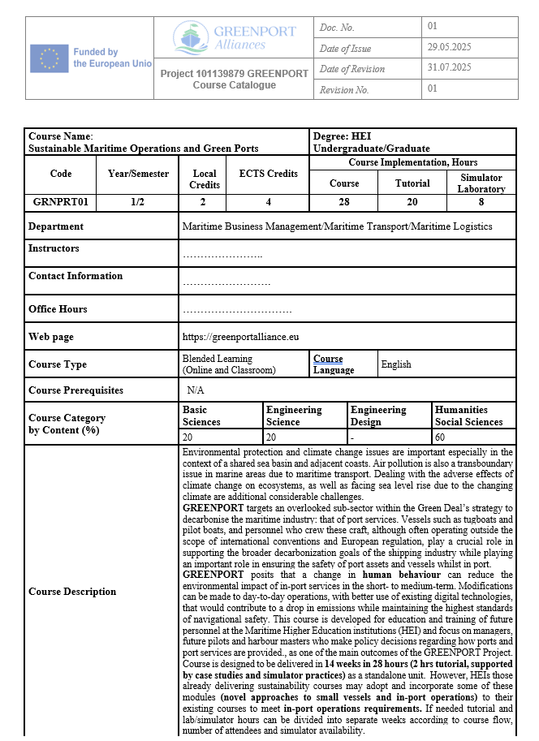
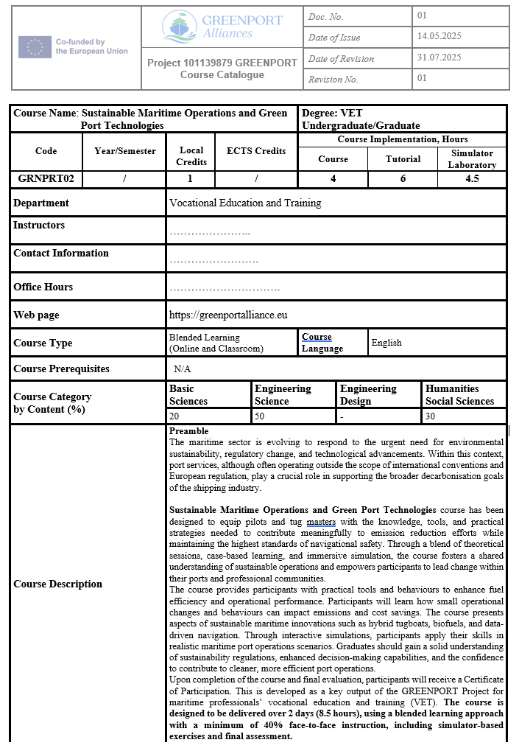
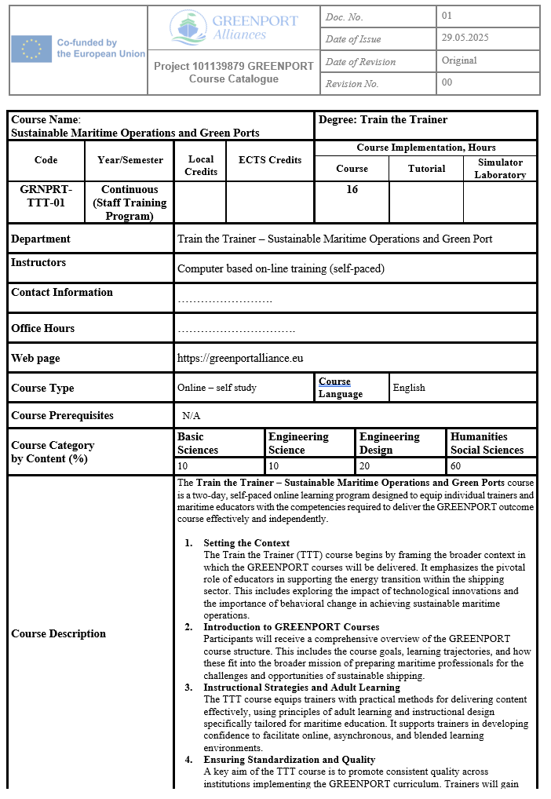

Summary
The three learning streams collectively form a vertically integrated curriculum for behavioural competence development in sustainable port operations:
- HEI (Conceptual Stage): Builds Capability through interdisciplinary understanding and policy literacy.
- VET (Operational Stage): Strengthens Opportunity through simulation and applied teamwork.
- TTT (Multiplication Stage): Sustains Motivation through digital facilitation and reflective teaching practice.
Together, they form a learning continuum (see Figure 2.2 – Behavioural Learning Continuum Across Streams) ensuring that behavioural transformation becomes embedded across all levels of maritime education and professional training.

Annex IV Pedagogical and Digital Tools
A cornerstone of the GREENPORT educational ecosystem is the digital learning infrastructure developed by Across Limits Ltd (Malta) in close collaboration with Nikola Vaptsarov Naval Academy (Bulgaria) and all academic partners. The GREENPORT e-learning platform serves as both a repository and an active learning environment supporting synchronous and asynchronous training across the three streams—HEI, VET, and TTT.
The tools described in this annex operationalise the COM-B framework, ensuring that Capability, Opportunity, and Motivation are systematically reinforced through digital learning experiences.
GREENPORT E-Learning Platform Overview
The GREENPORT Learning Management System (LMS) integrates a modular structure aligned with the project’s course catalogues. It offers:
- Course dashboards for TTT with standardised navigation.
- Interactive lessons using SCORM and HTML5 formats.
- Assessment and feedback tools embedded in each module.
- Analytics dashboard for tracking learner engagement and behavioural indicators.
- Instructor console for uploading simulation data and reflective assignments.
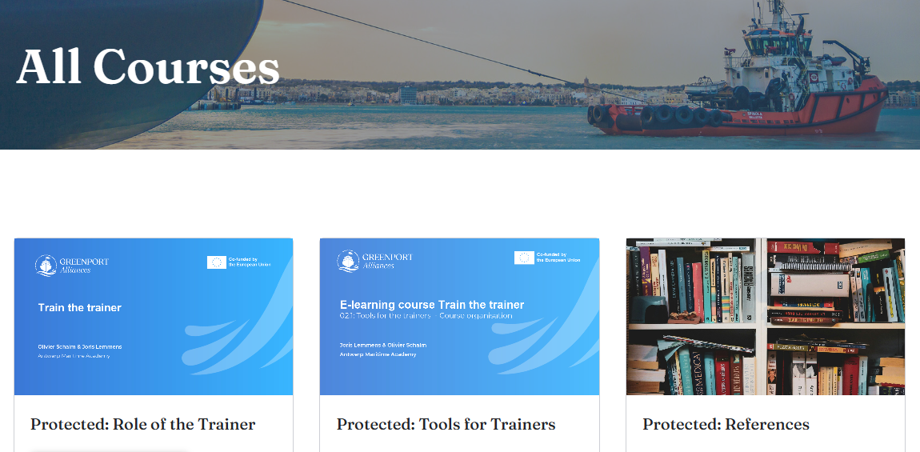
The picture above illustrates a representative screenshot of the GREENPORT LMS main interface, displaying the navigation layout for the TTT course stream.
Digital Quizzes and Interactive Materials
To strengthen knowledge retention and formative assessment, each module embeds interactive app and branching scenarios.
Examples include:
Course Stream | Learning Purpose | COM-B Link
HEI | Reinforces conceptual Capability through visual reasoning | Capability
VET | Builds situational awareness and operational accuracy | Opportunity
TTT | Encourages trainers to plan behaviour-oriented lessons | Motivation
Each quiz includes immediate feedback, explaining correct responses and referencing specific regulatory or technical contexts (EU Green Deal, FuelEU Maritime, IMO GHG Strategy).
Simulation Exercise Templates
Simulation plays a central role in VET and HEI courses, providing experiential environments where learners apply knowledge to realistic operational tasks.
Template Structure Example:
- Scenario Title: Tugboat Emission Optimisation in Port of Aveiro
- Objectives: Apply low-emission manoeuvring techniques and evaluate fuel consumption data.
- Input Data: Wind, current, vessel characteristics, engine load.
- Tasks: Execute manoeuvre; collect data; compare fuel-efficiency outcomes.
- Reflection Prompt: “Identify decisions that led to emission reductions.”
Each simulation session concludes with an automated debriefing report, highlighting behavioural indicators (response time, corrective actions, collaboration efficiency).

Behavioural Integration Across Tools
Tool Category | COM-B Dimension Targeted | Behavioural Intent
LMS Dashboard & Progress Tracking | Motivation | Encourage self-regulated learning through progress visibility.
Interactive Quizzes & Branching Scenarios | Capability | Strengthen conceptual mastery via active engagement.
Simulation Templates & Data Dashboards | Opportunity | Provide realistic contexts for skill application.
Reflection Journals & Peer Feedback | Motivation → Behaviour | Foster continuous improvement and internalisation of sustainable practice.
Collectively, these pedagogical and digital tools transform the GREENPORT platform into a behaviourally intelligent learning environment that supports both individual and institutional learning evolution.
Summary
The integration of digital pedagogical tools within GREENPORT achieves a dual function:
- Educational Innovation – enhancing accessibility, interactivity, and learner autonomy.
- Behavioural Transformation – translating environmental awareness into operational and teaching practice.
By embedding the COM-B model within every digital element—from quizzes to reflections—the consortium ensures that technical competence, contextual opportunity, and sustained motivation remain the pillars of maritime sustainability education.

